The Enfield Gov / Email’s Issue:
984. Lorraine Cordell _Re_ Simon Cordell_ (48)
/ Page Numbers: 4093,
From: Lorraine Cordell [lorraine32@blueyonder.co.uk]
Sent: 10 August 2018 13:38
To: 'Ludmilla Lyavoo'
Subject: RE: Simon Cordell
Dear Ludmilla, Lyavoo
- Could you please send me the link to the application form as I have been looking for all day my brother even went up to the civic centre and they could not give him a link they said there is not one.
- I wanted to get this done as soon as possible and Enfield Council website is not great to use.
Regards
Lorraine Cordell
Evidence: Exhibit 2 / 16/08/2018.
“Emails were here for the 16^{th of} August 2018 but have been removed as they were not needed but the emails forwarded where!”
Additional Email Attachments & Emails / Issue:
997. Ludmilla Lyavoo _RE_ Simon Cordell_ (2)
16/08/2018
/ Page Numbers:
1953,
“Emails were here for the 16^{th of} August 2018 but have been removed as they were not needed but the emails forwarded where!”
FW
From: Lorraine Cordell [mailto:lorraine32@blueyonder.co.uk]
Sent: 10 August 2018 13:38
To: 'Ludmilla Lyavoo'
Subject: RE: Simon Cordell
Dear Ludmilla Lyavoo
- Could you please send me the link to the application form as I have been looking for all day my brother even went up to the civic centre and they could not give him a link they said there is not one.
- I wanted to get this done as soon as possible and Enfield Council website is not great to use.
Regards
Lorraine Cordell
1957,
Be the first to receive the latest Council news straight to your inbox
SIGN UP ONLINE NOW
www.enfield.gov.uk/enewsletters
Enfield
http://www.enfield.gov.uk
Enfield Council is committed to serving the whole borough fairly, delivering excellent services and building strong communities.
Opinions expressed in this email are those of the individual and not necessarily those of the London Borough of Enfield. This email and any attachments or files transmitted with it are strictly confidential and intended solely for the named addressee. It may contain privileged and confidential information and if you are not the intended recipient and receive it in error you must not copy, distribute, or use the communication in any other way. All traffic handled by the Government Connect Secure Extranet may be subject to recording/and or monitoring in accordance with relevant legislation.
This email has been scanned for viruses, but we cannot guarantee that it will be free of viruses or malware. The recipient should perform their own virus checks.
Be the first to receive the latest Council news straight to your inbox
SIGN UP ONLINE NOW
www.enfield.gov.uk/enewsletters
Enfield
http://www.enfield.gov.uk
Enfield Council is committed to serving the whole borough fairly, delivering excellent services and building strong communities.
Opinions expressed in this email are those of the individual and not necessarily those of the London Borough of Enfield. This email and any attachments or files transmitted with it are strictly confidential and intended solely for the named addressee. It may contain privileged and confidential information and if you are not the intended recipient and receive it in error you must not copy, distribute, or use the communication in any other way. All traffic handled by the Government Connect Secure Extranet may be subject to recording/and or monitoring in accordance with relevant legislation.
This email has been scanned for viruses, but we cannot guarantee that it will be free of viruses or malware. The recipient should perform their own virus checks.
1958,
Be the first to receive the latest Council news straight to your inbox
SIGN UP ONLINE NOW
www.enfield.gov.uk/enewsletters
Enfield
http://www.enfield.gov.uk
Enfield Council is committed to serving the whole borough fairly, delivering excellent services and building strong communities.
Opinions expressed in this email are those of the individual and not necessarily those of the London Borough of Enfield. This email and any attachments or files transmitted with it are strictly confidential and intended solely for the named addressee. It may contain privileged and confidential information and if you are not the intended recipient and receive it in error you must not copy, distribute, or use the communication in any other way. All traffic handled by the Government Connect Secure Extranet may be subject to recording/and or monitoring in accordance with relevant legislation.
This email has been scanned for viruses, but we cannot guarantee that it will be free of viruses or malware. The recipient should perform their own virus checks.
1959,
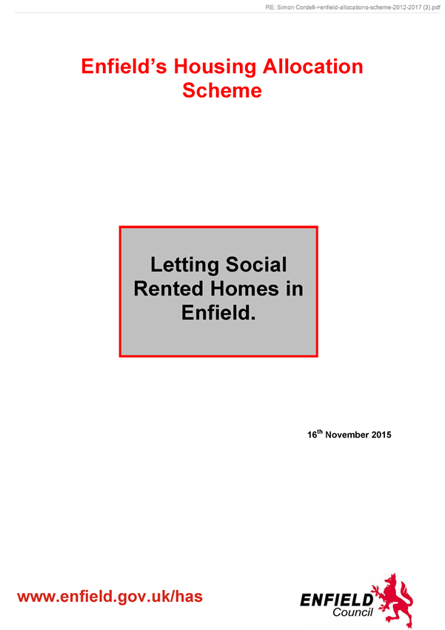
1960,
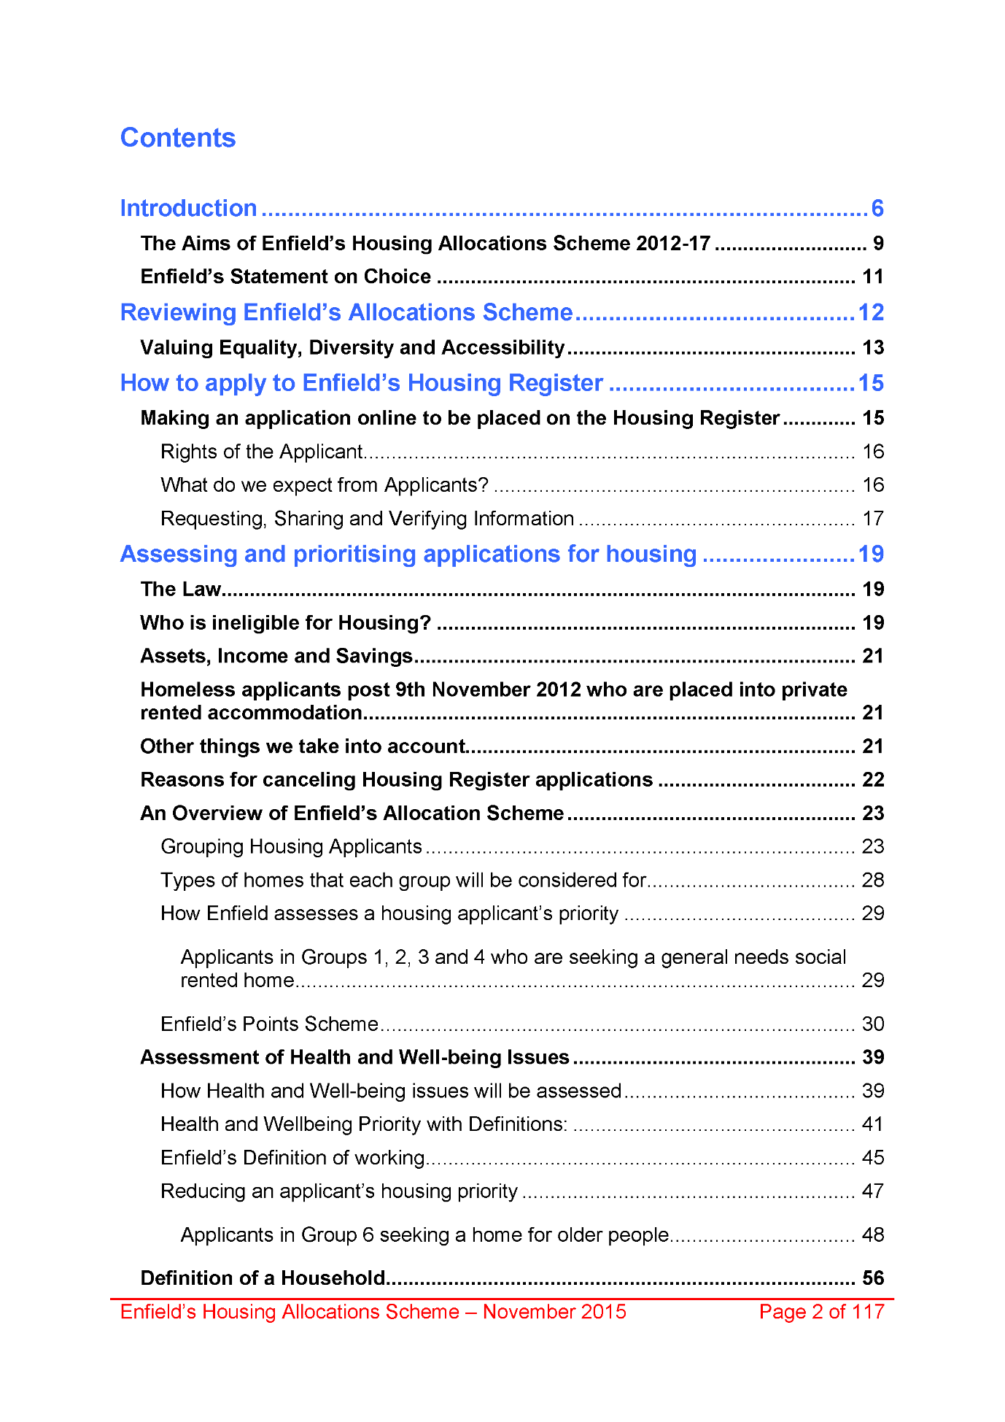
1961,
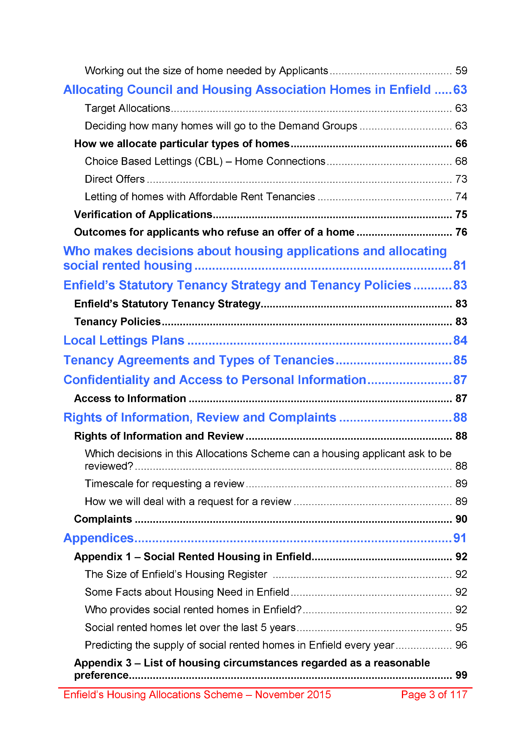
1962,
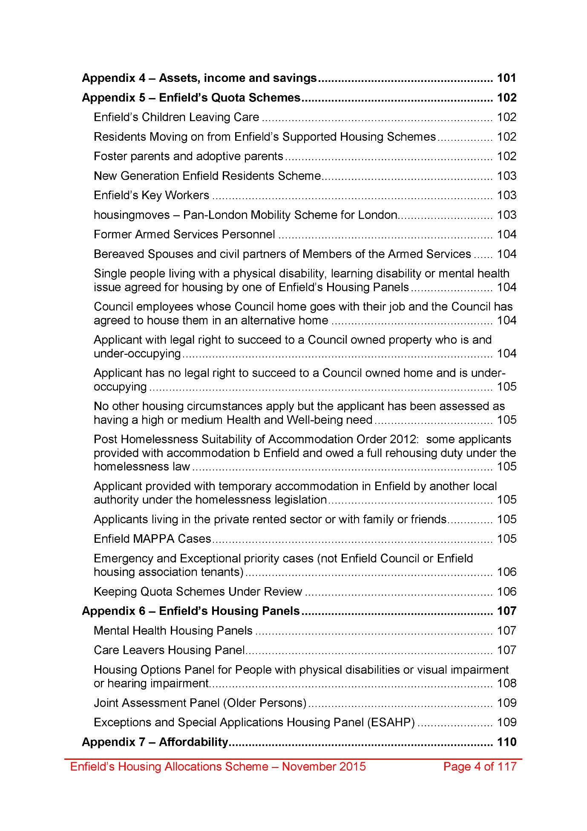
1963,
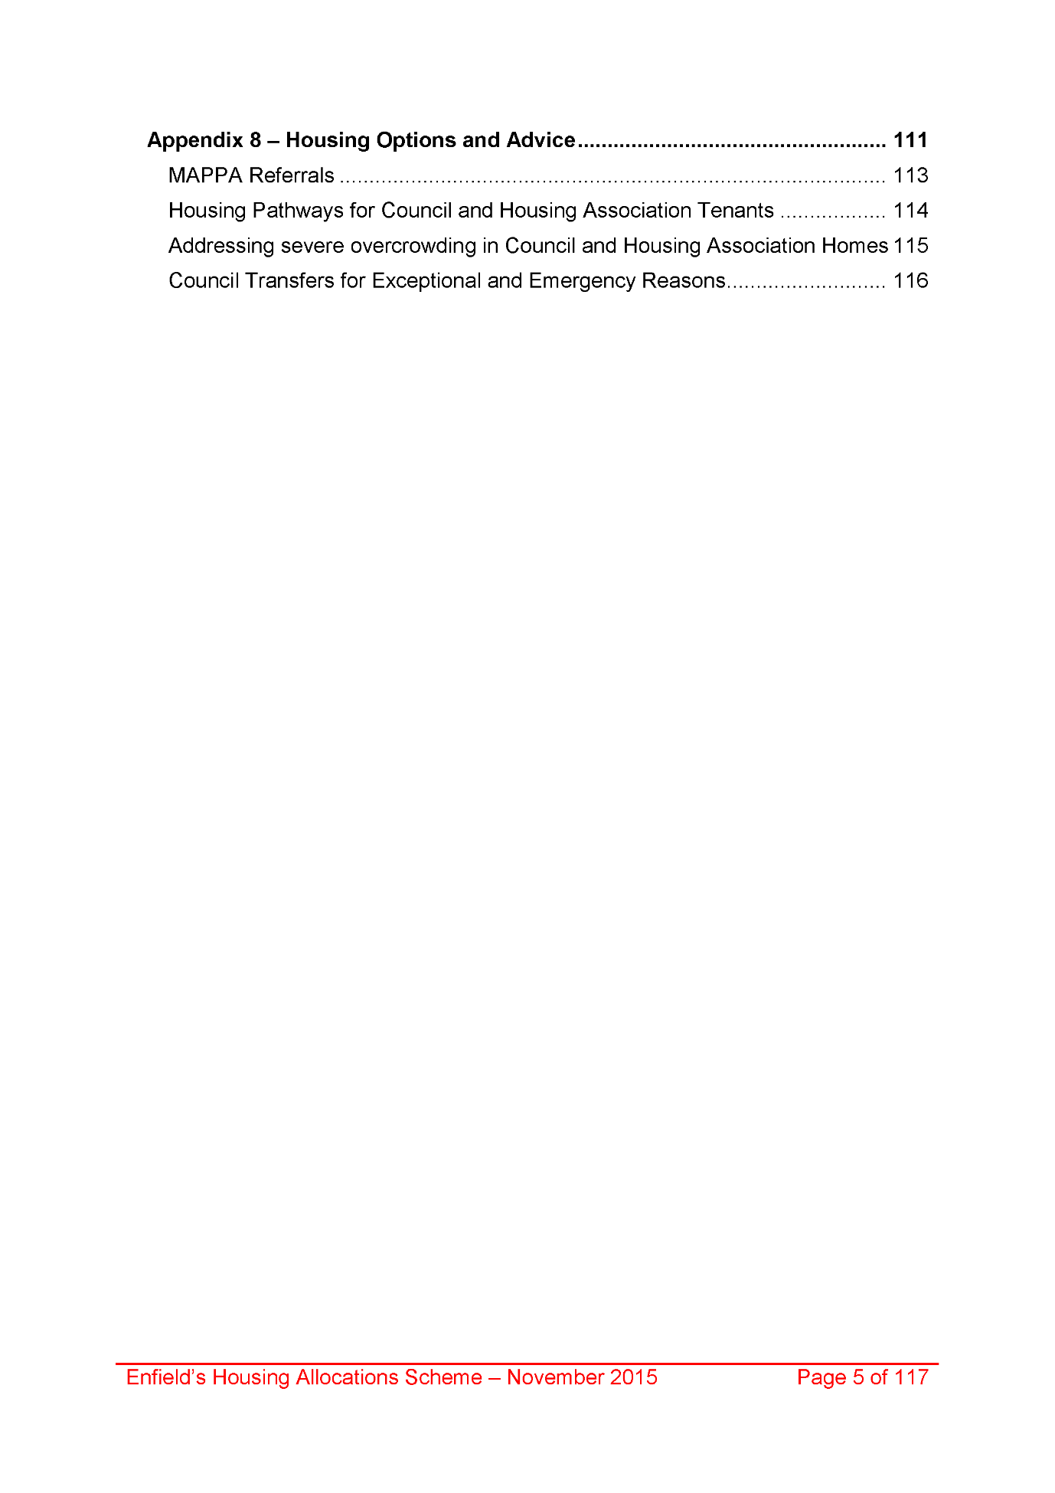
1964,
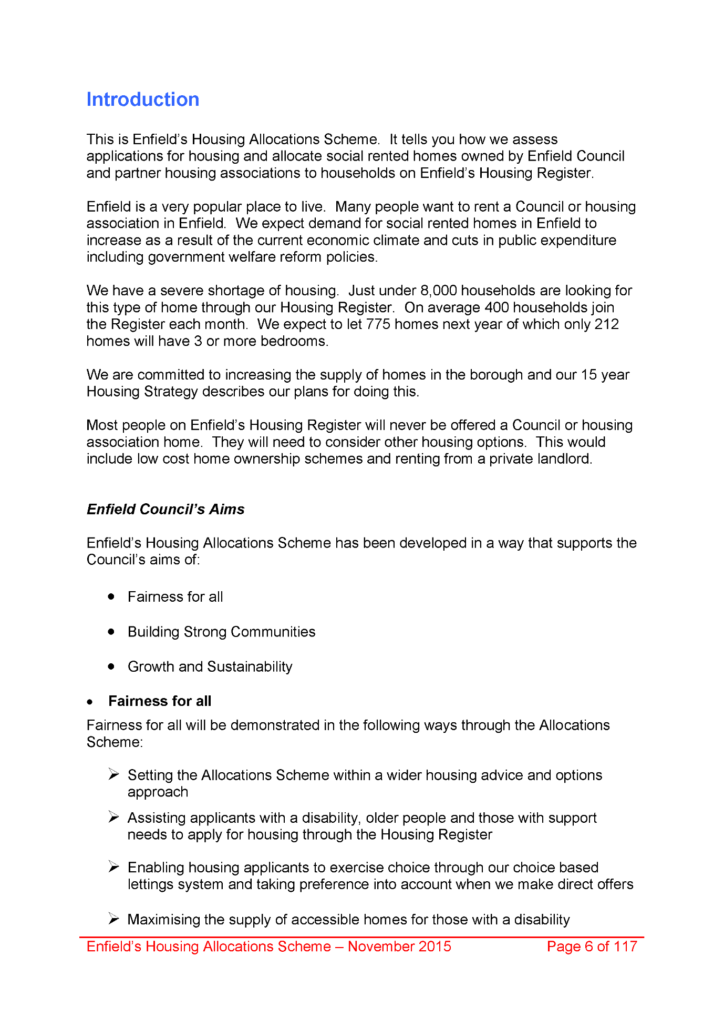
1965,
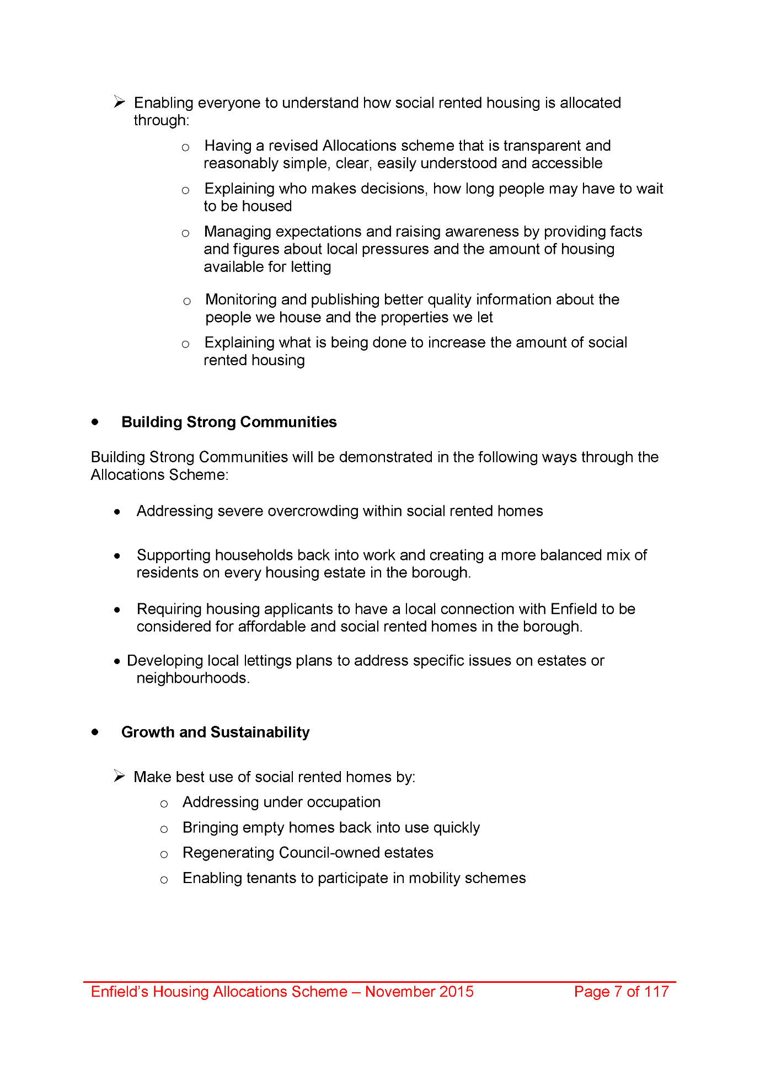
1966,
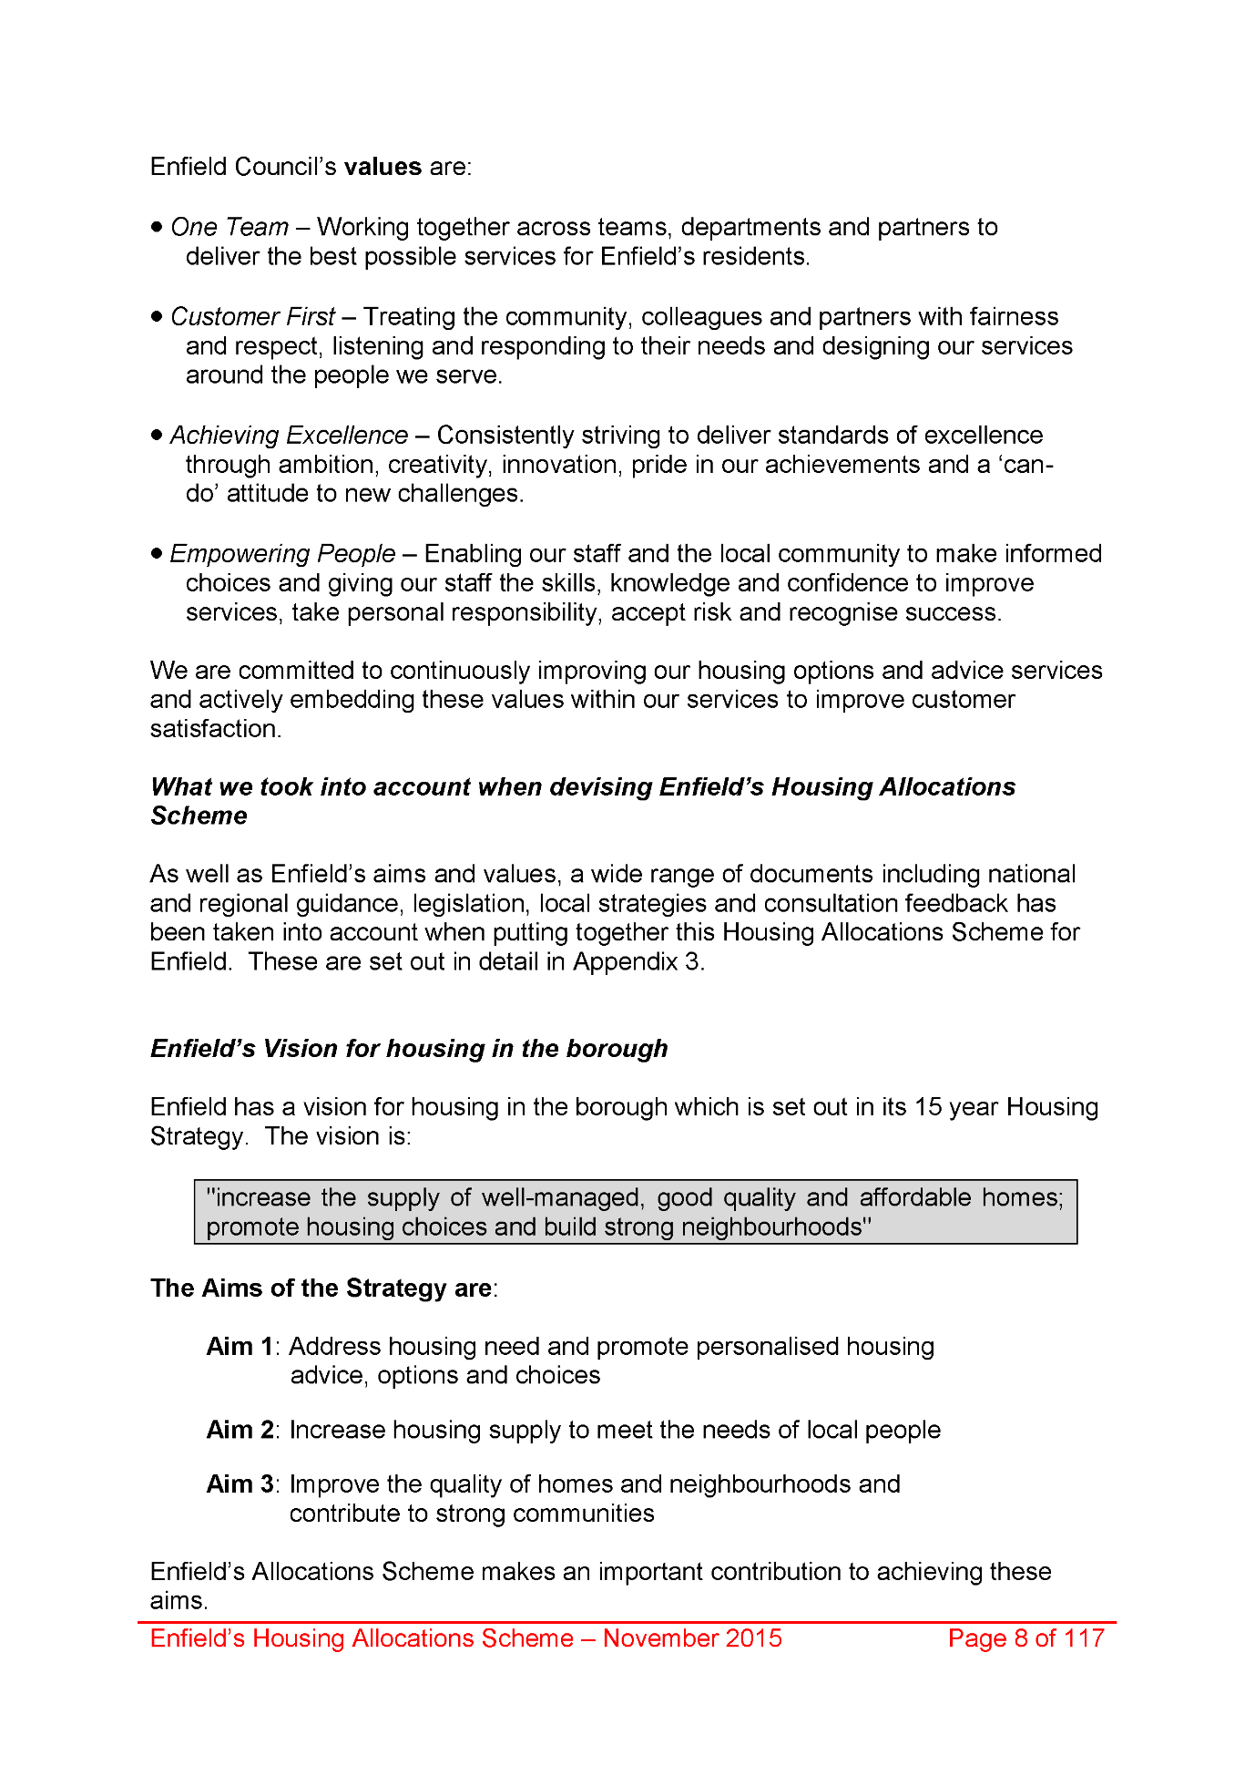
1967,
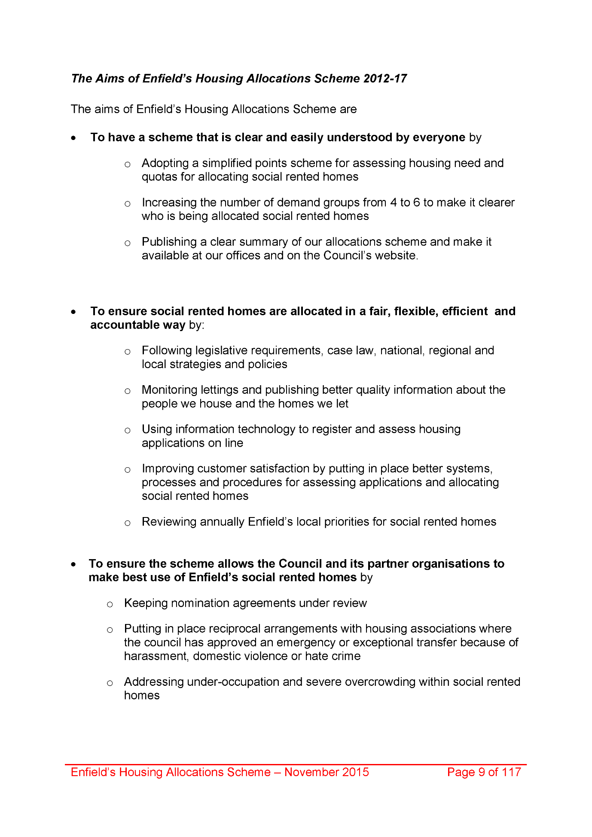
1968,
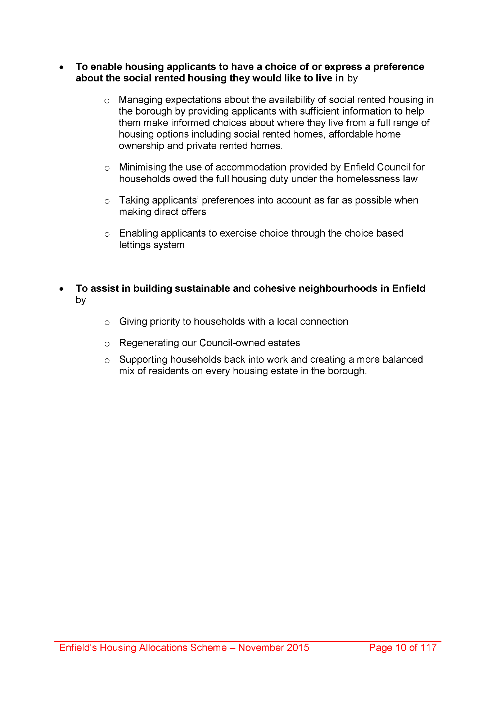
1969,
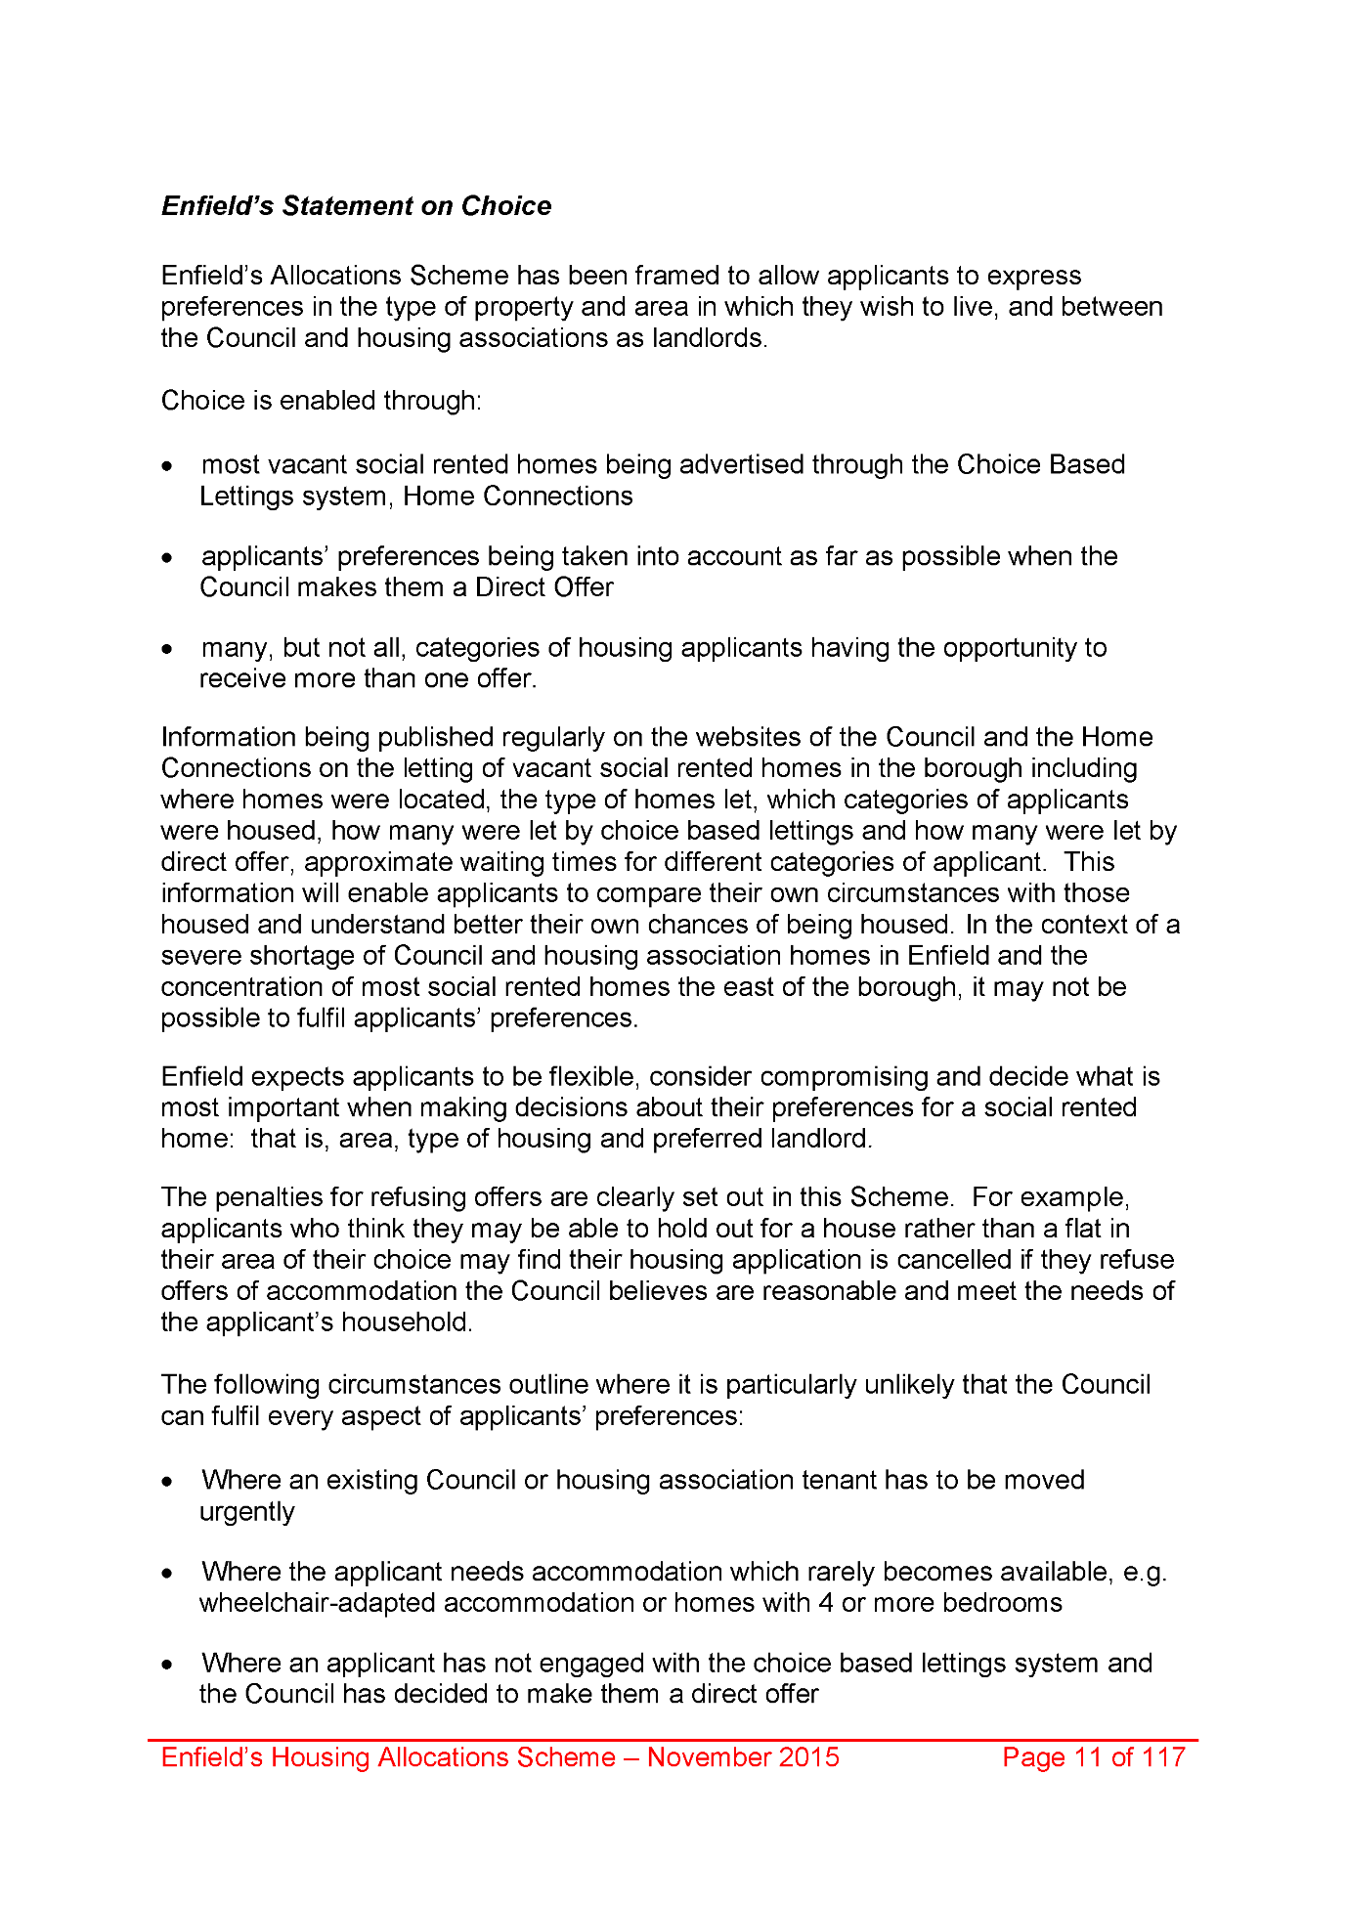
1970,
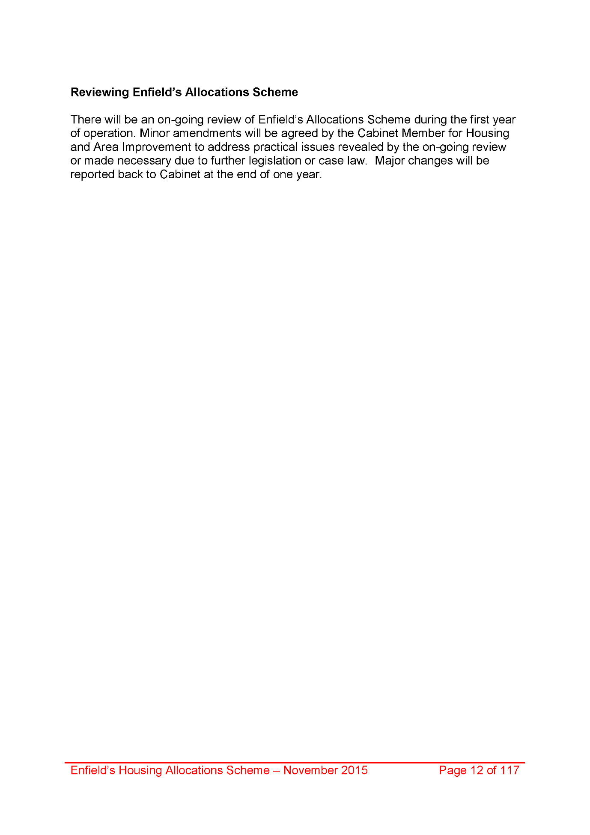
1971,
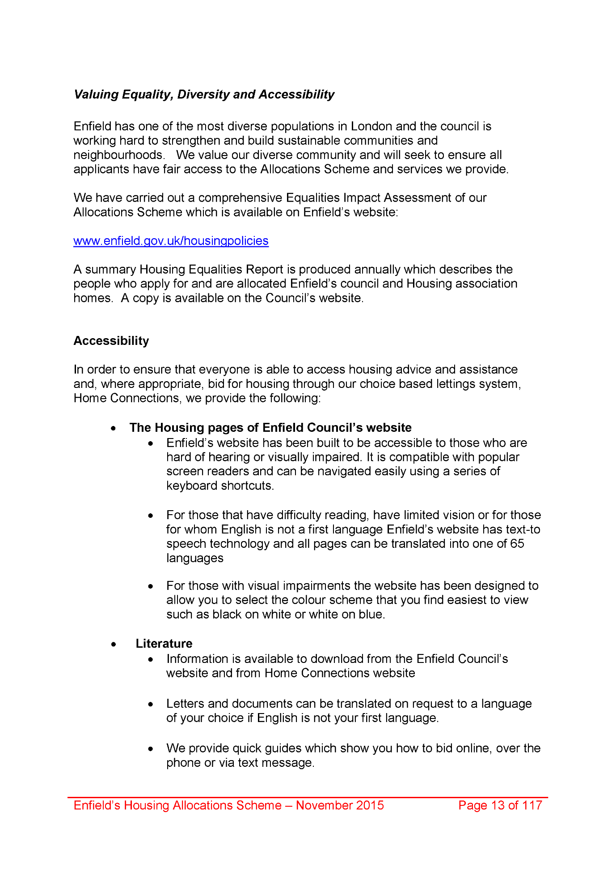
1972,
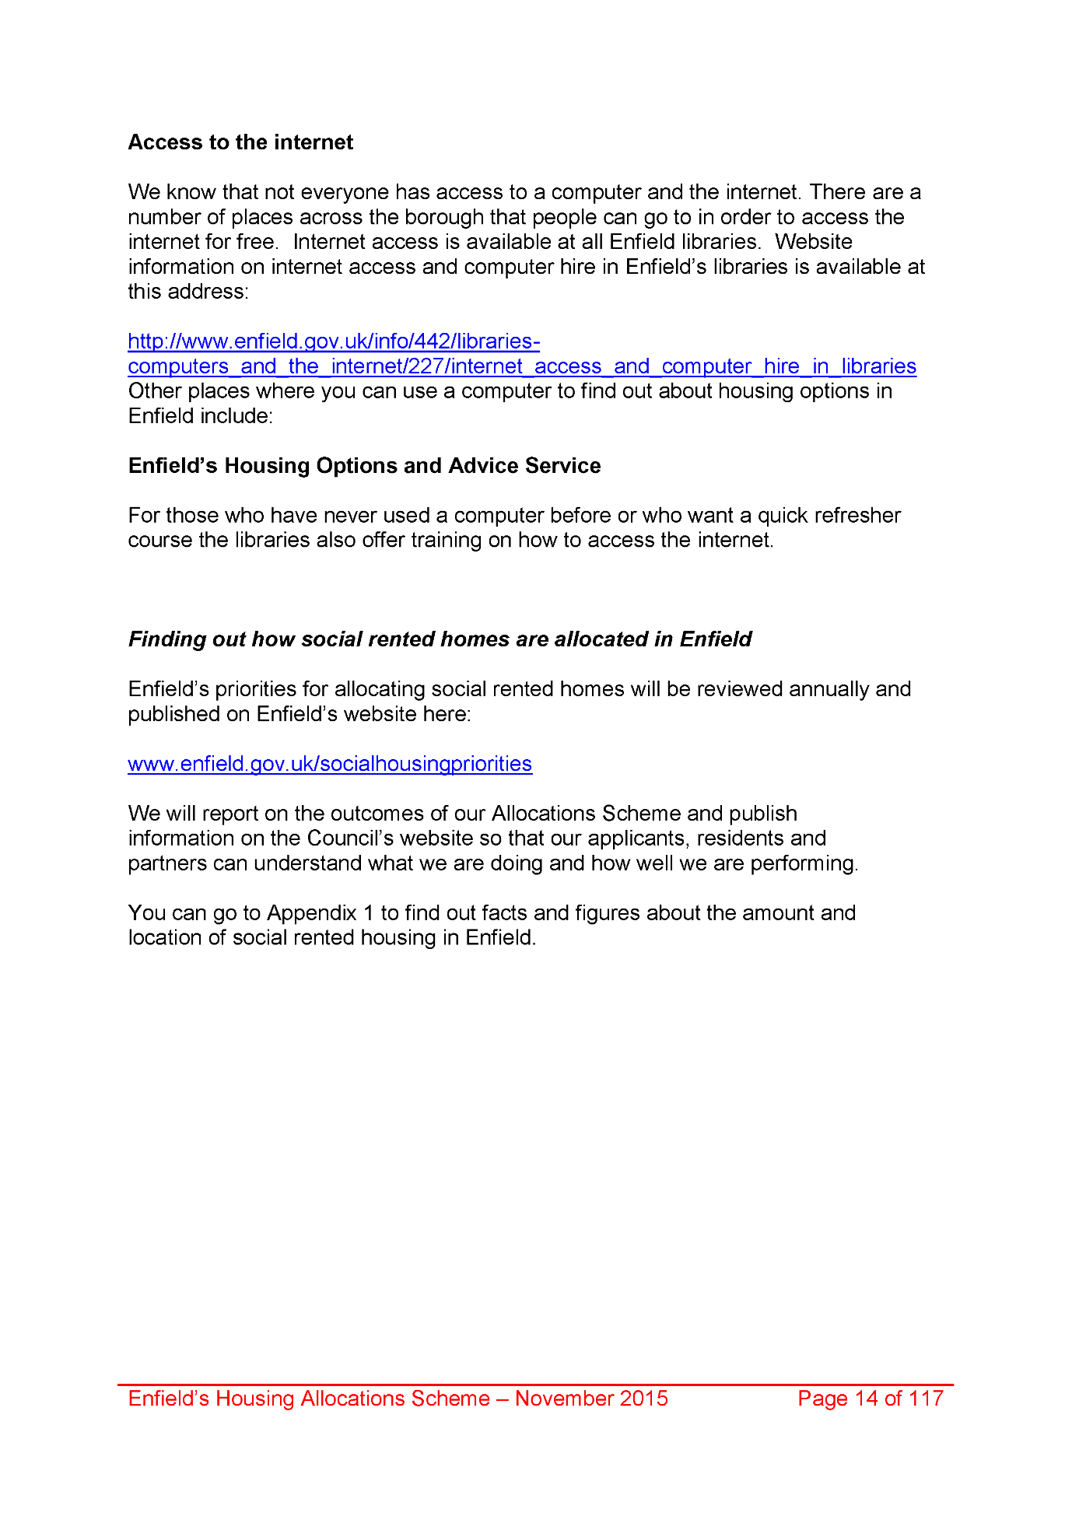
1973,
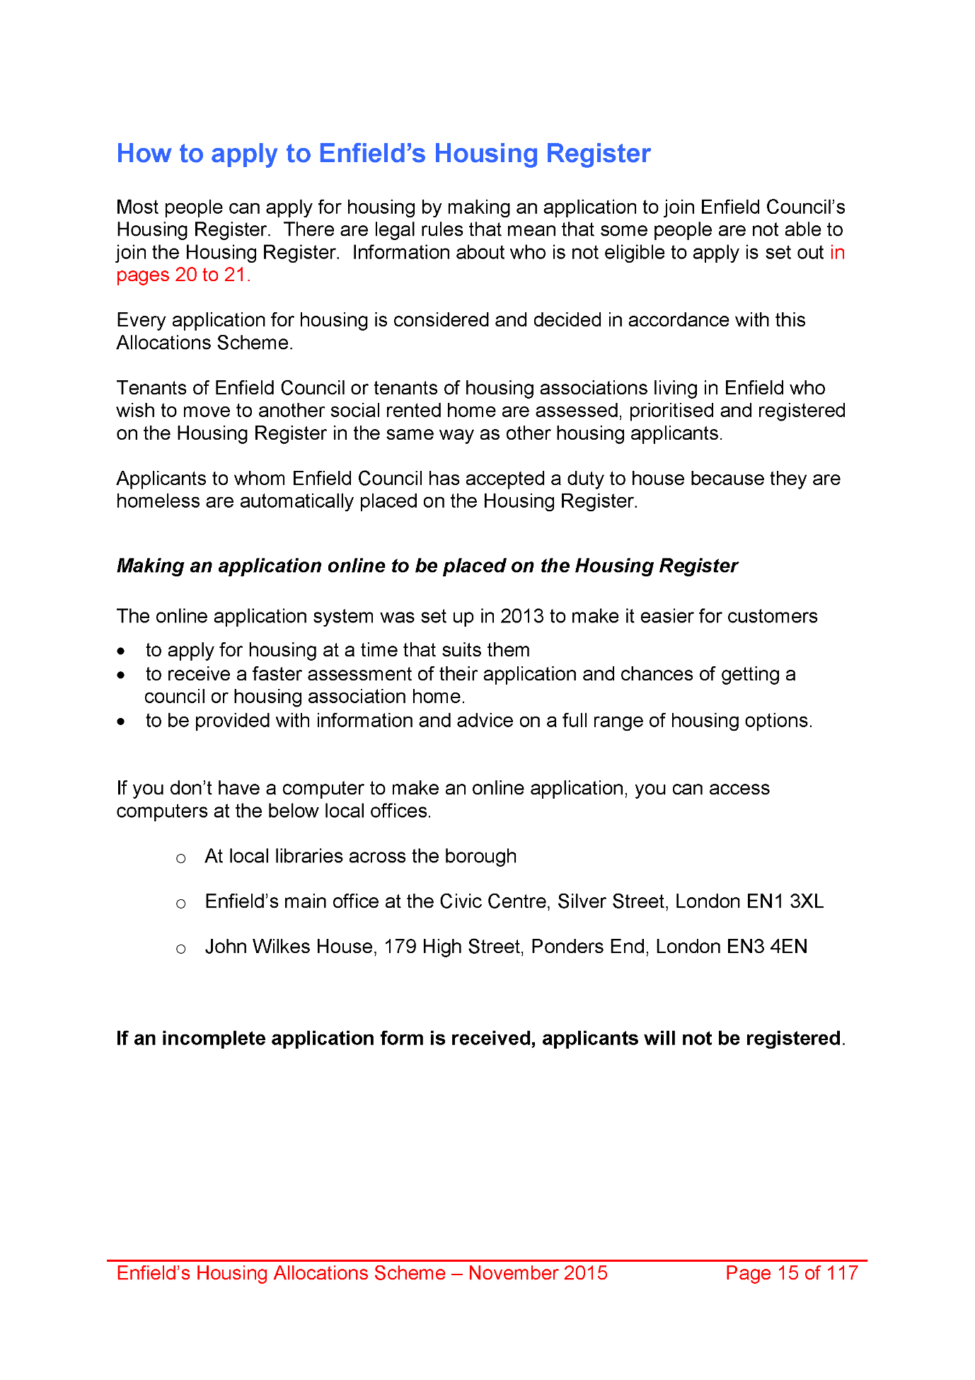
1974,
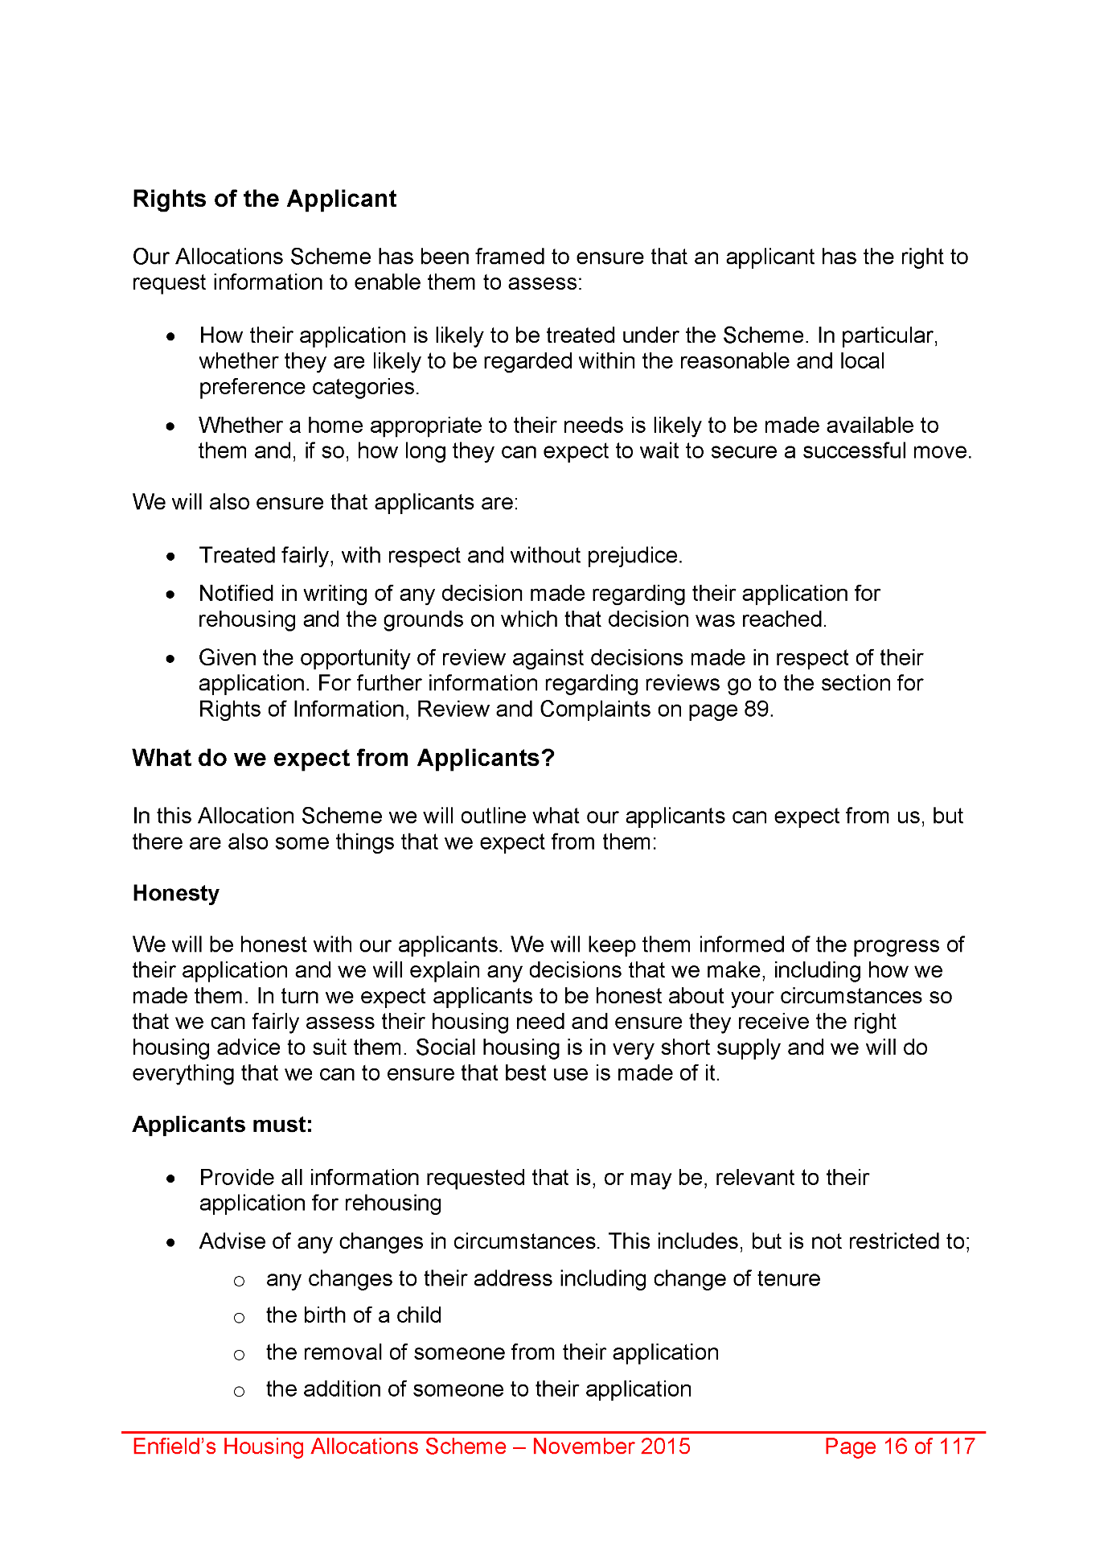
1975,
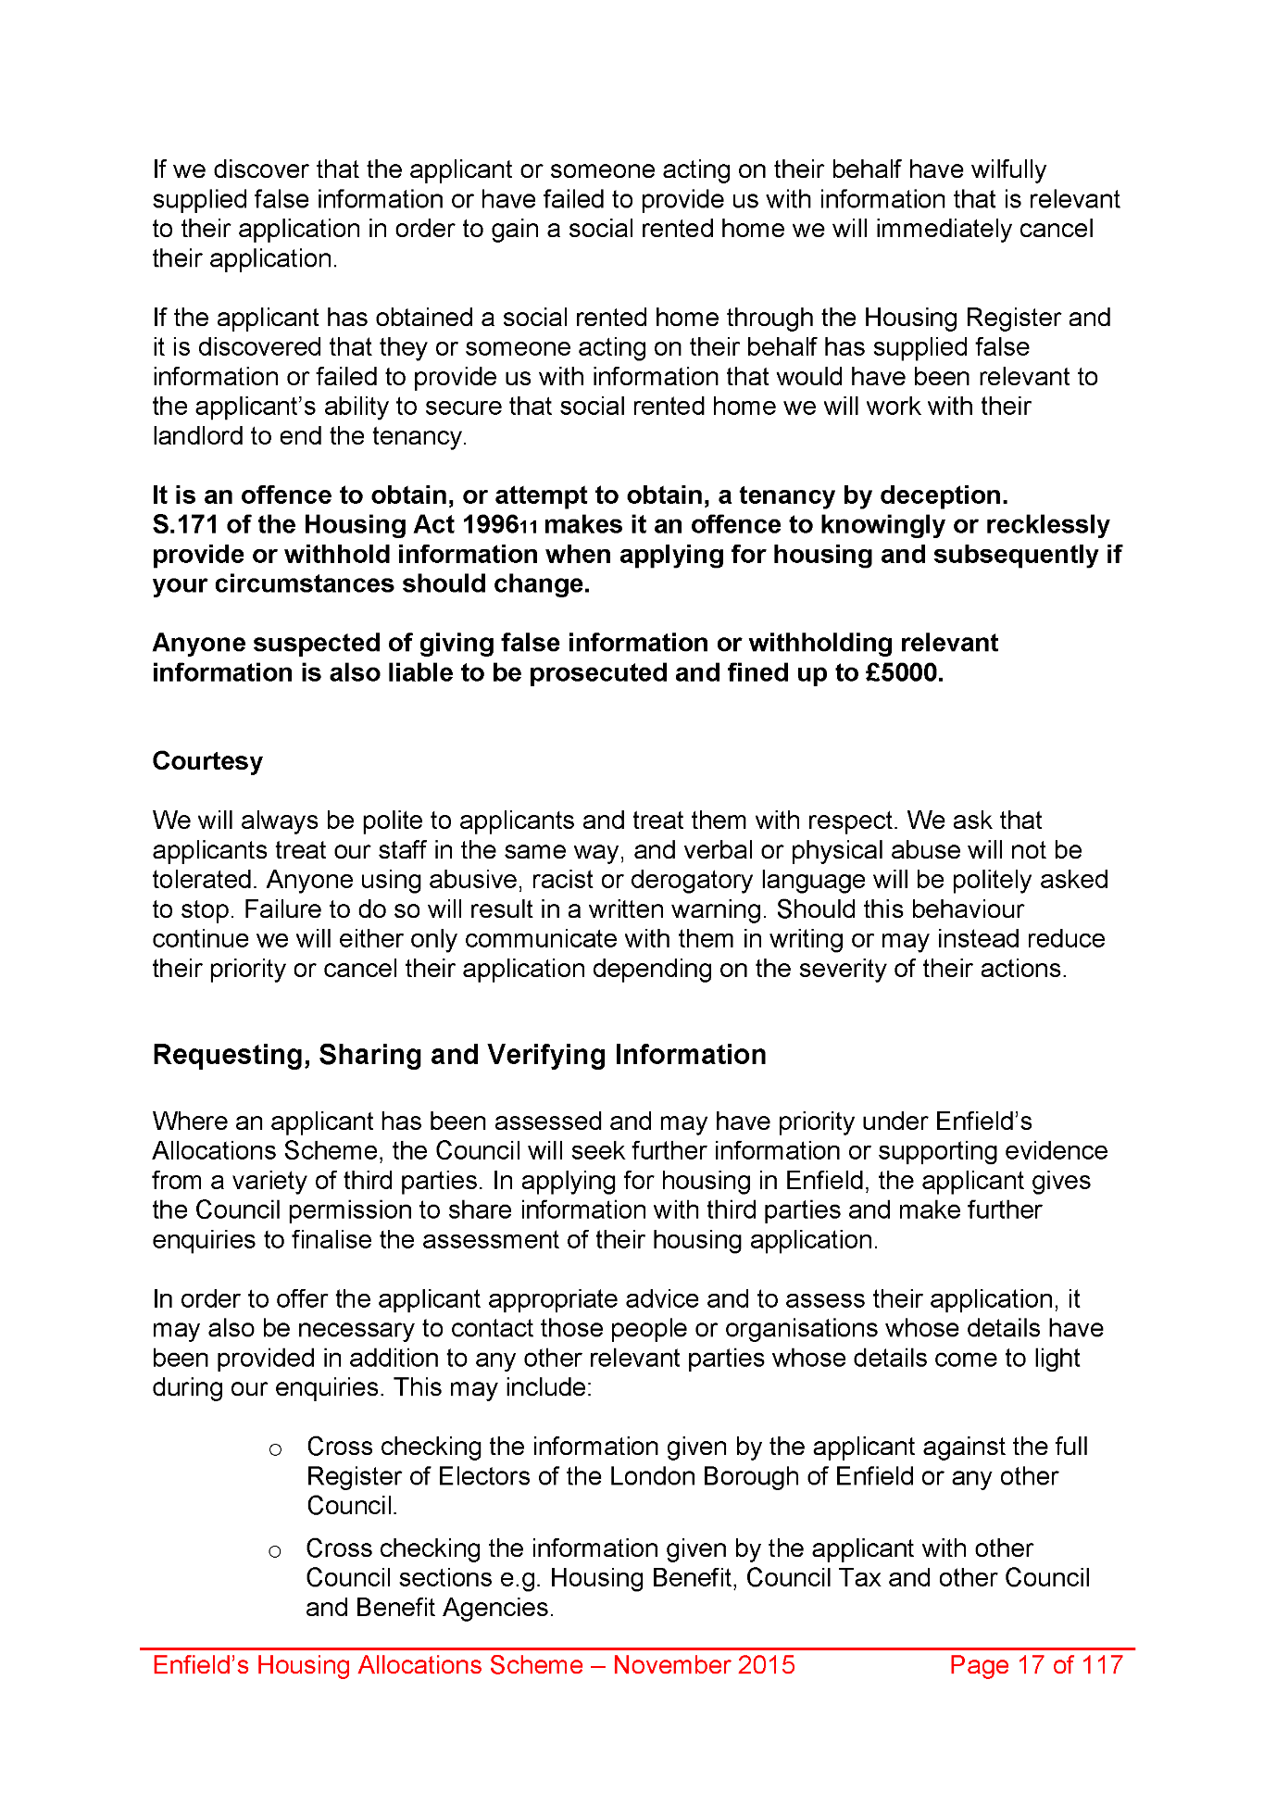
1976,
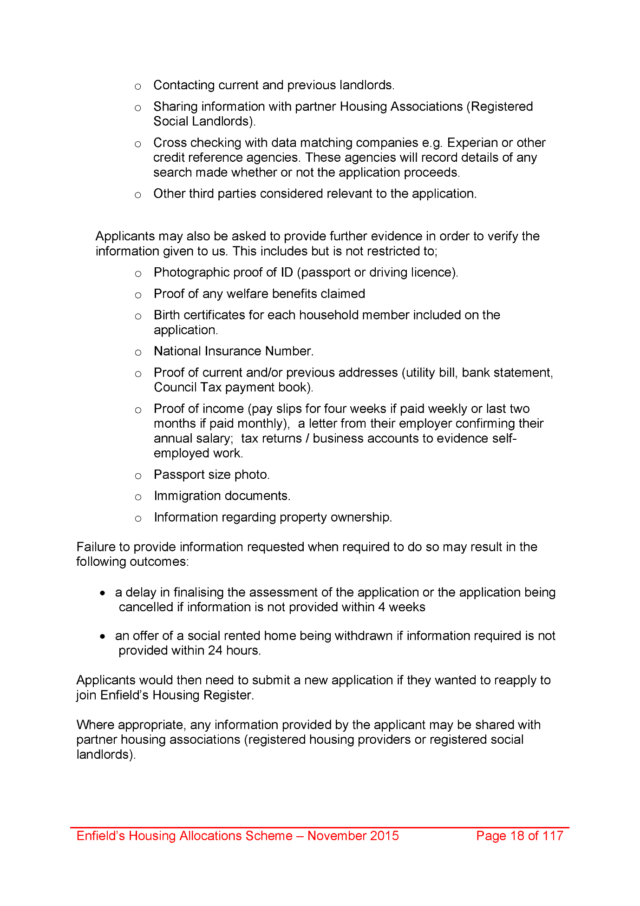
1977,
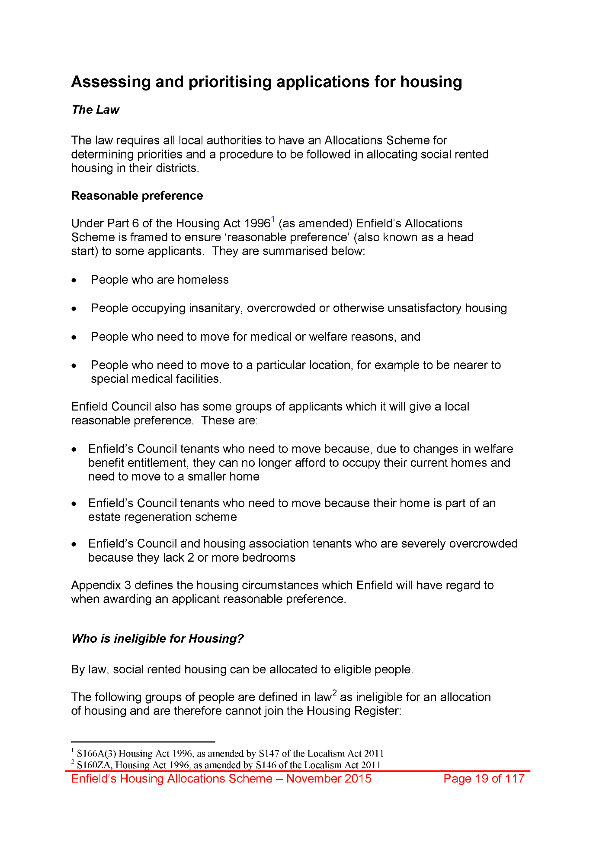
1978,
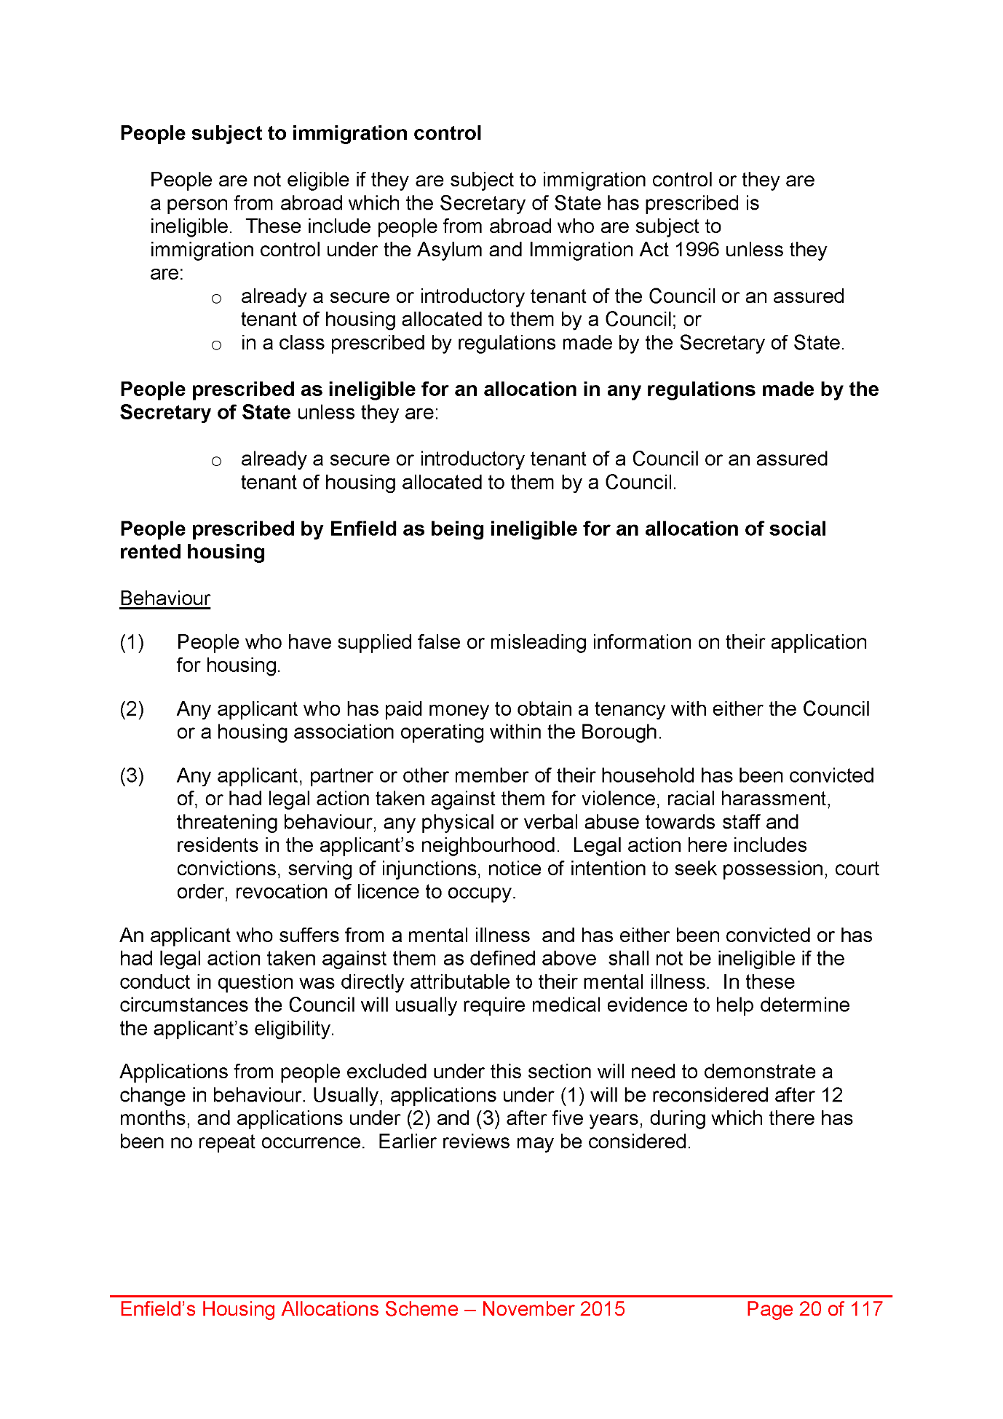
1979,
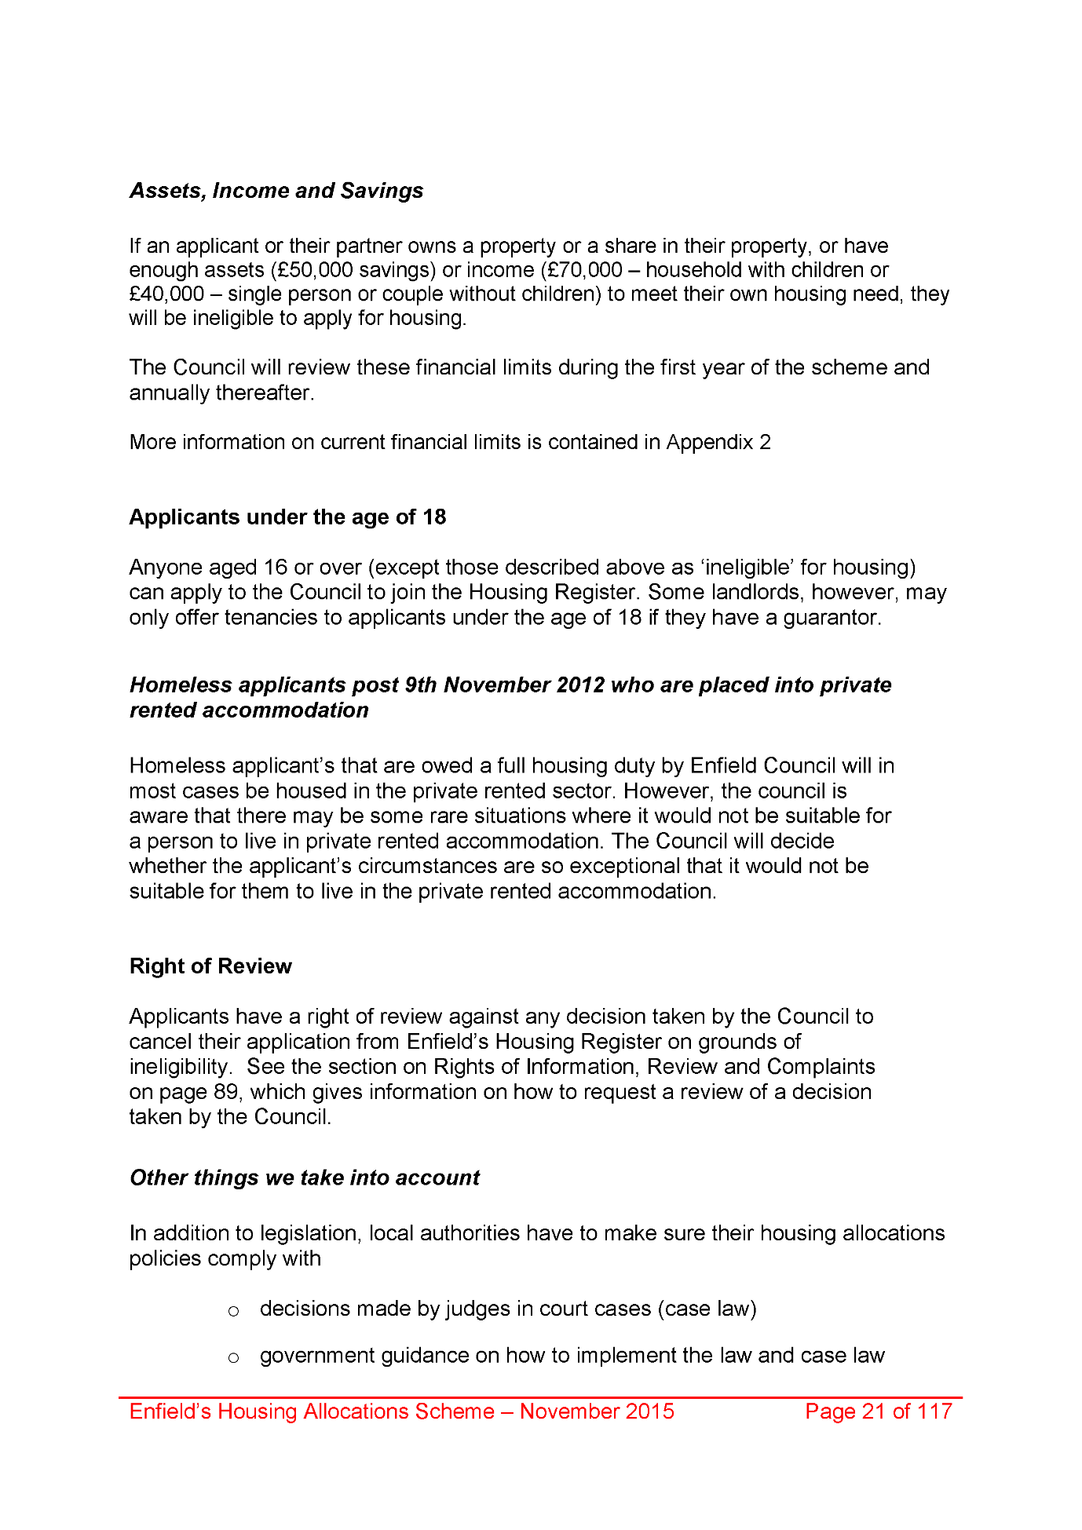
1980,
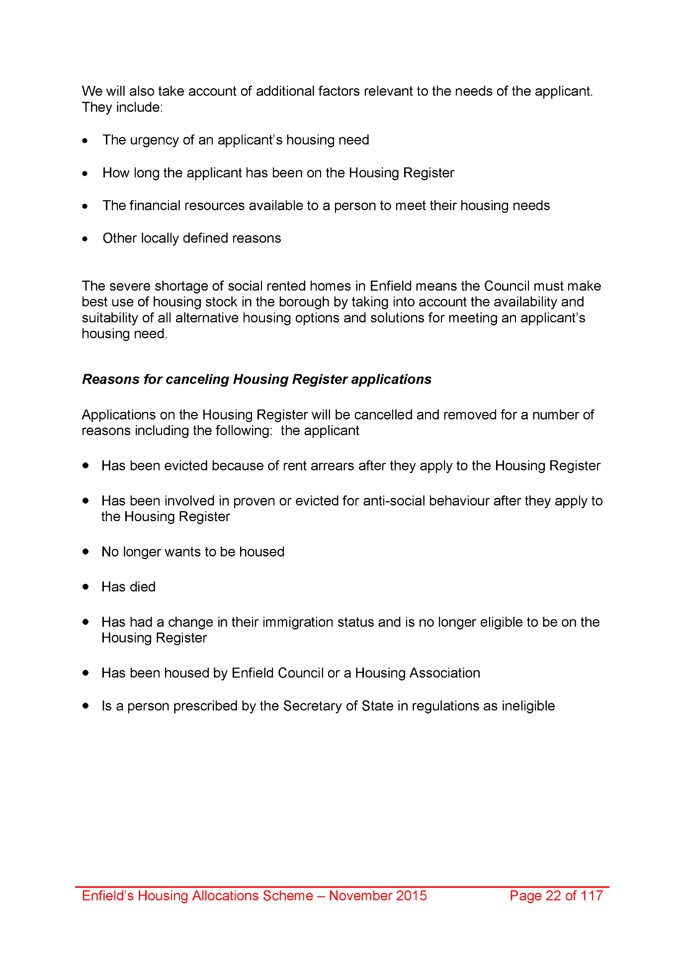
1981,
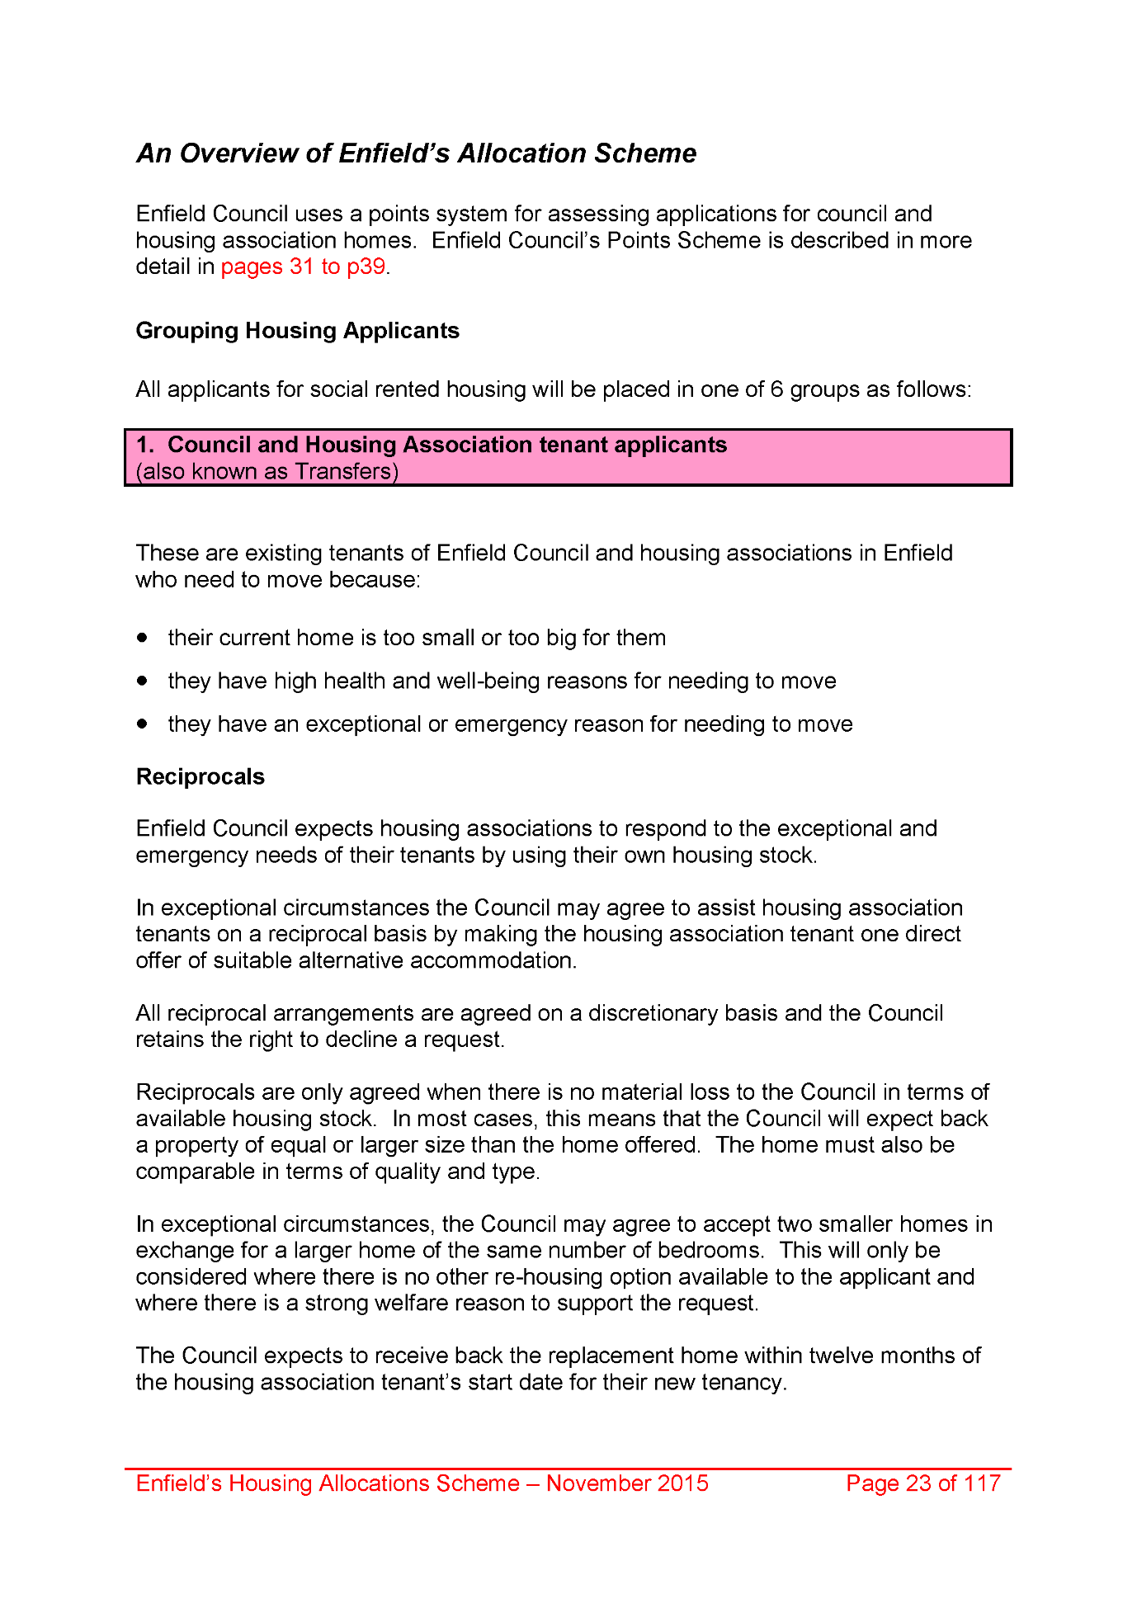
1982,
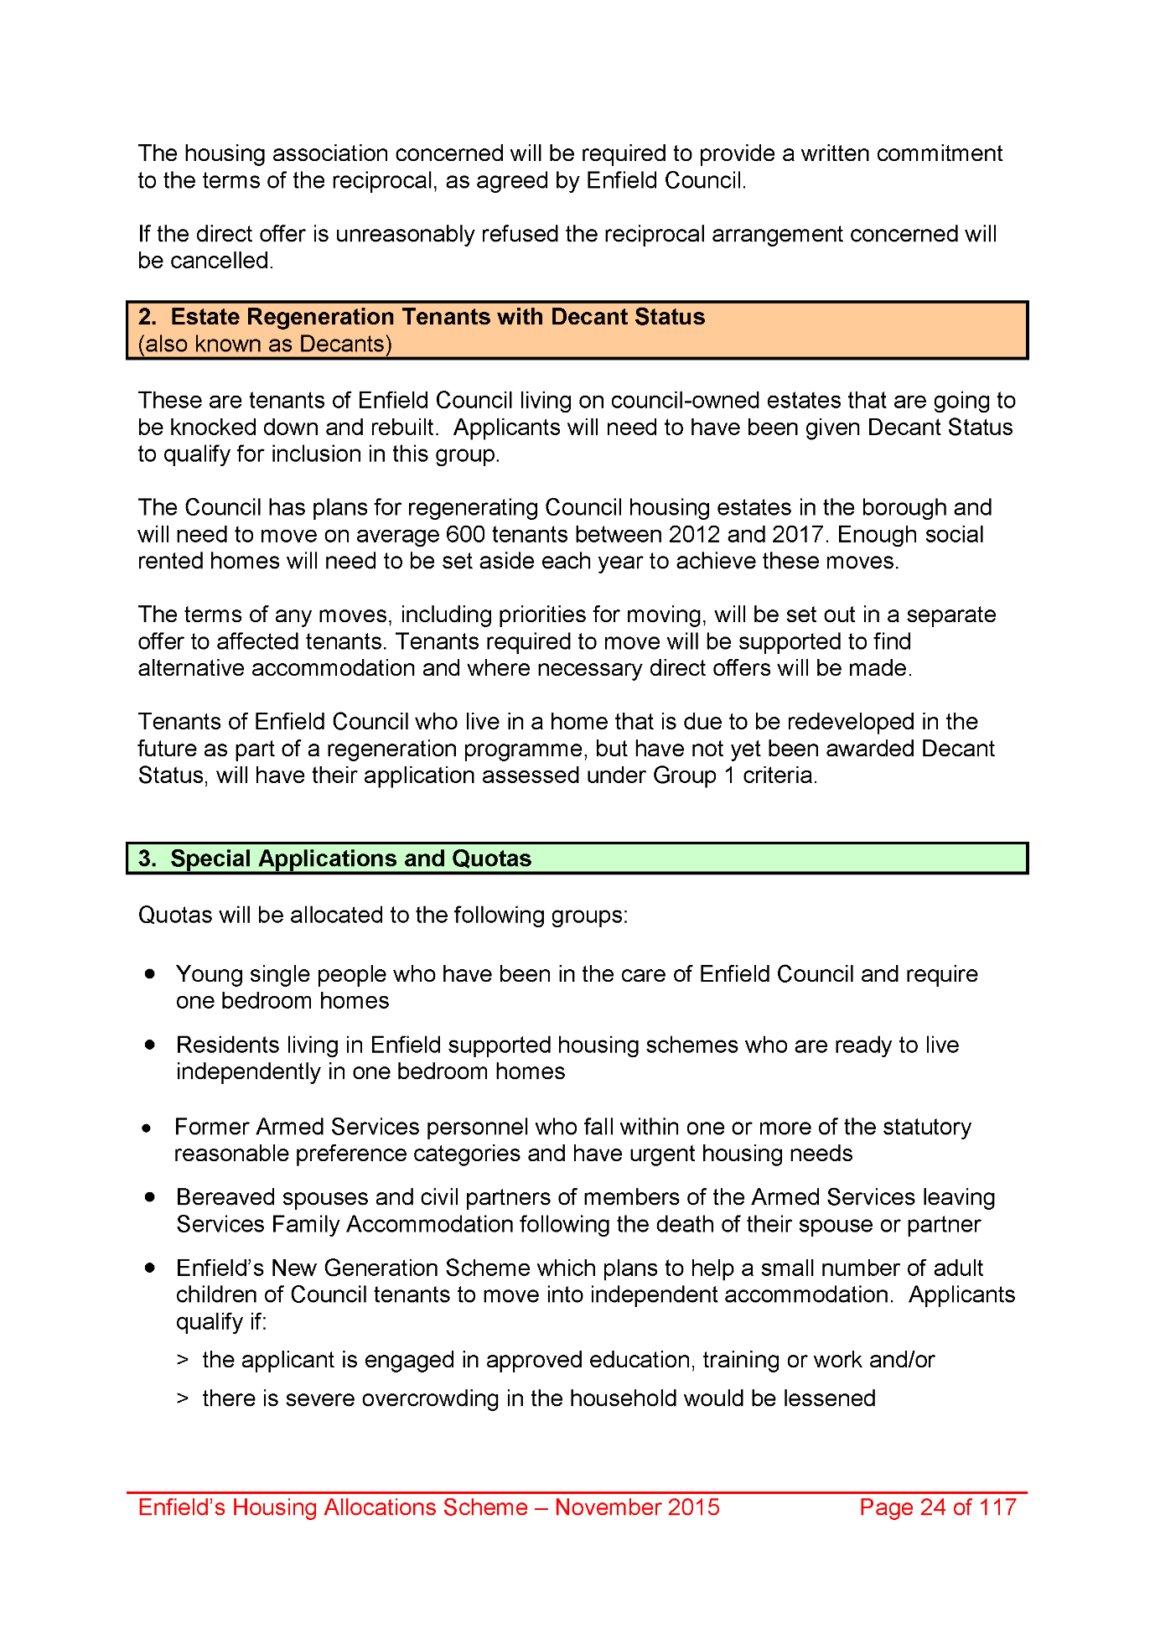
1983,
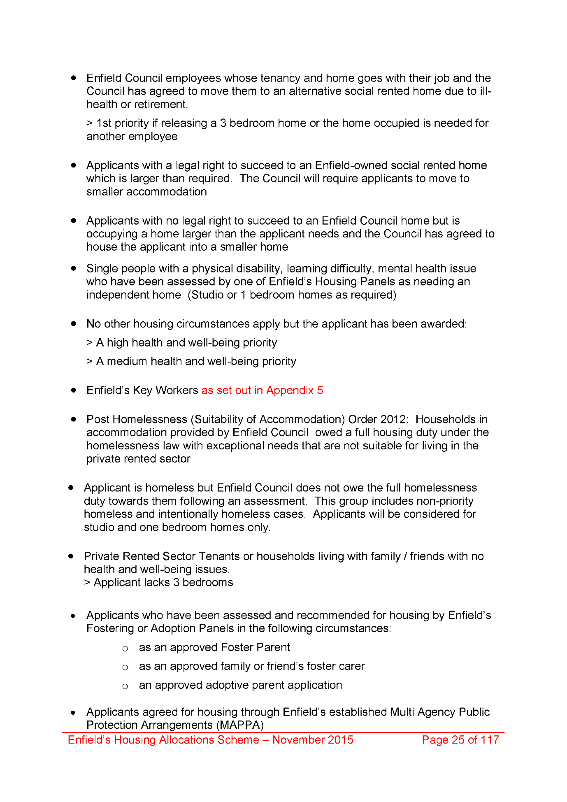
1984,
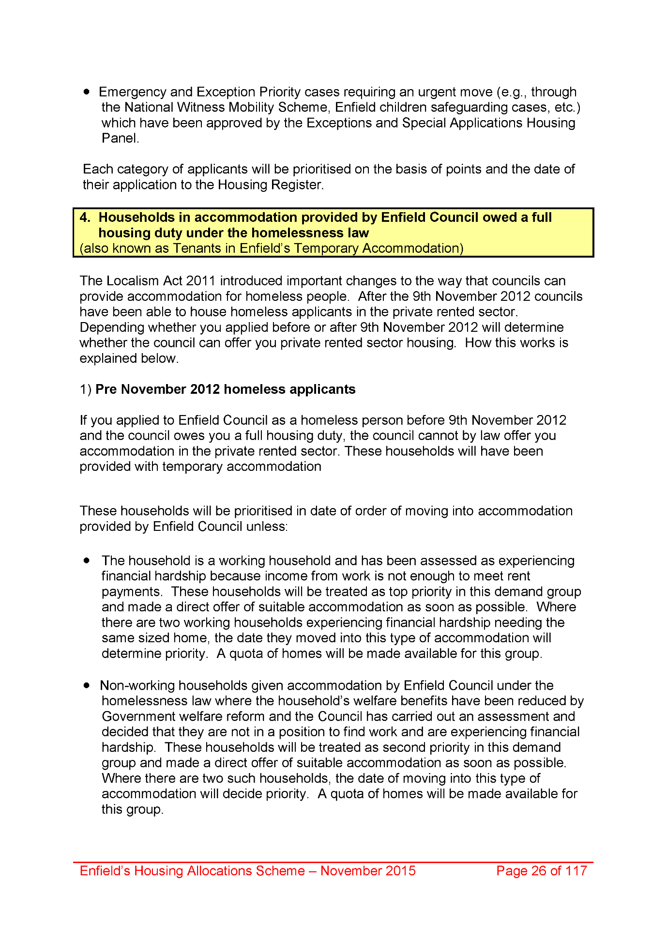
1985,
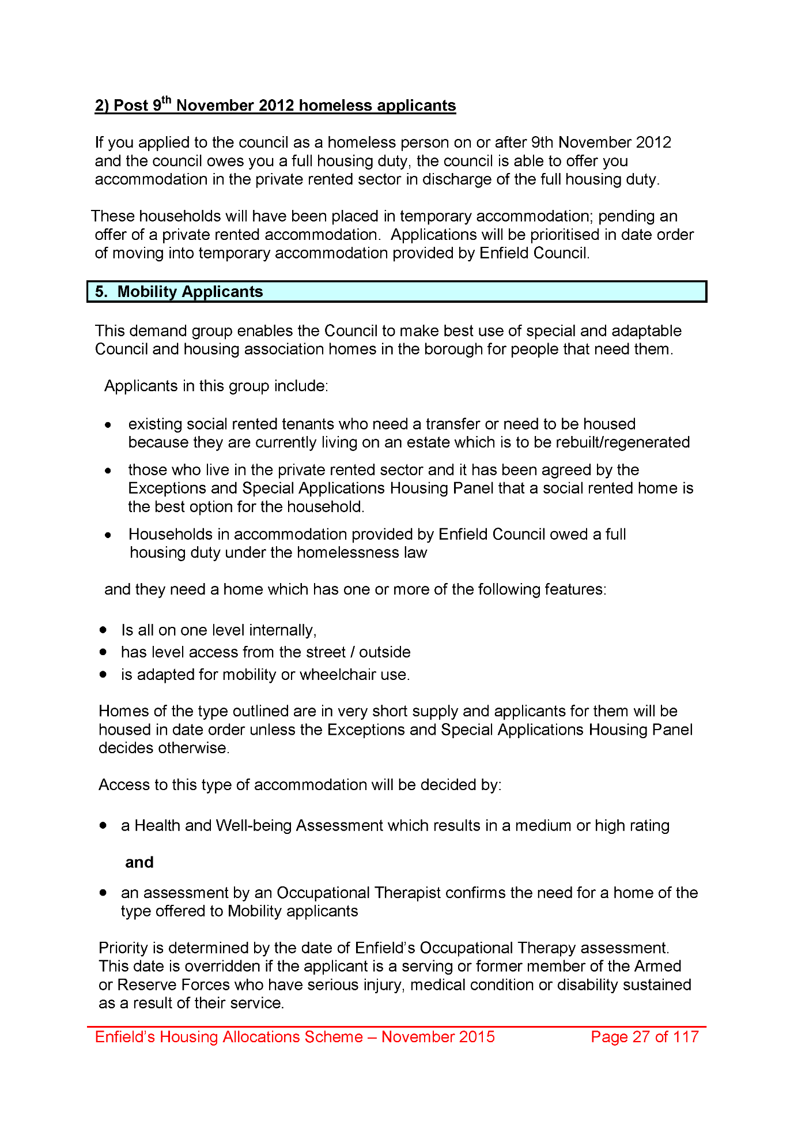
1986,
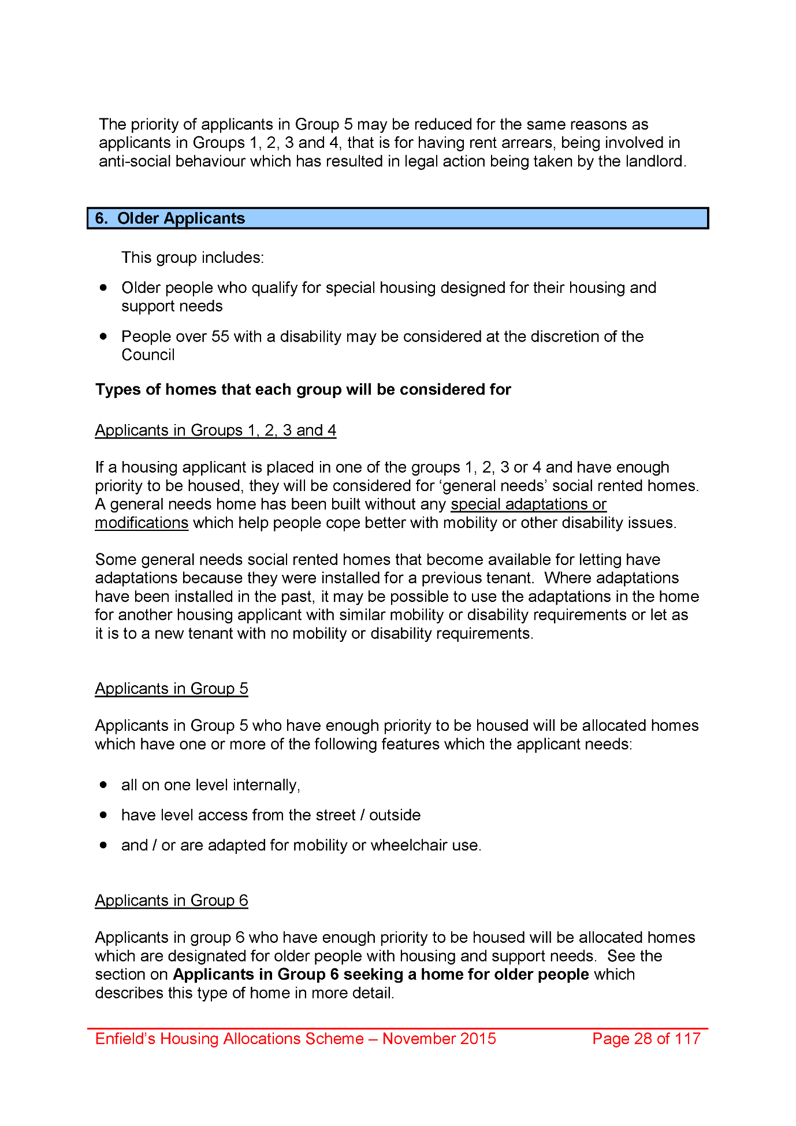
1987,
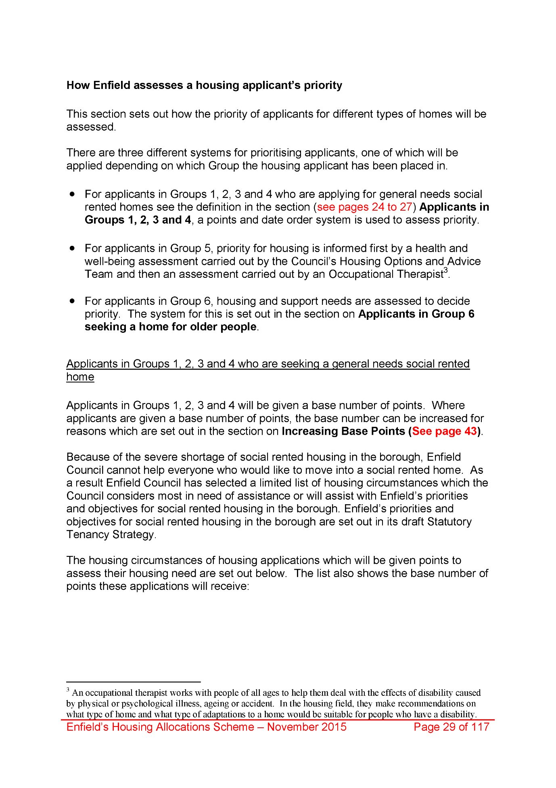
1988,
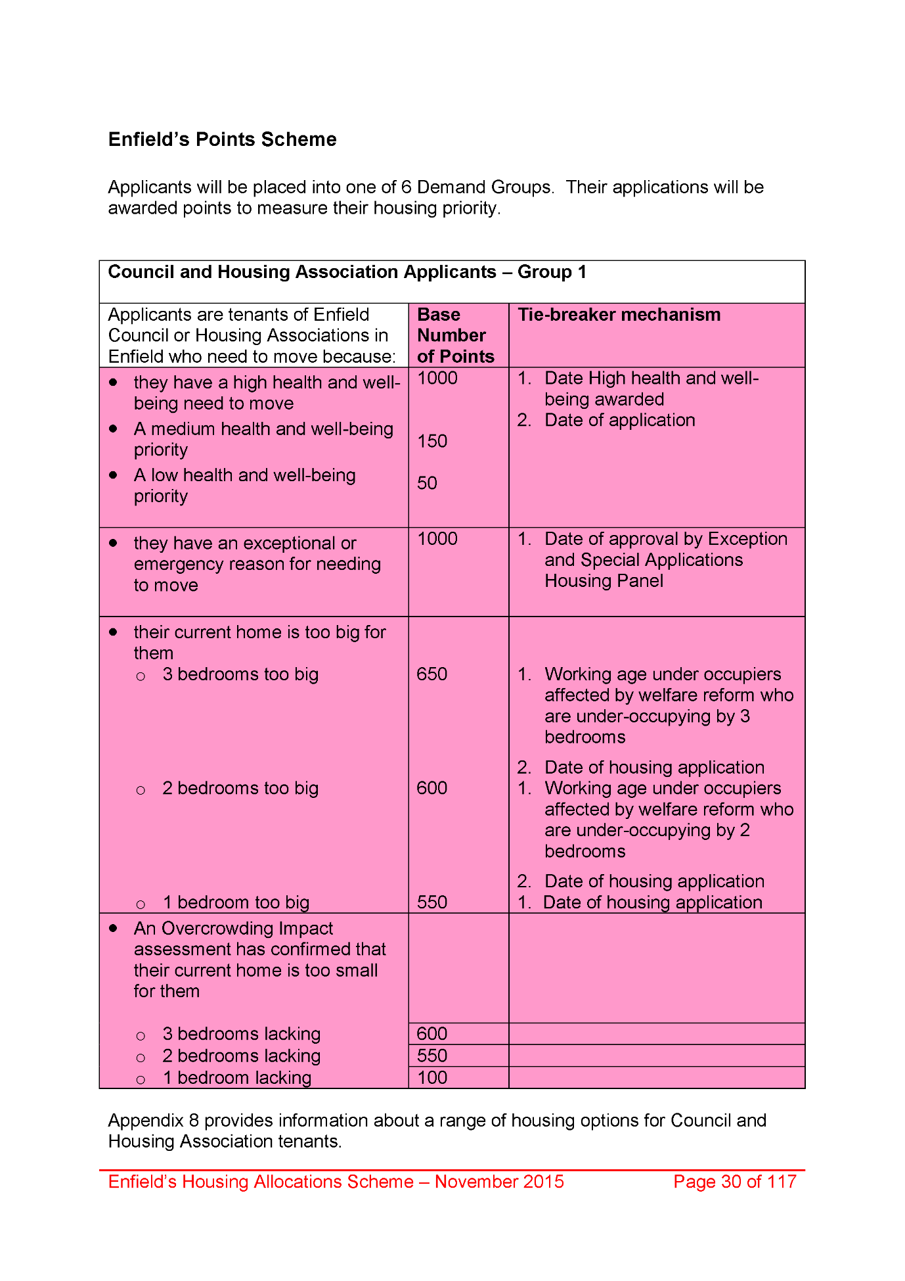
1989,
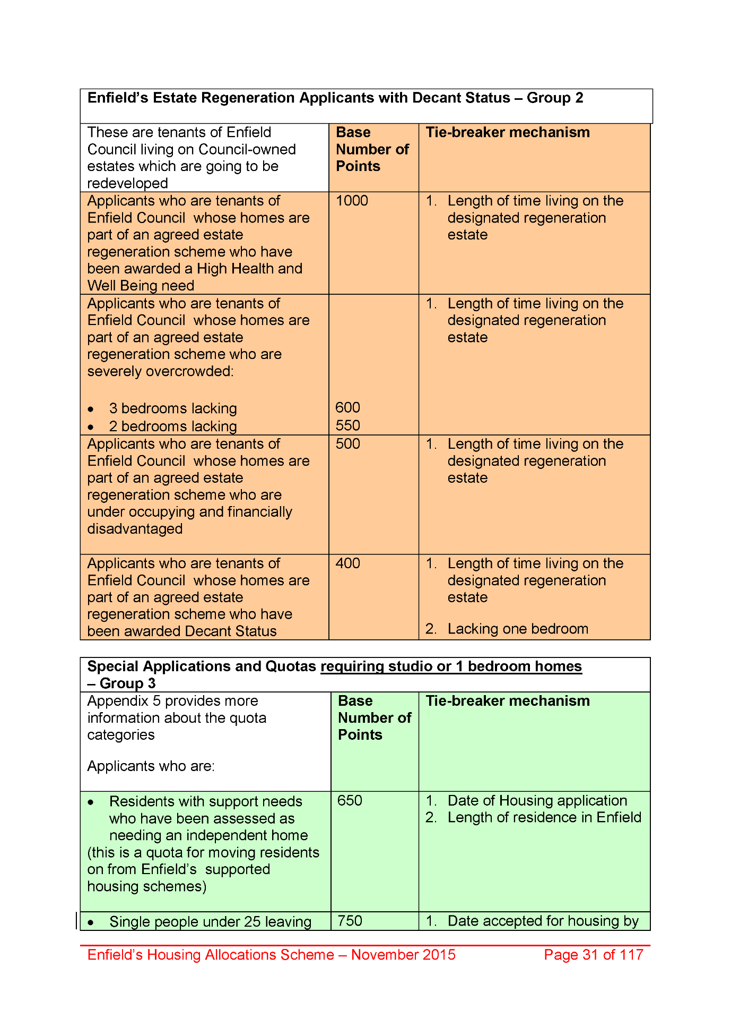
1990,
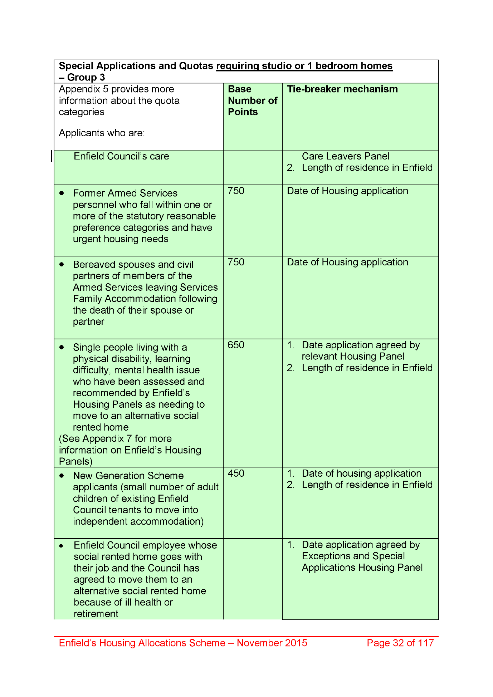
1991,
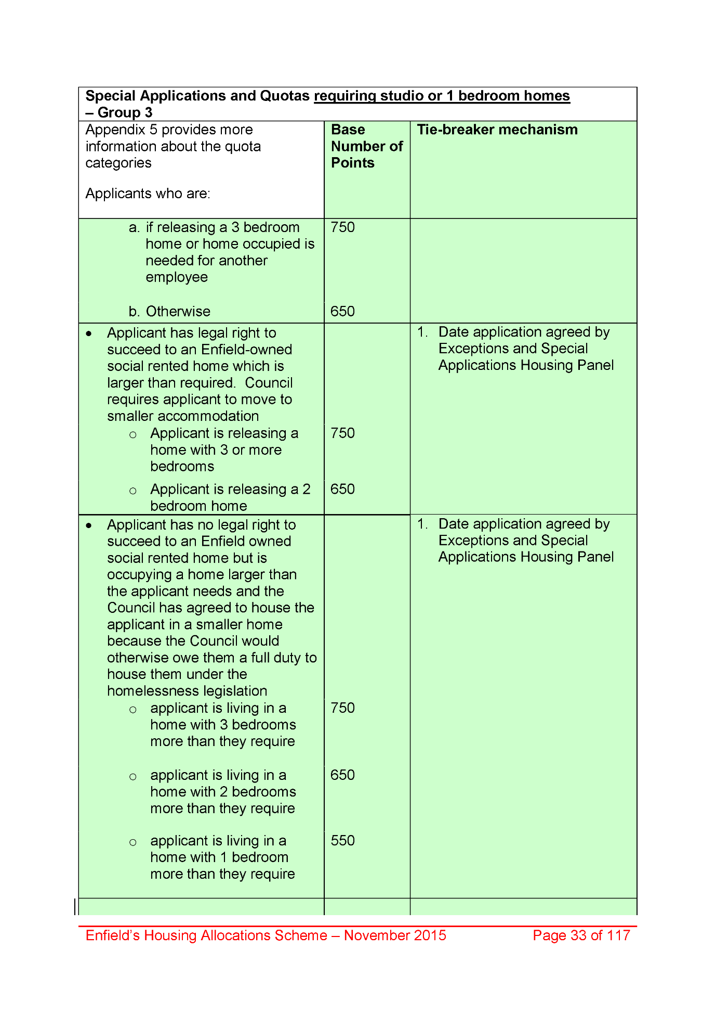
1992,
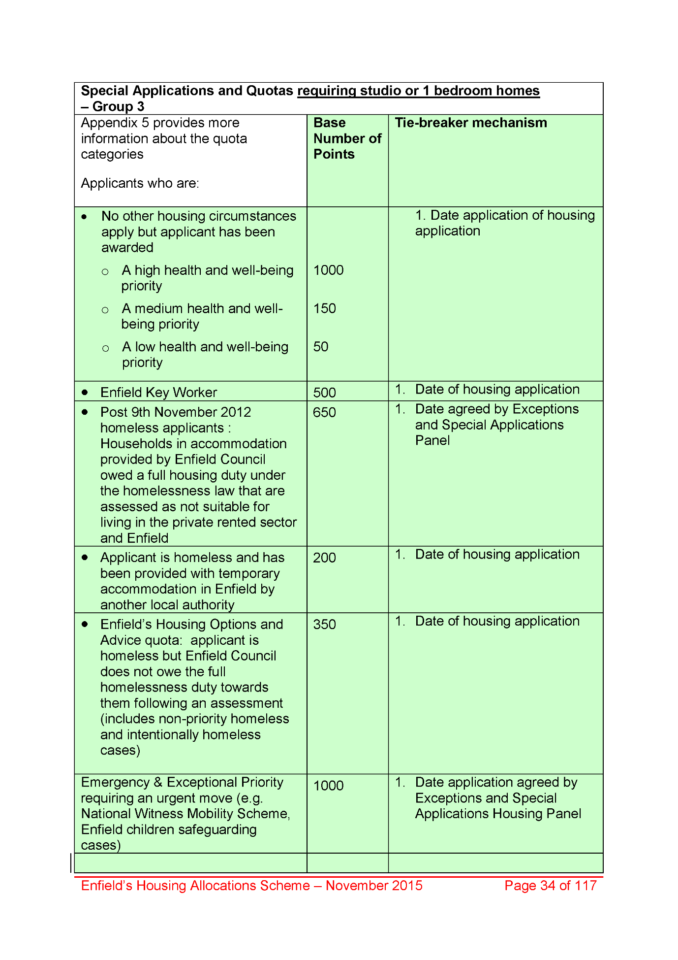
1993,
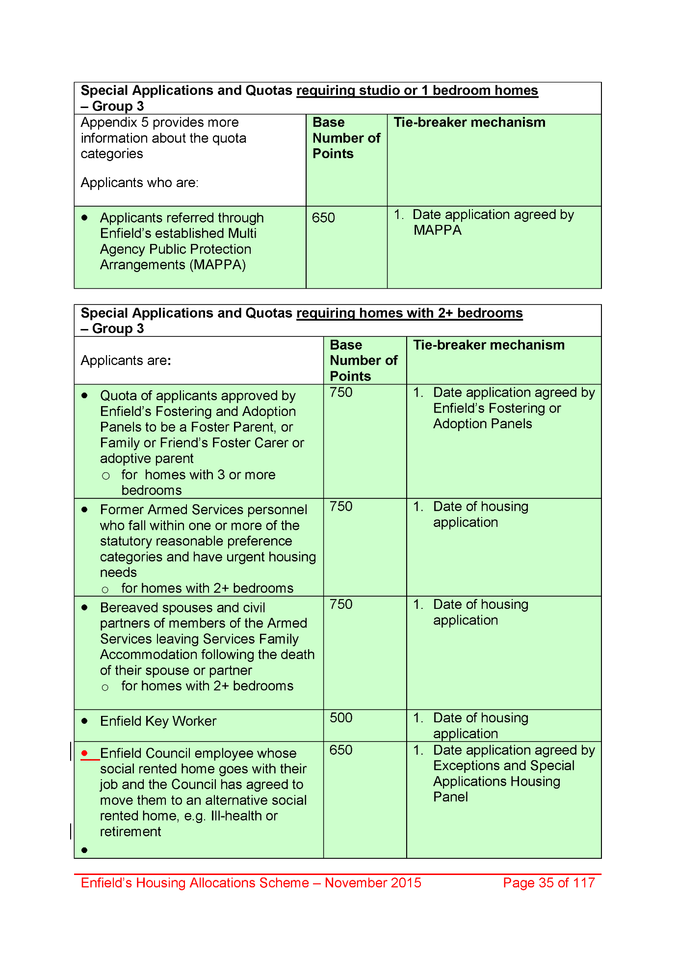
1994,
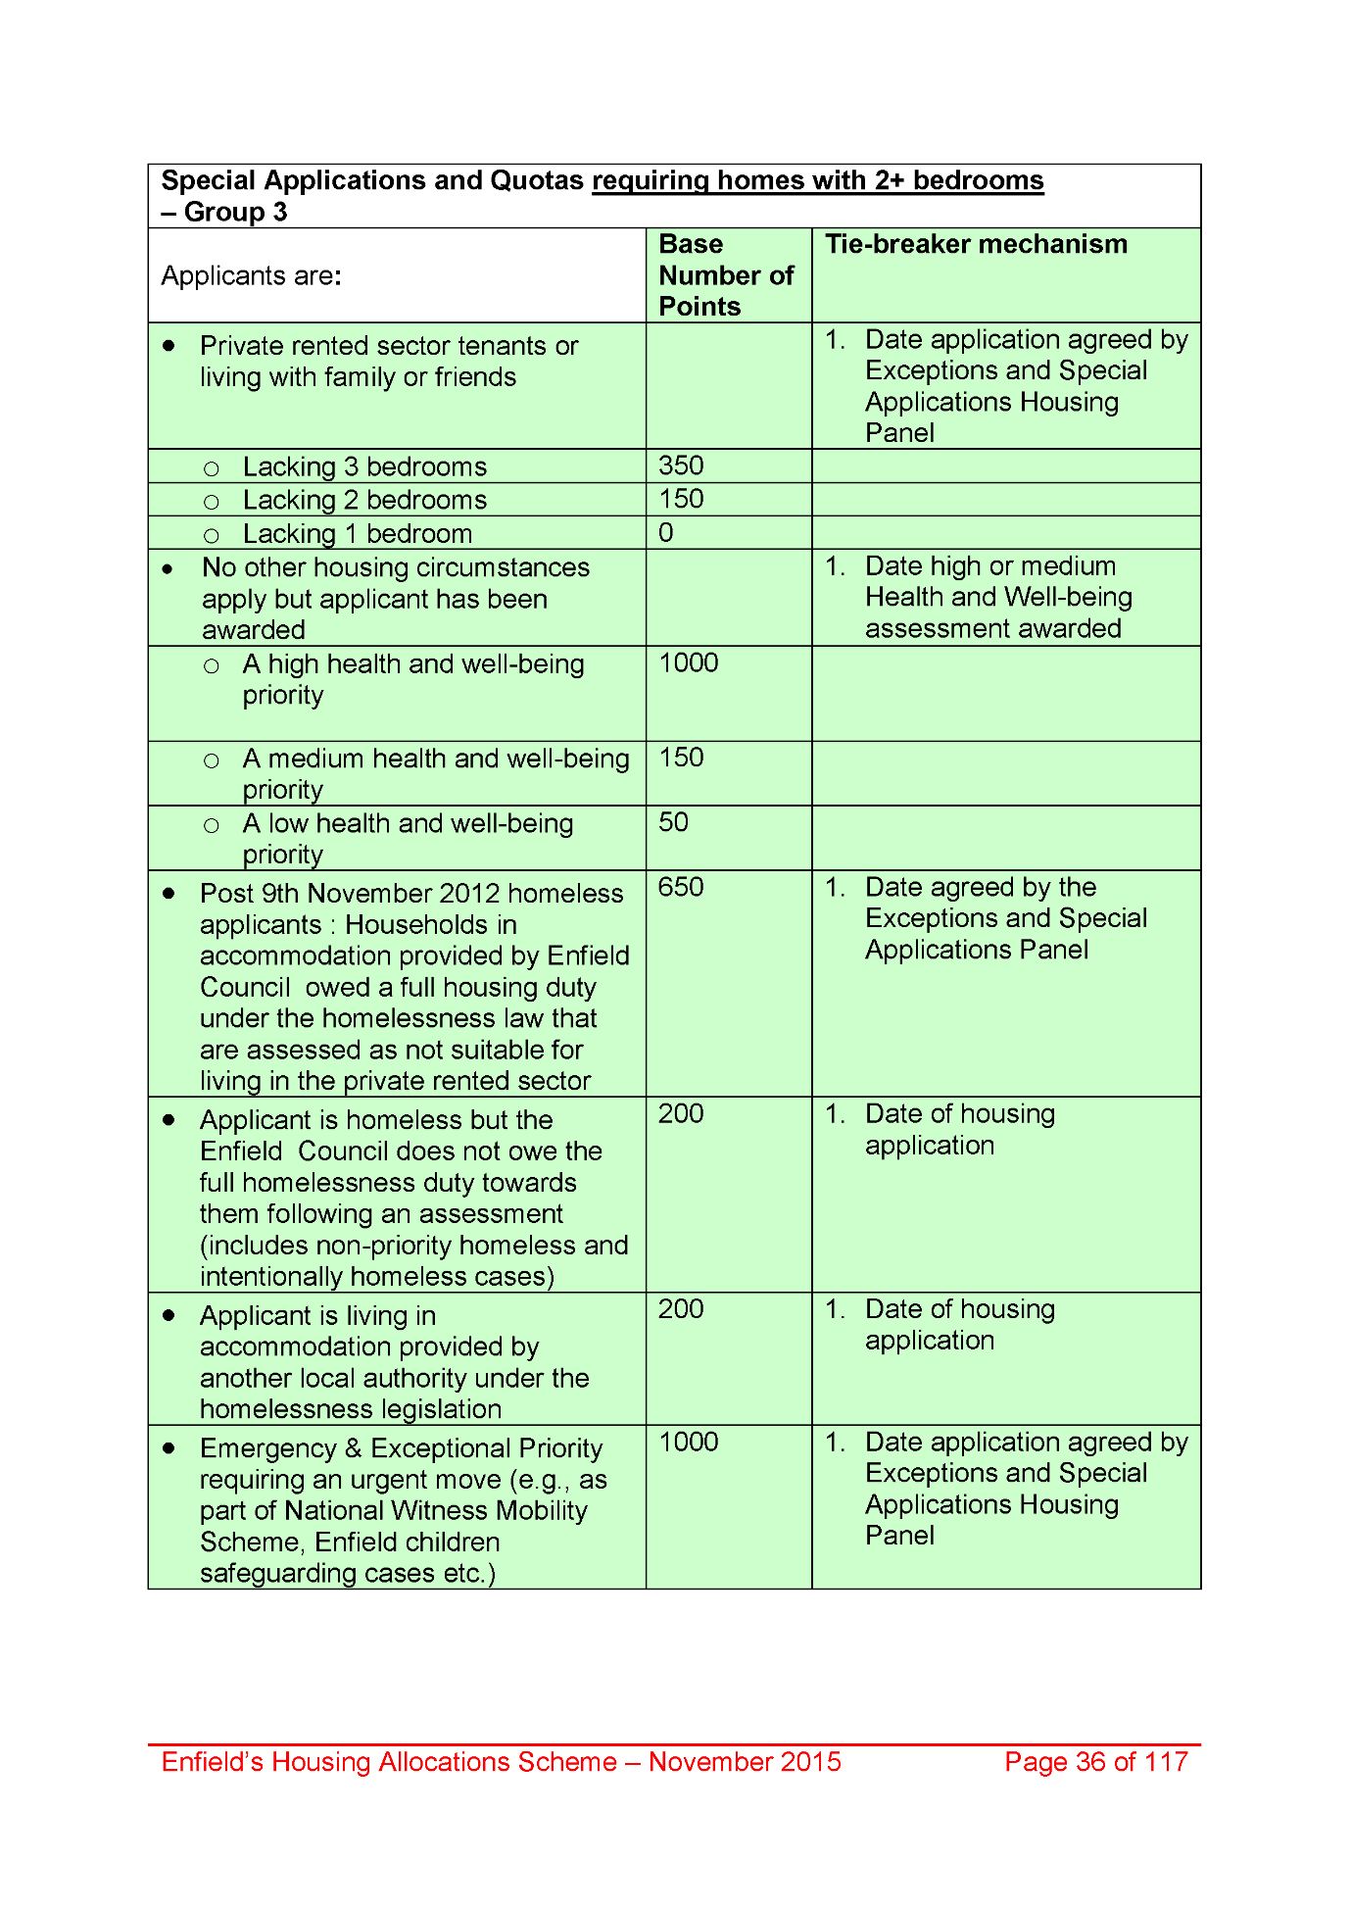
1995,
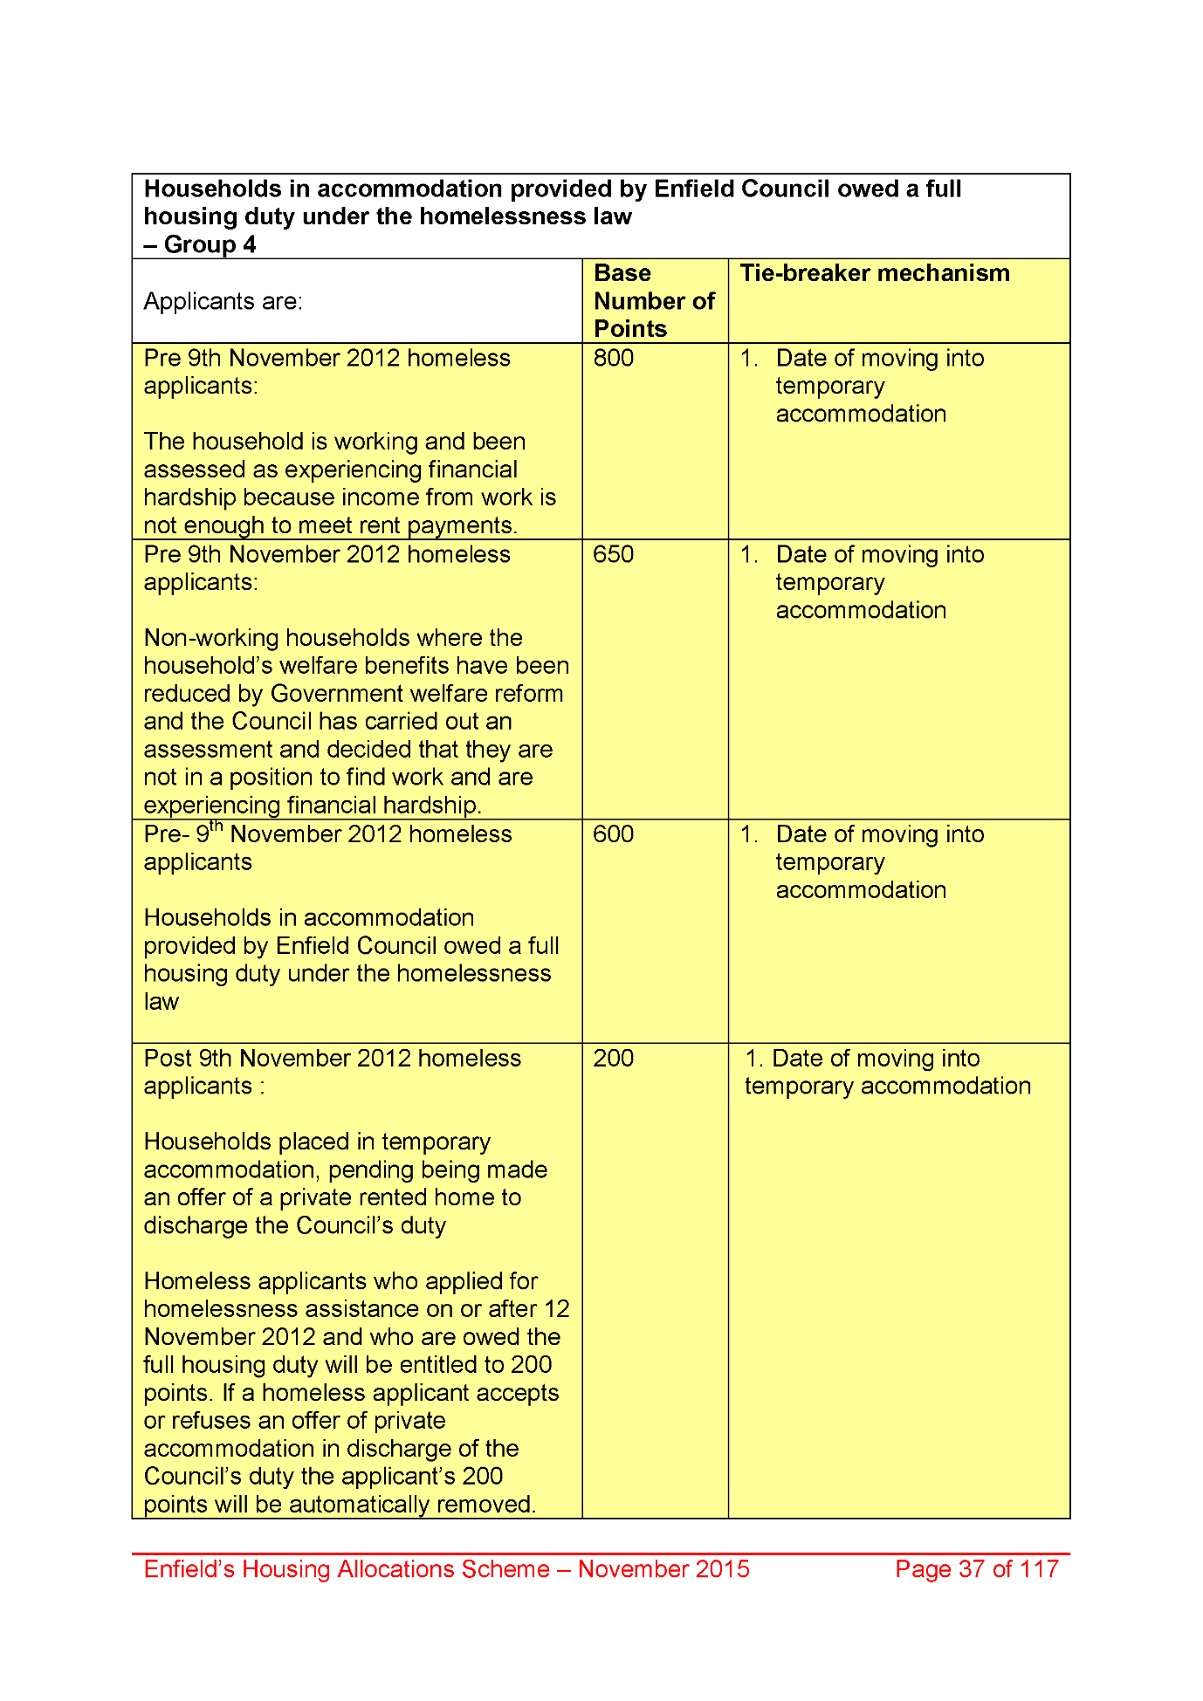
1996,
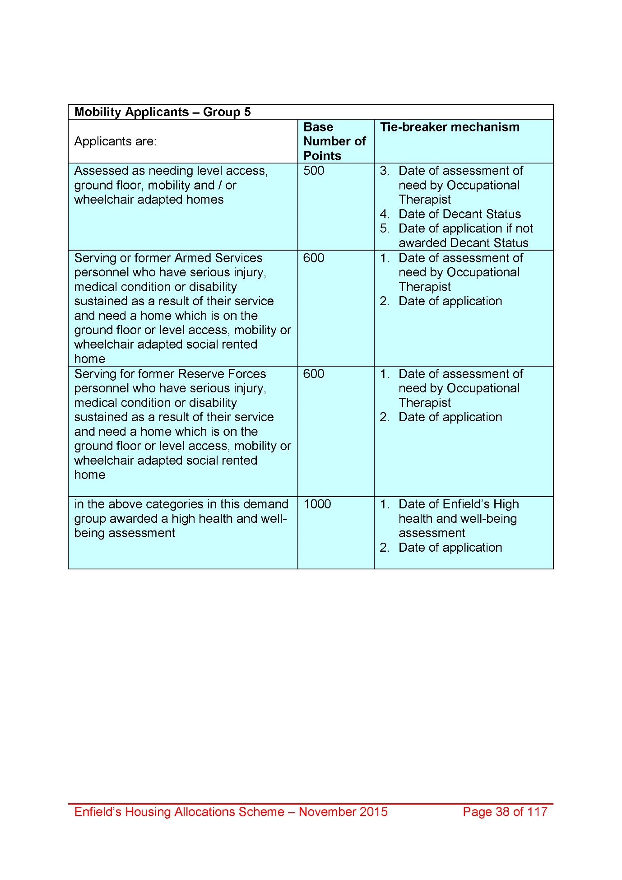
1997,
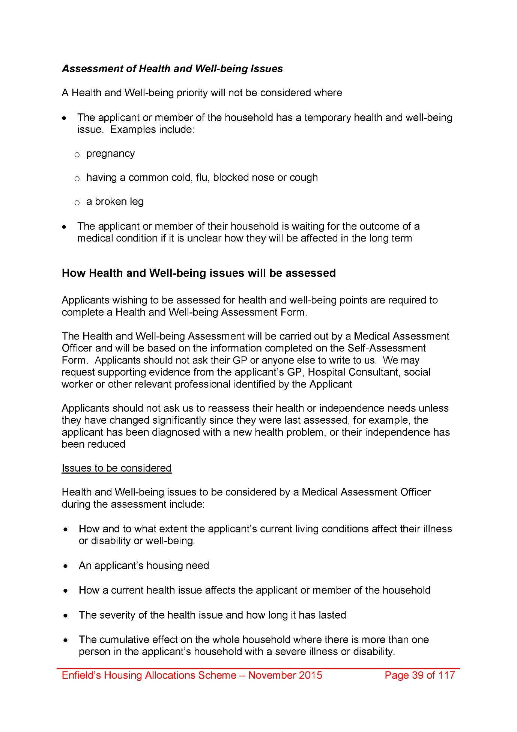
1998,
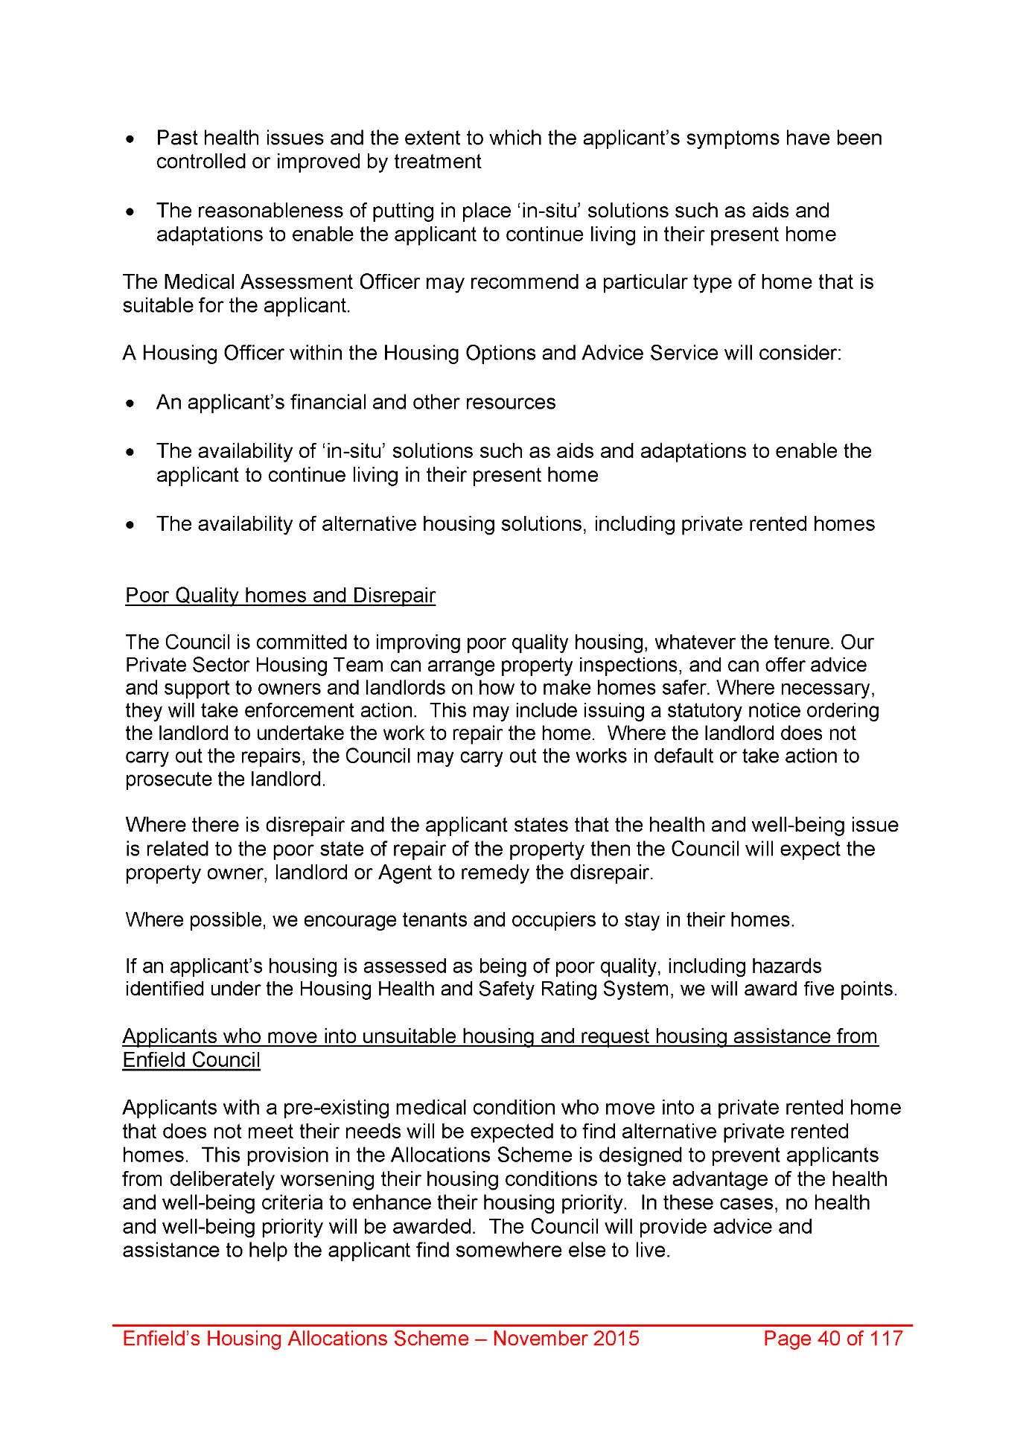
1999,
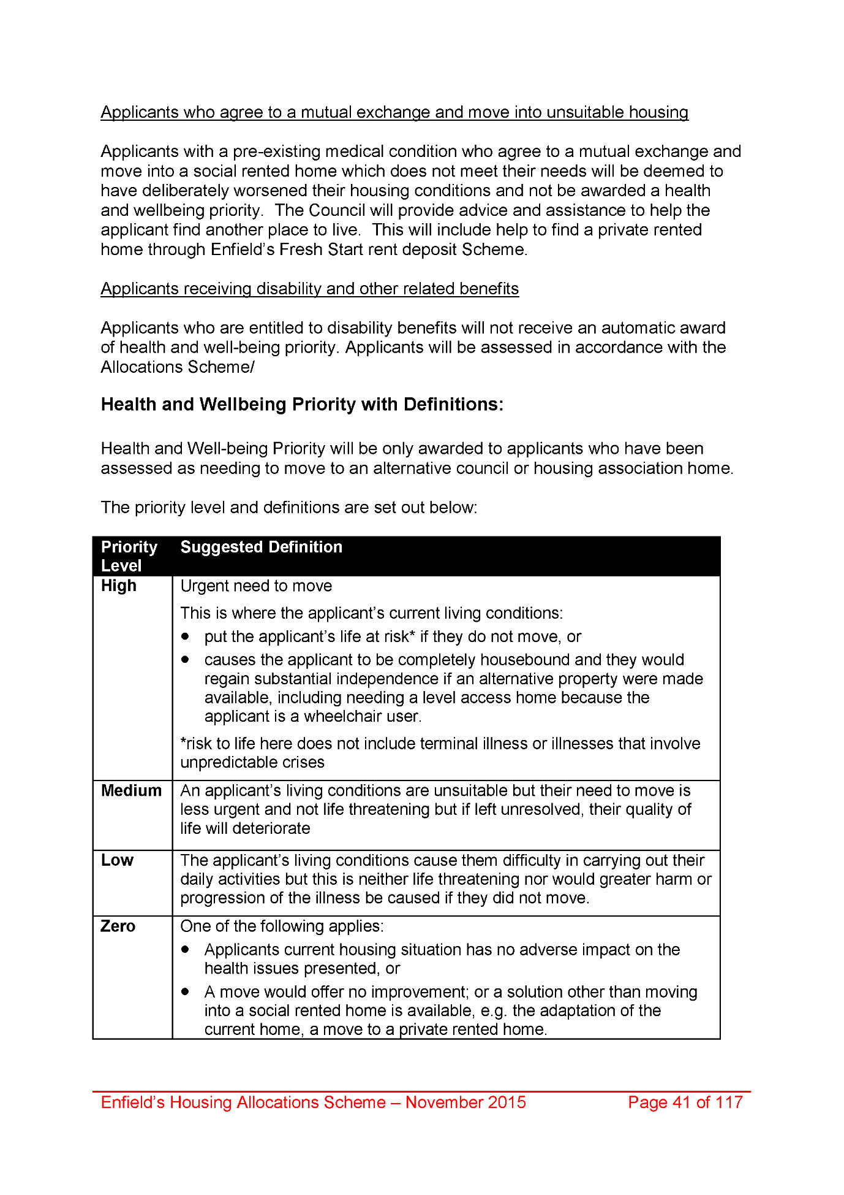
2000,
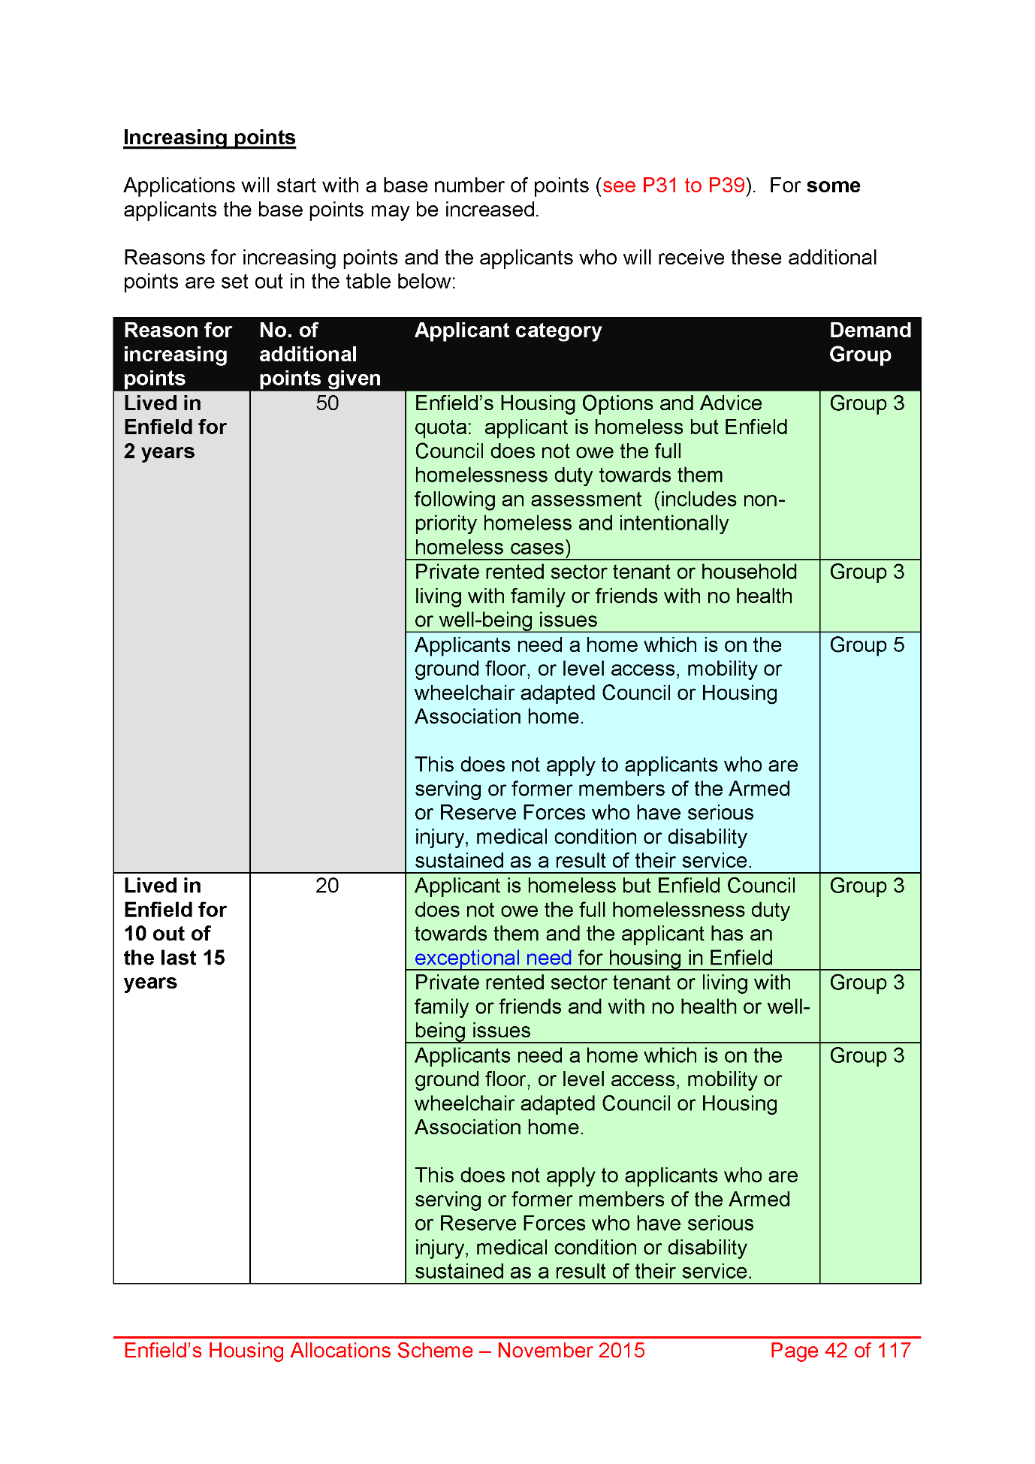
2001,
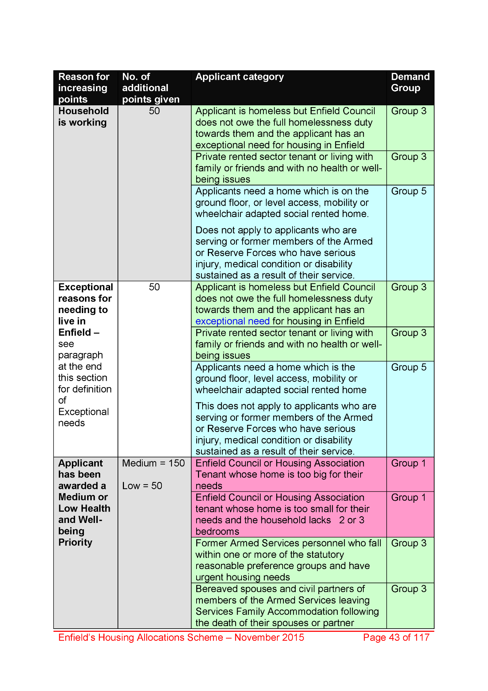
2002,
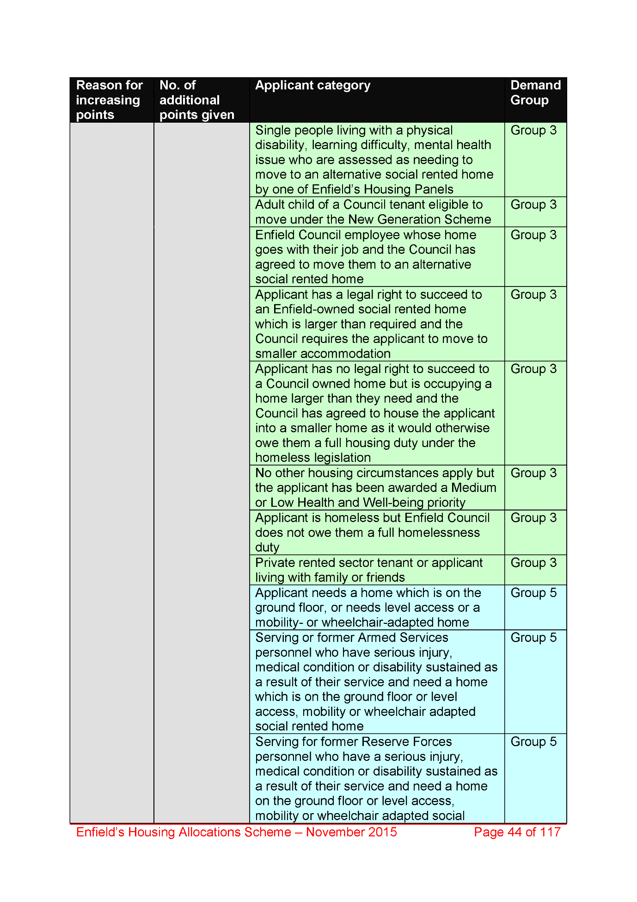
2003,
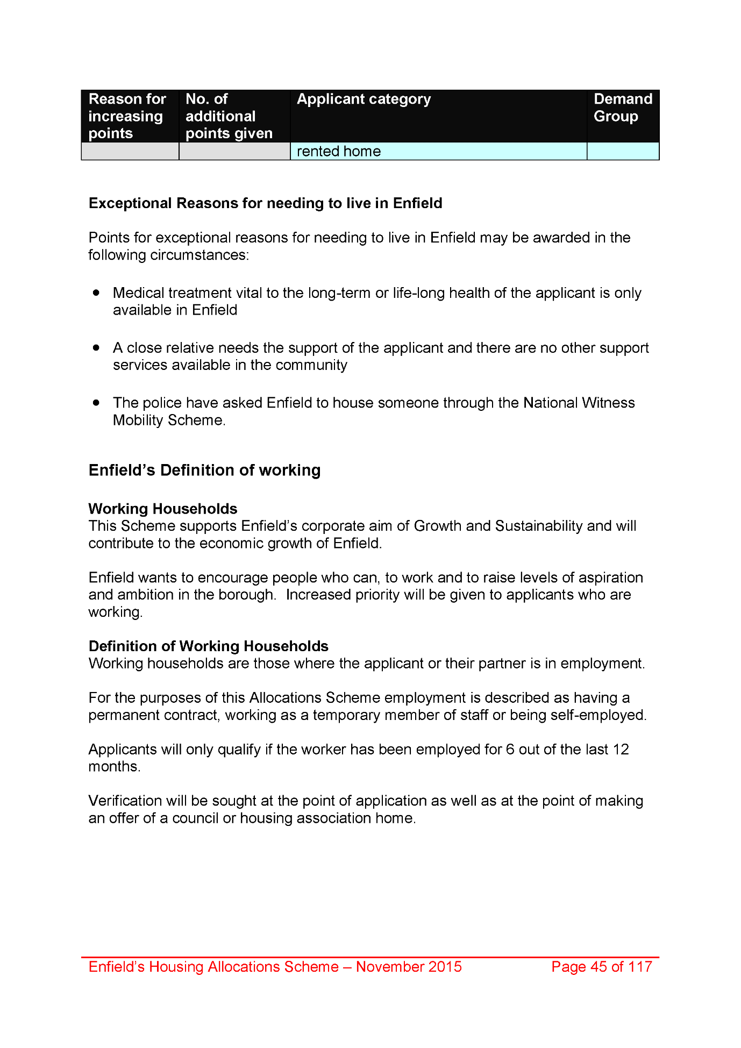
2004,
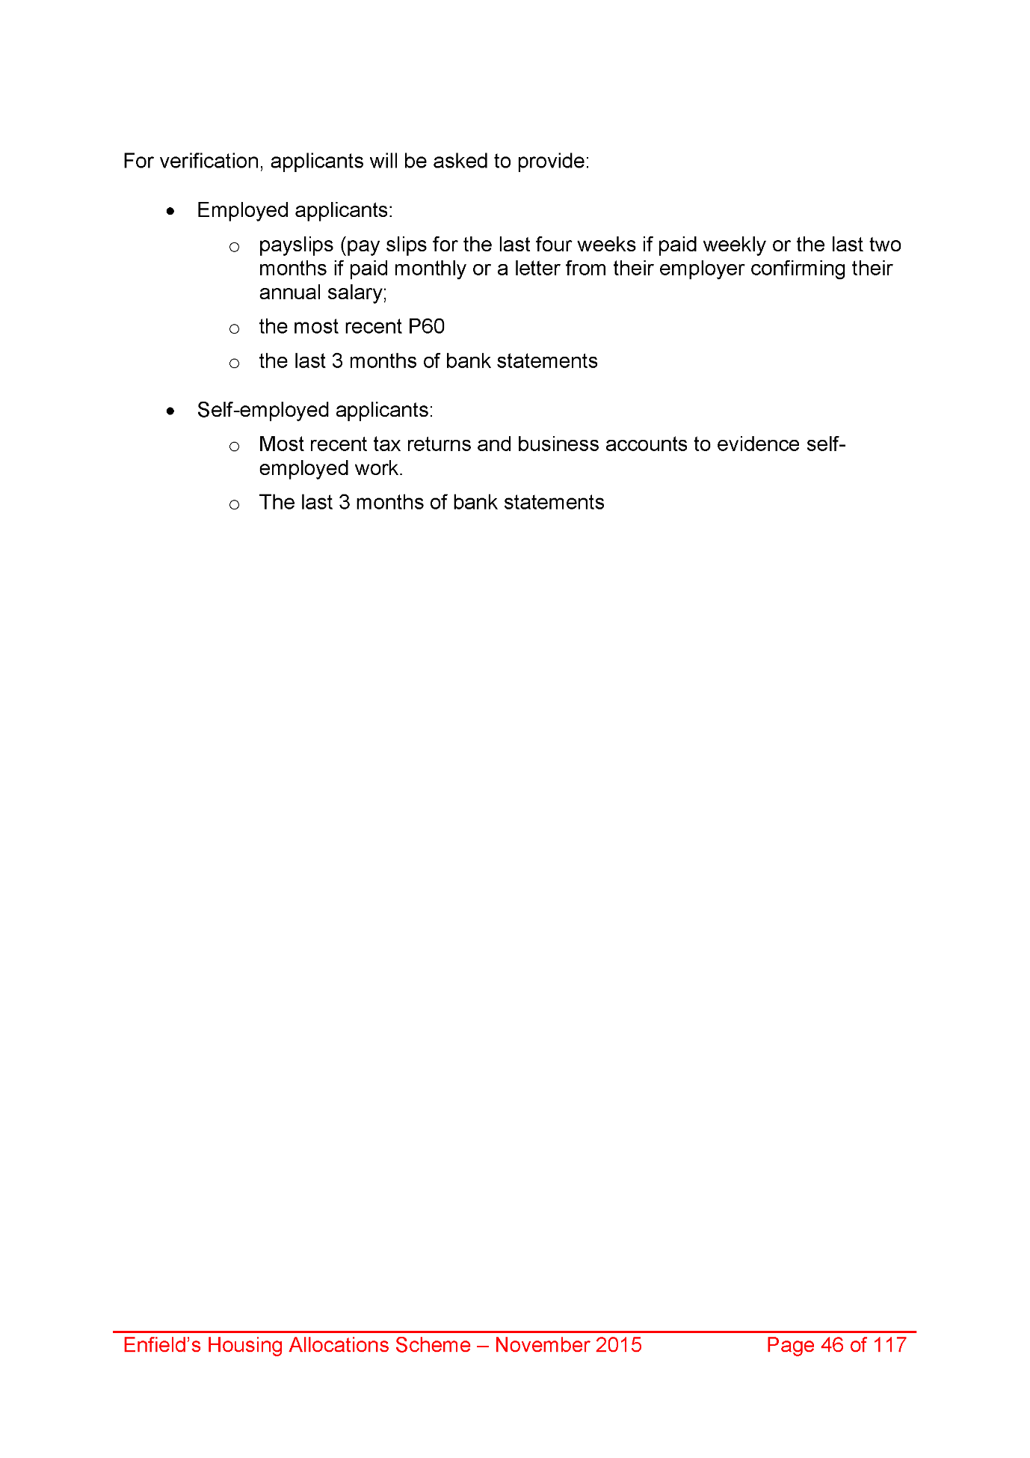
2005,
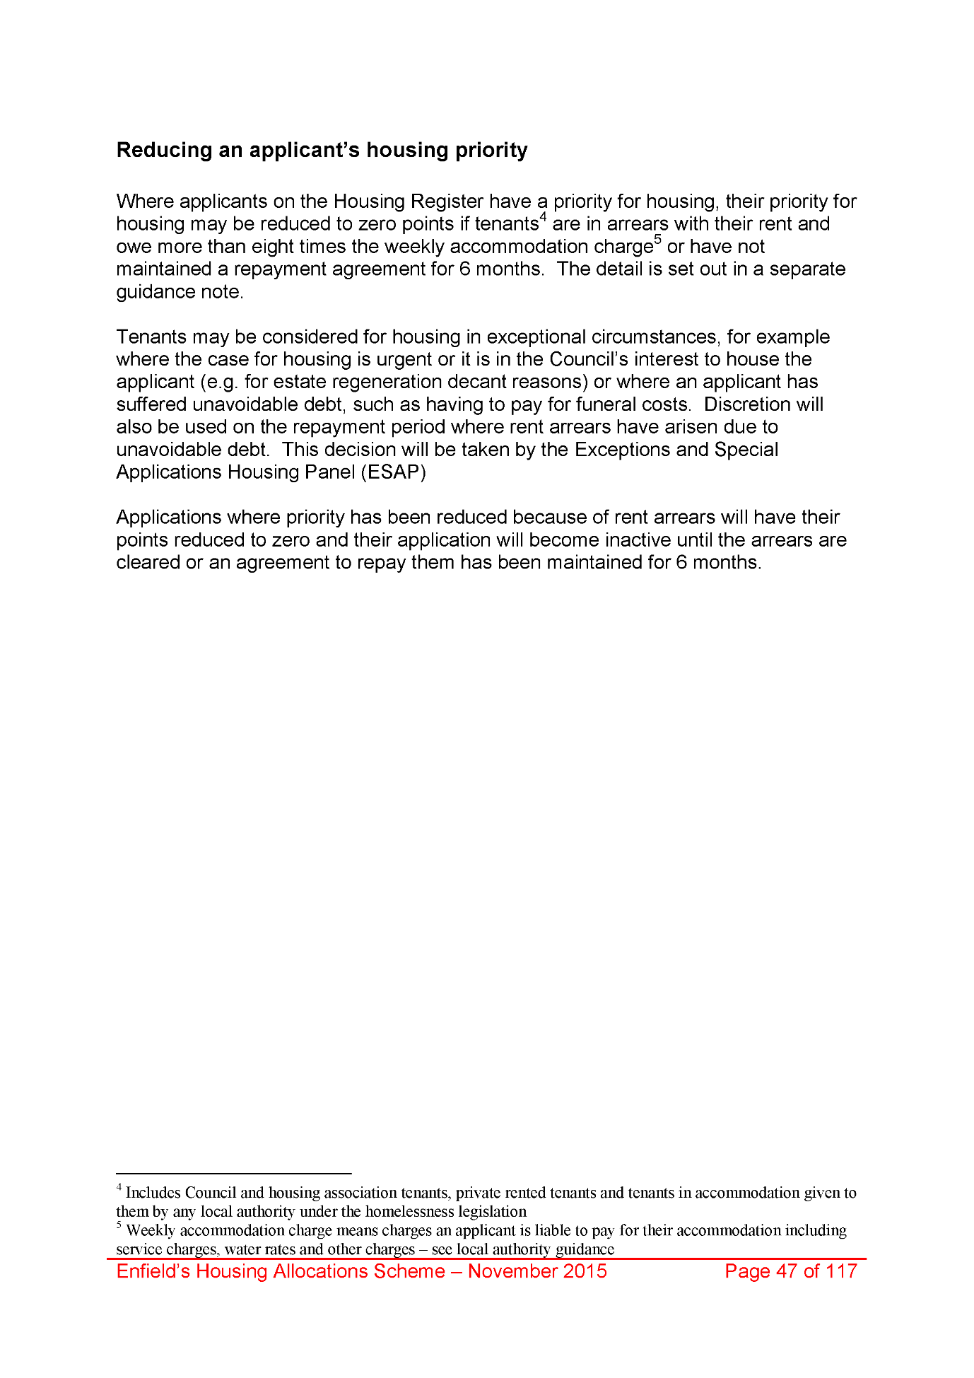
2006,
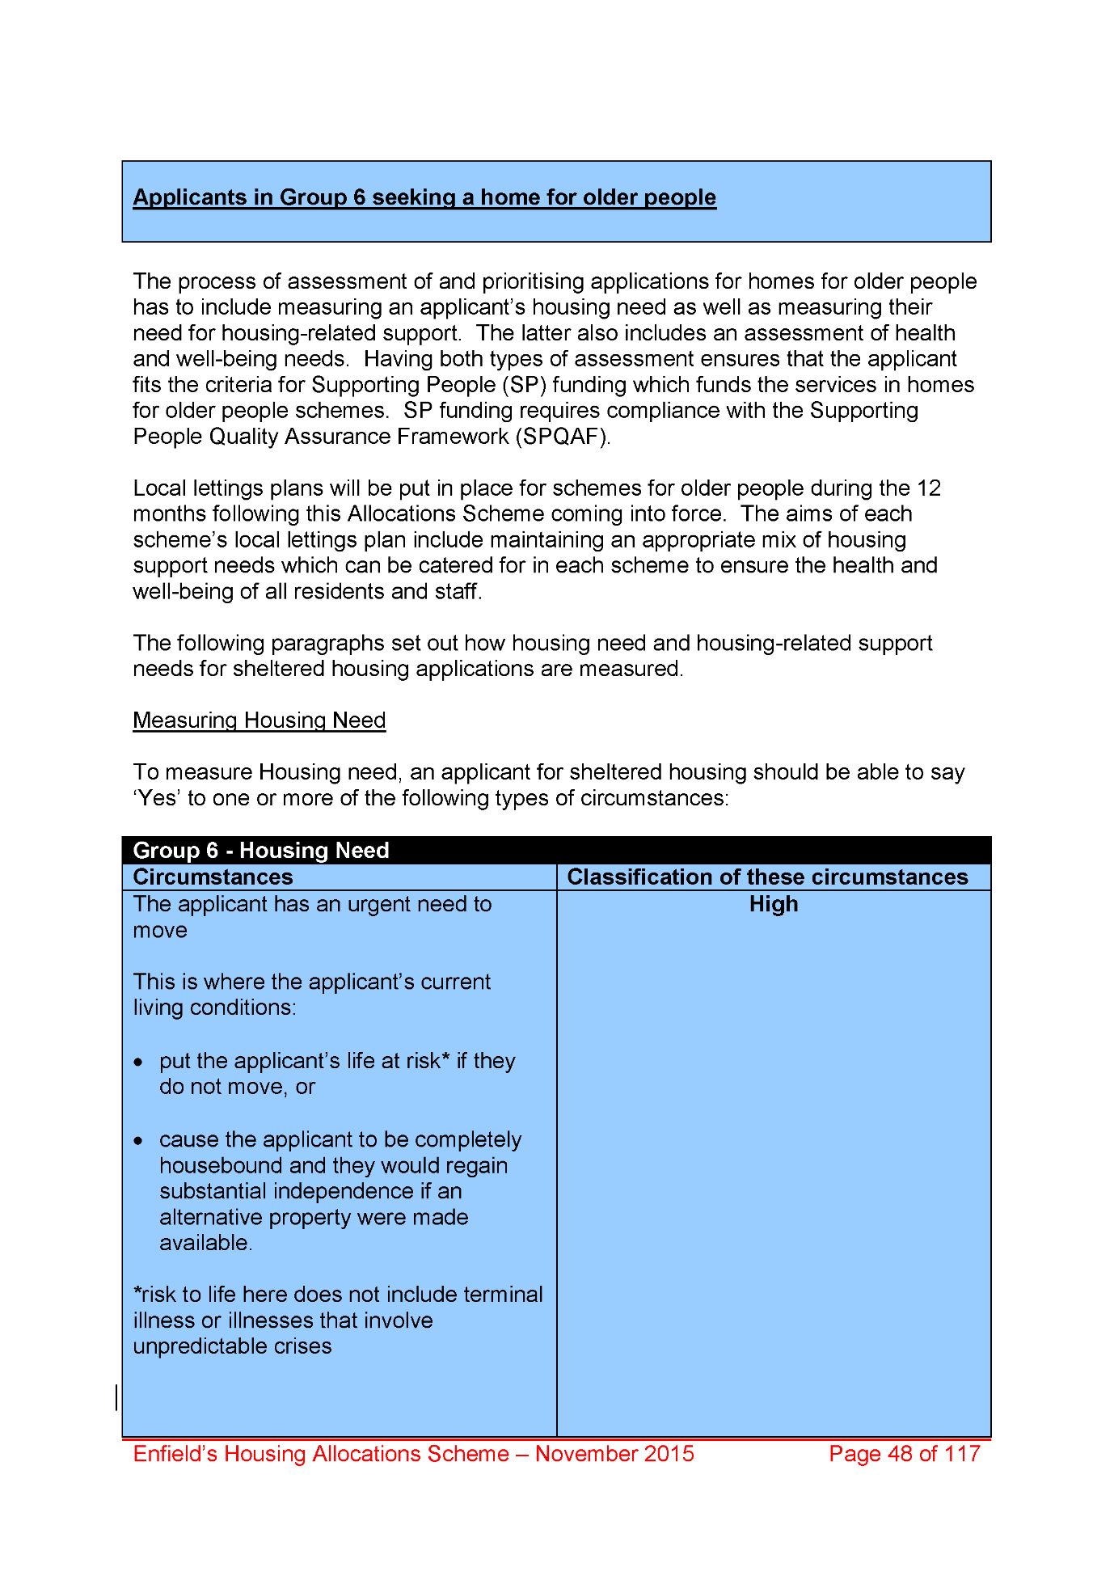
2007,
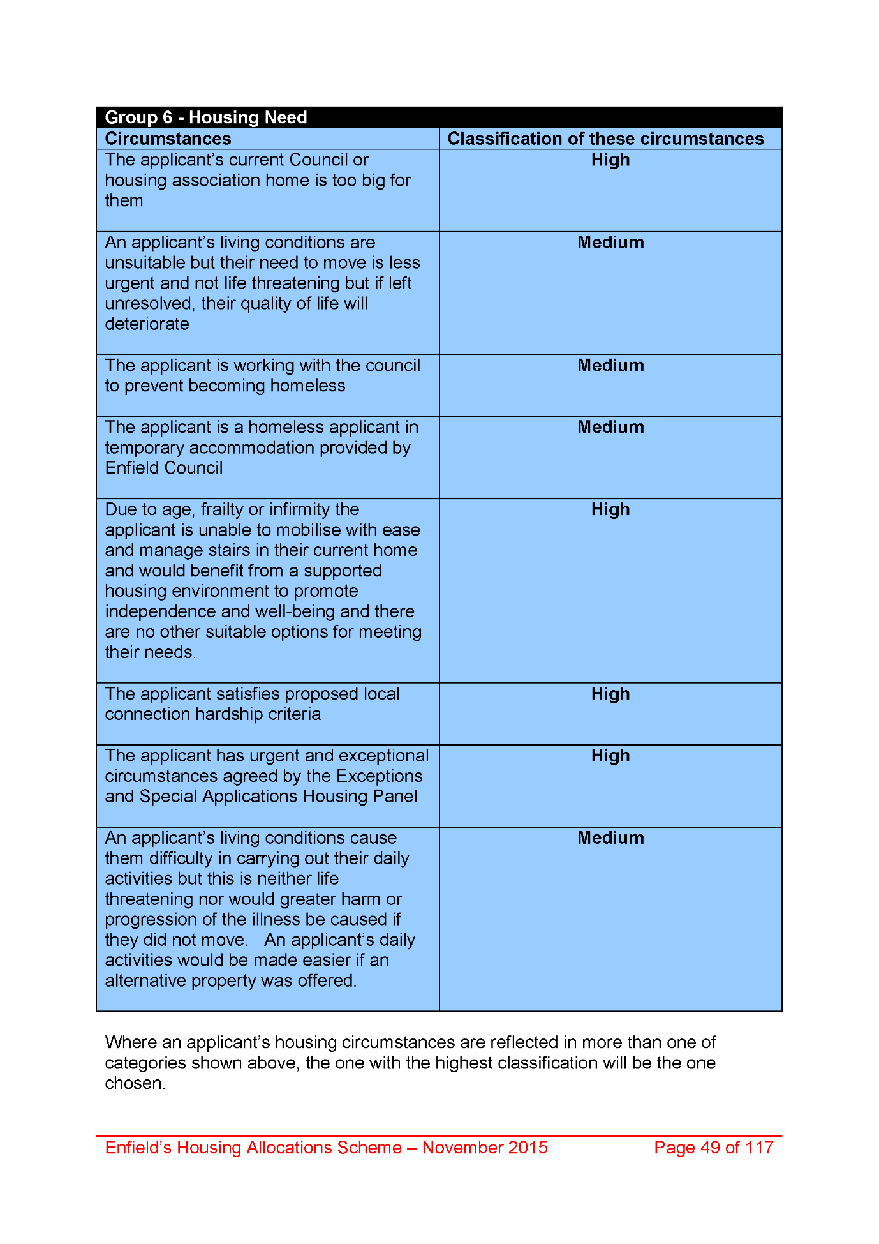
2008,
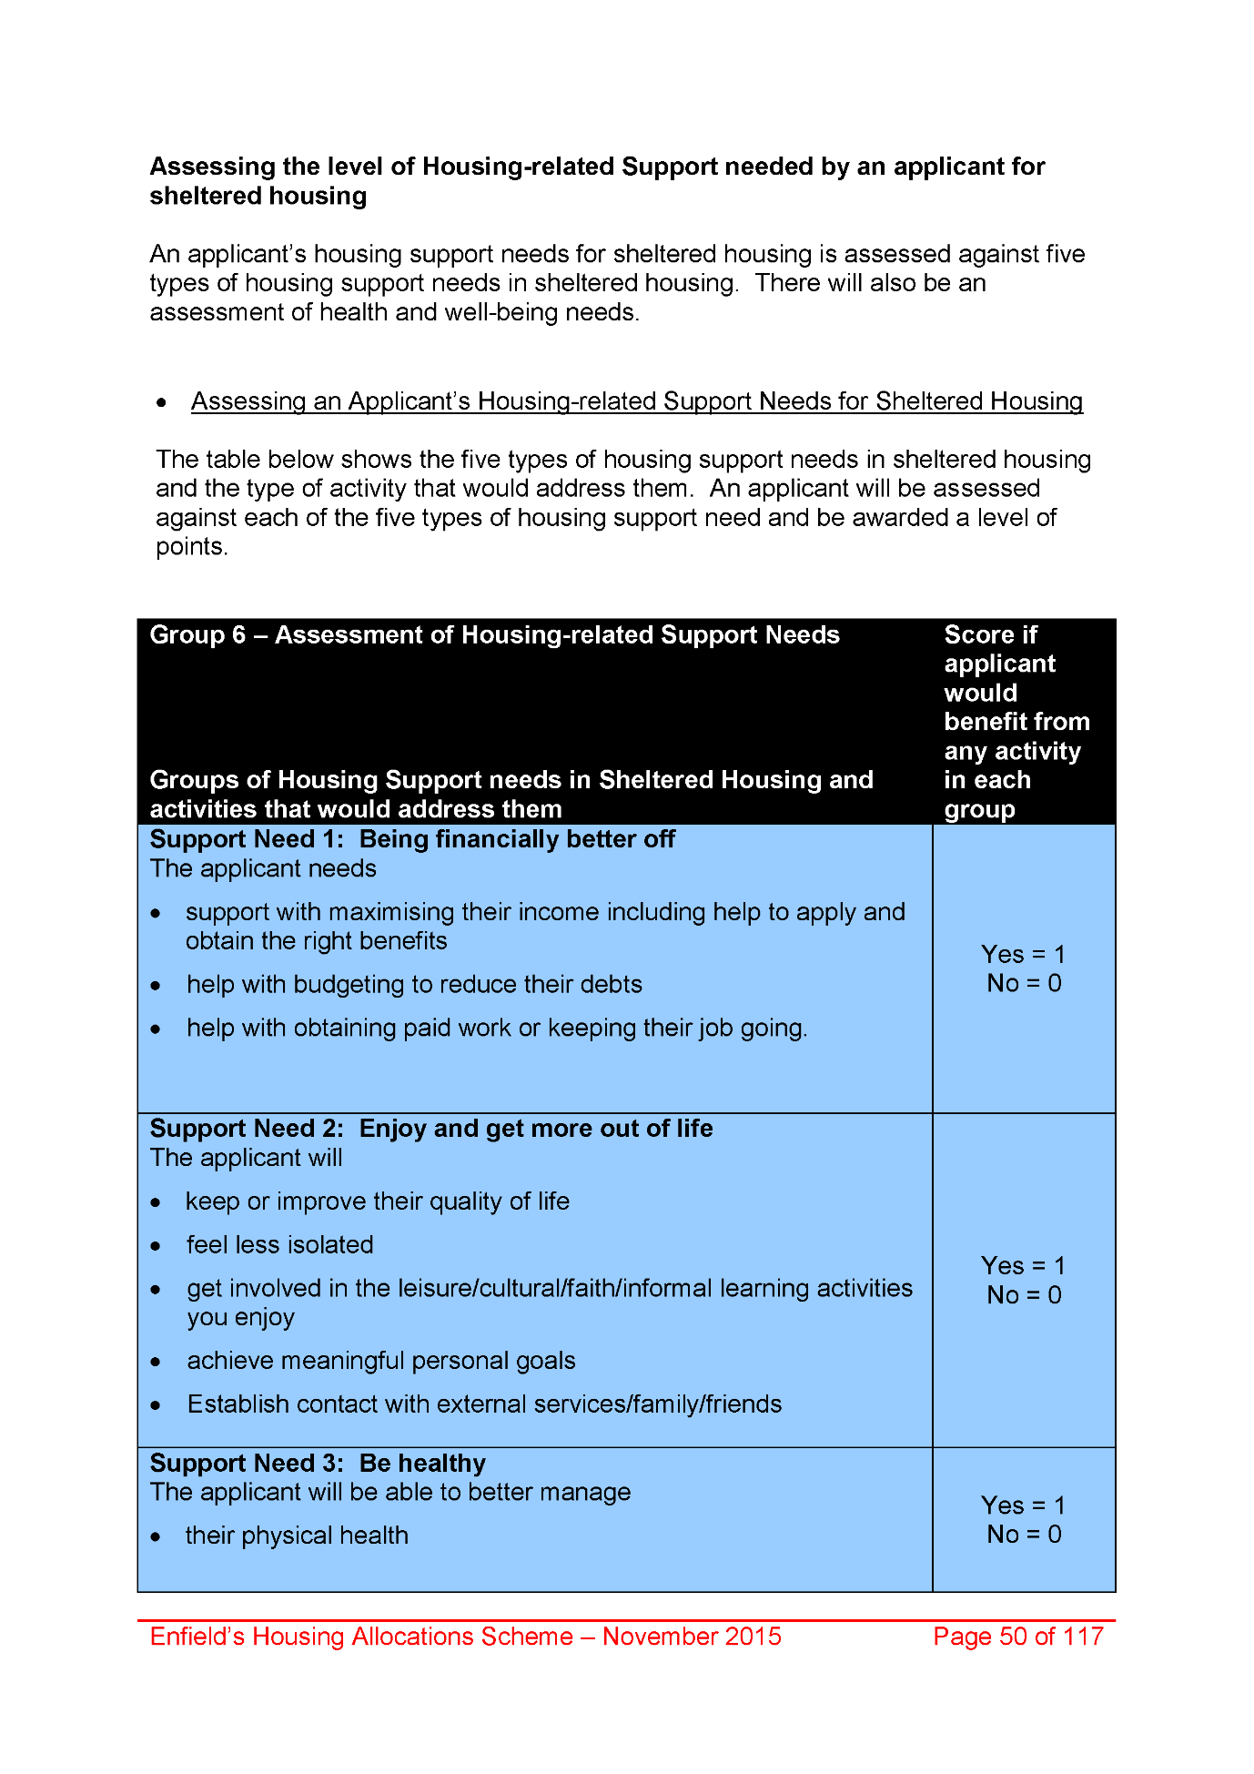
2009,
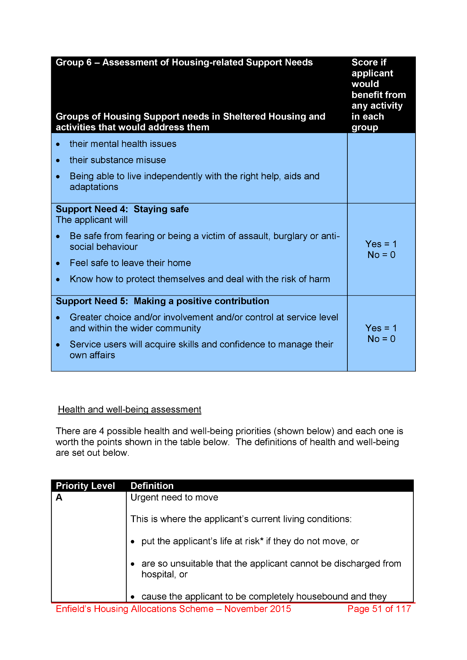
2010,
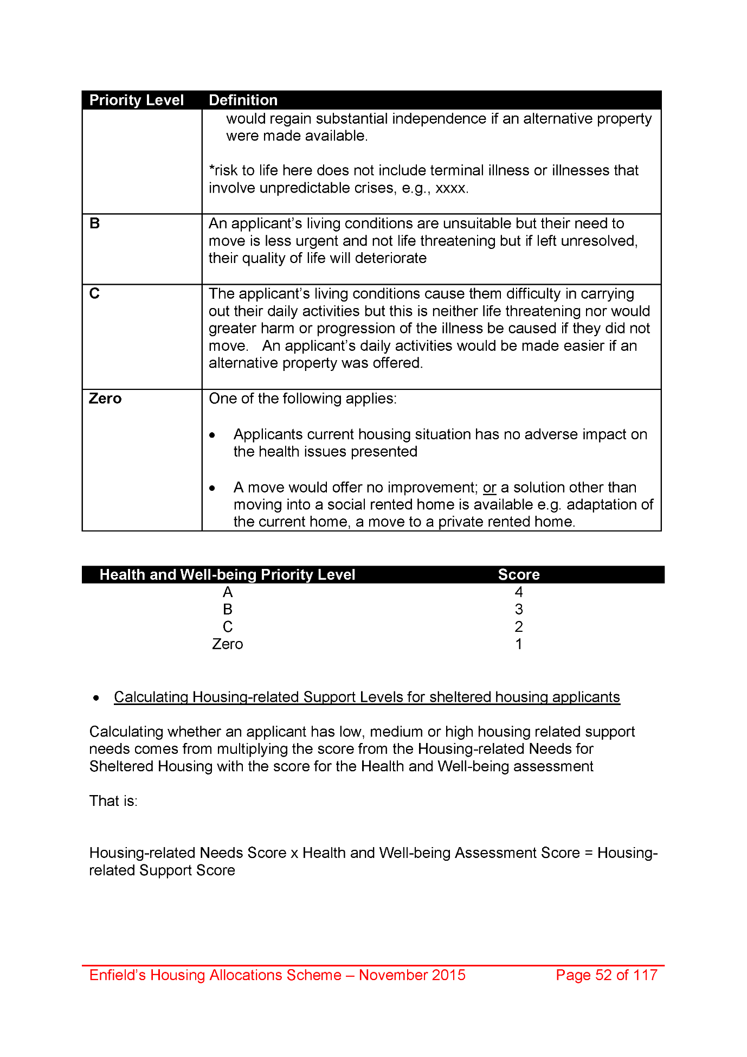
2011,
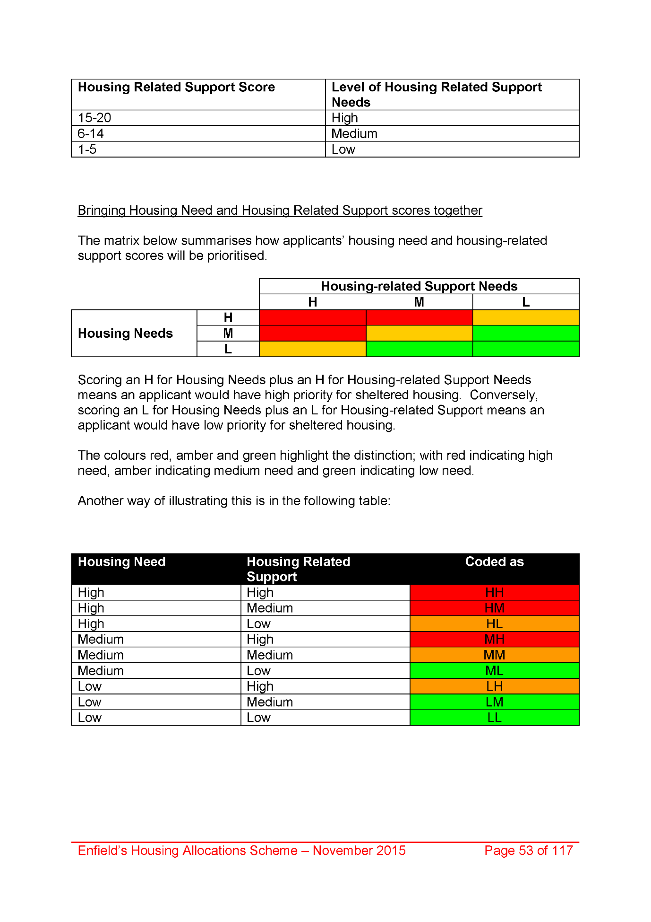
2012,
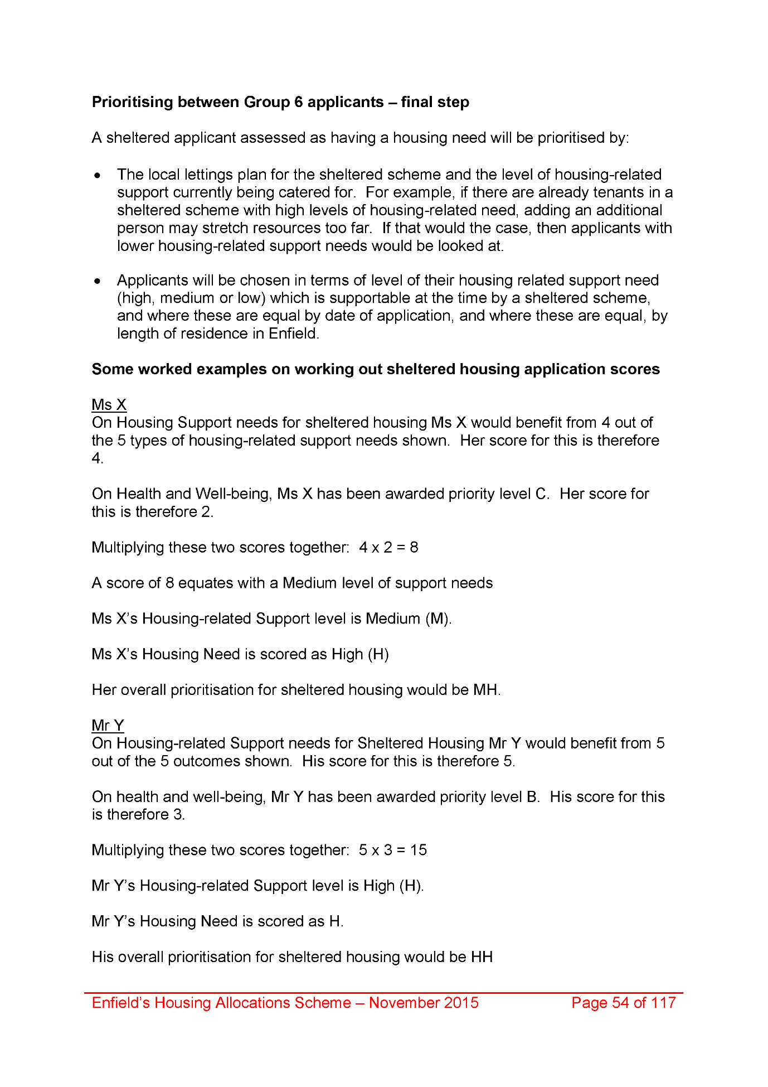
2013,
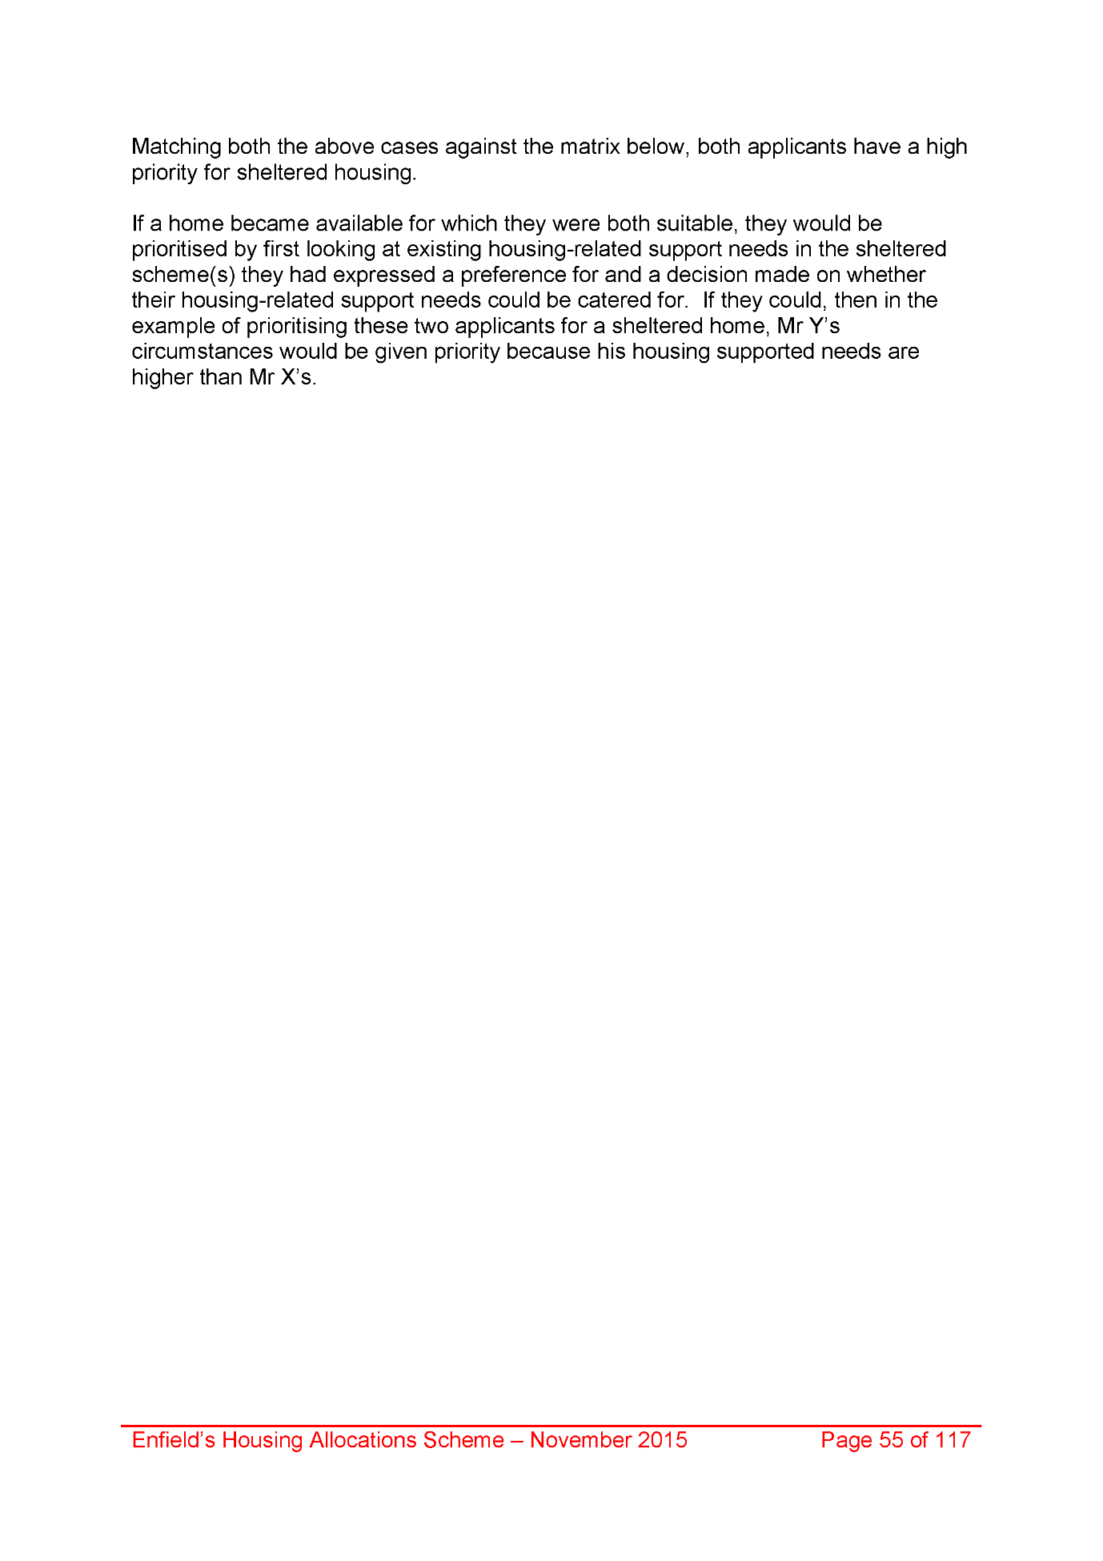
2014,
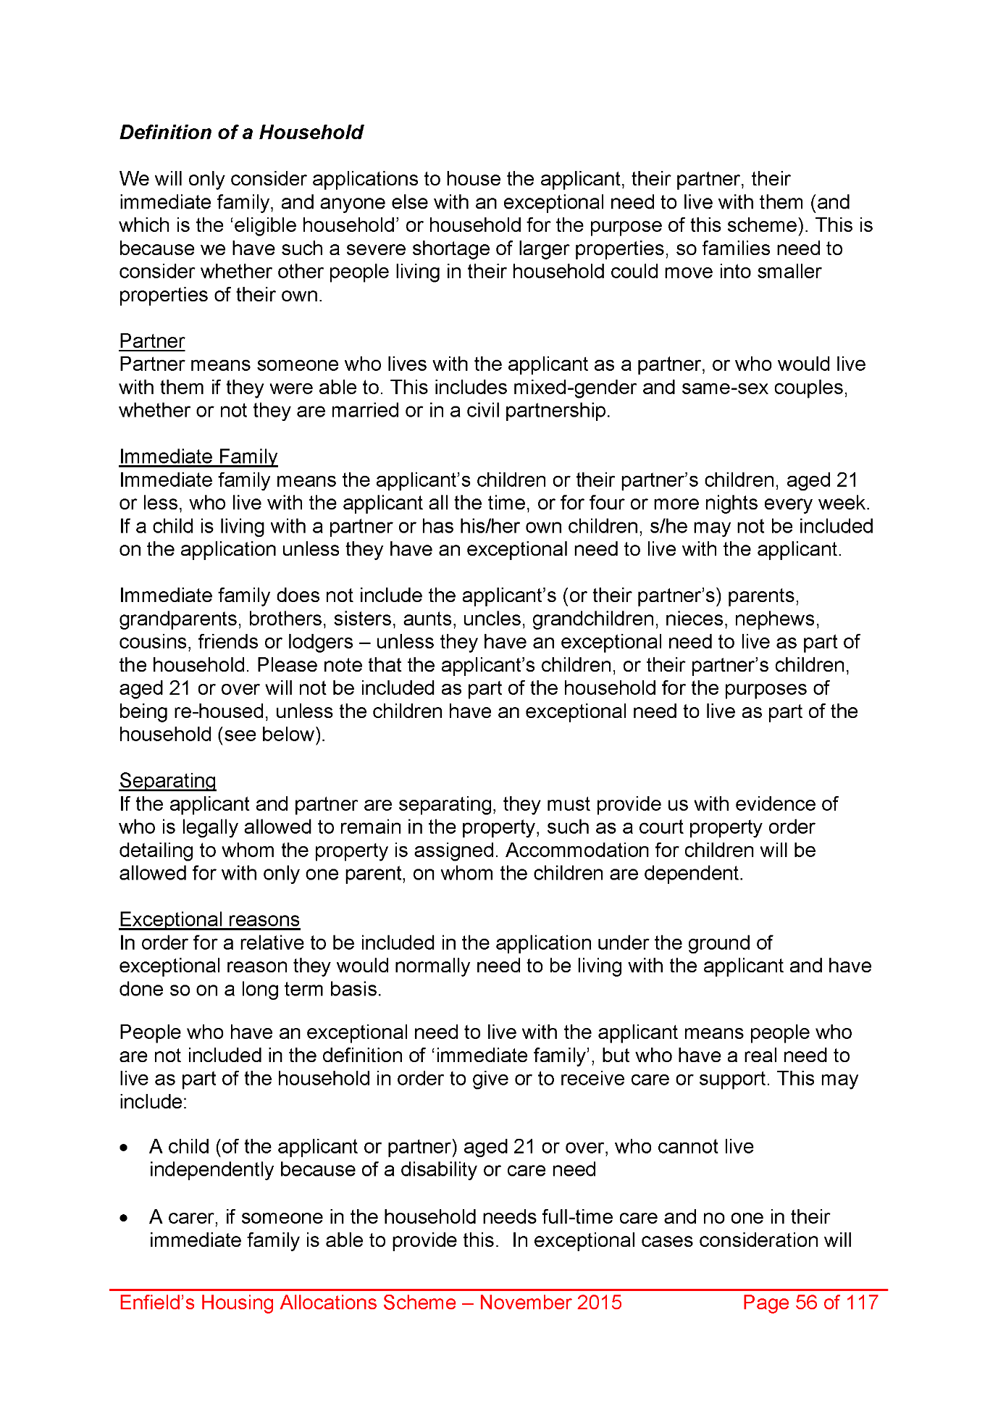
2015,
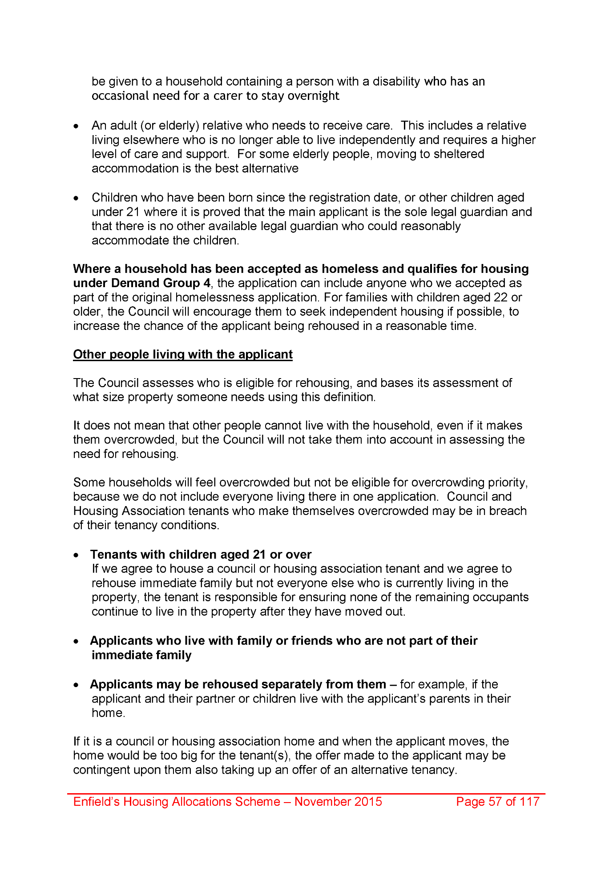
2016,
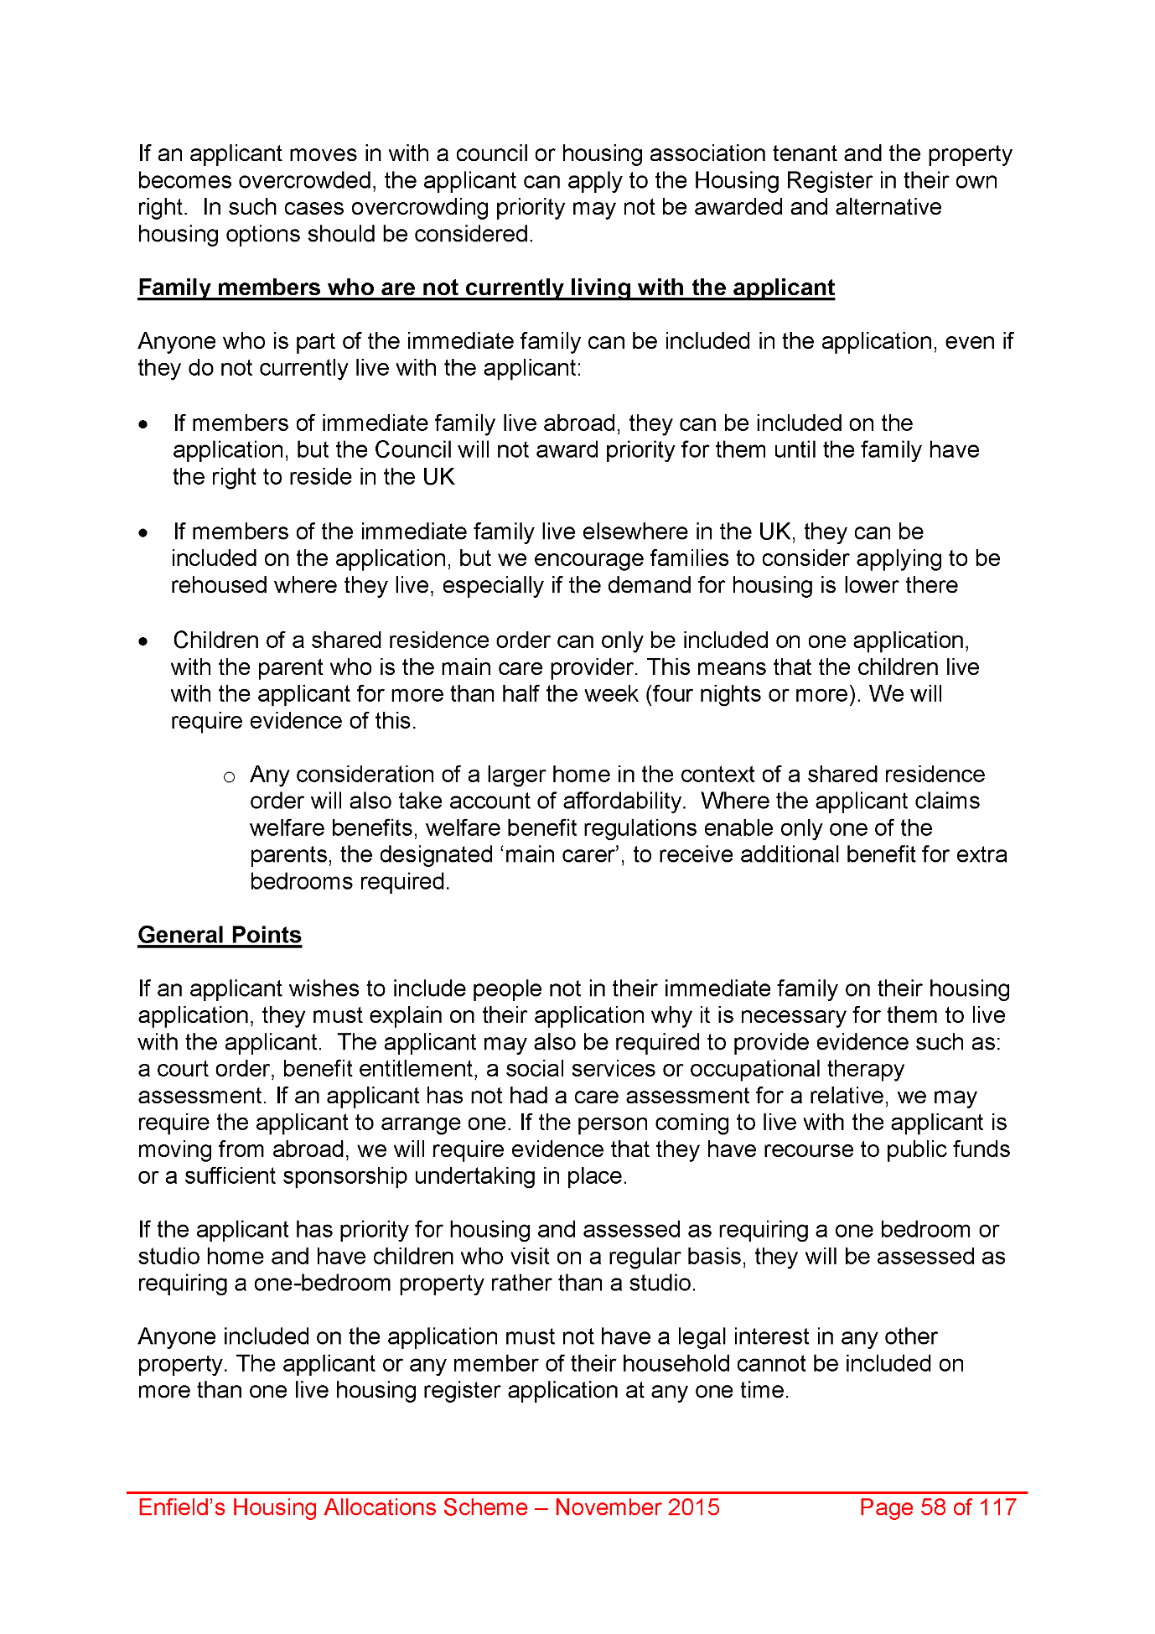
2017,
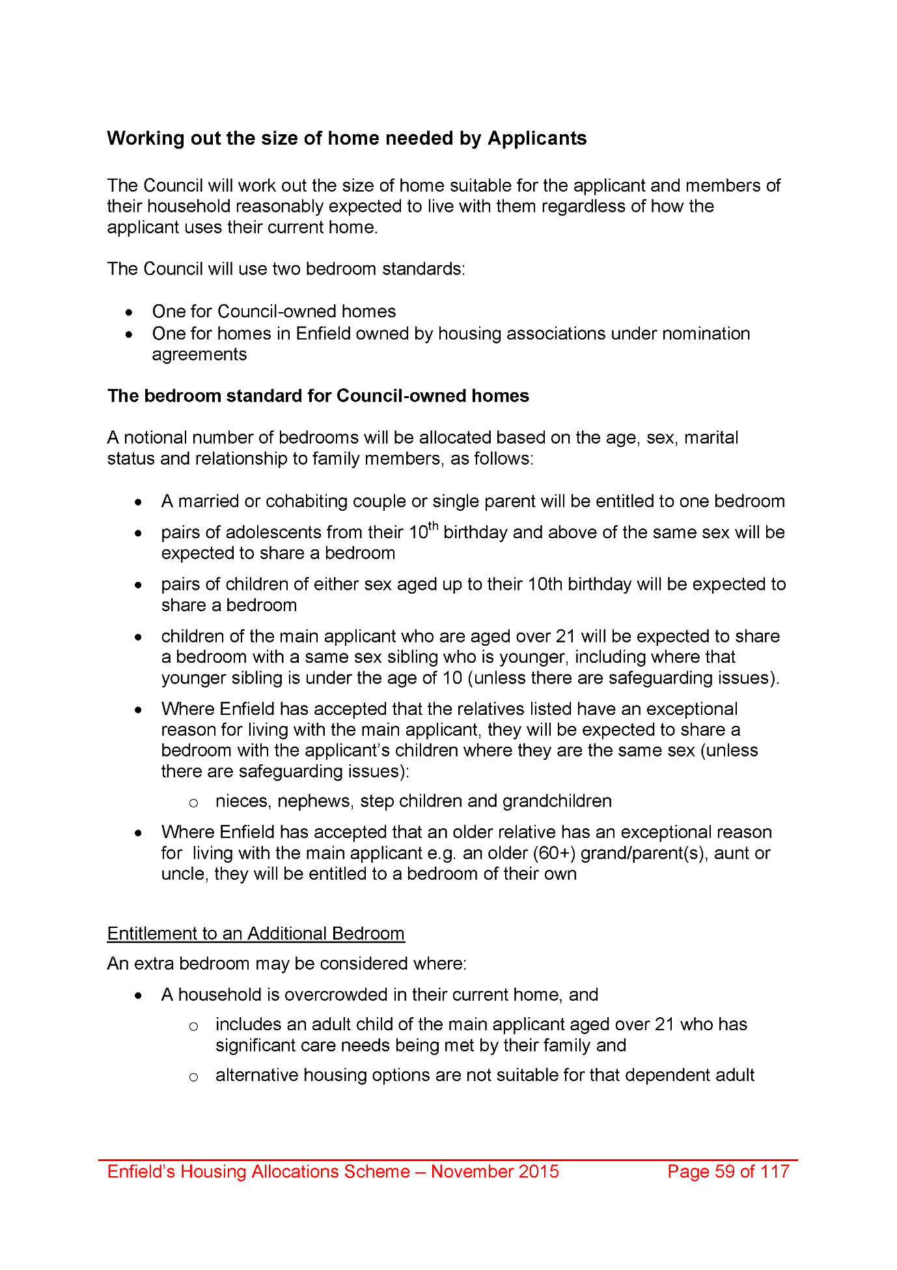
2018,
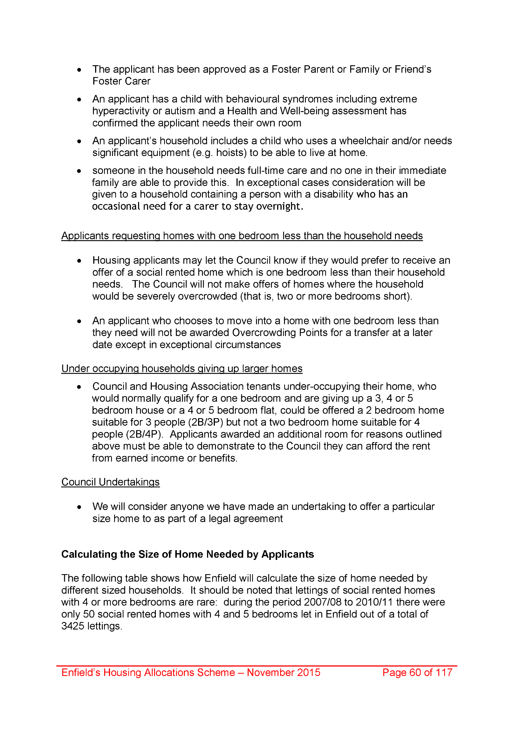
2019,
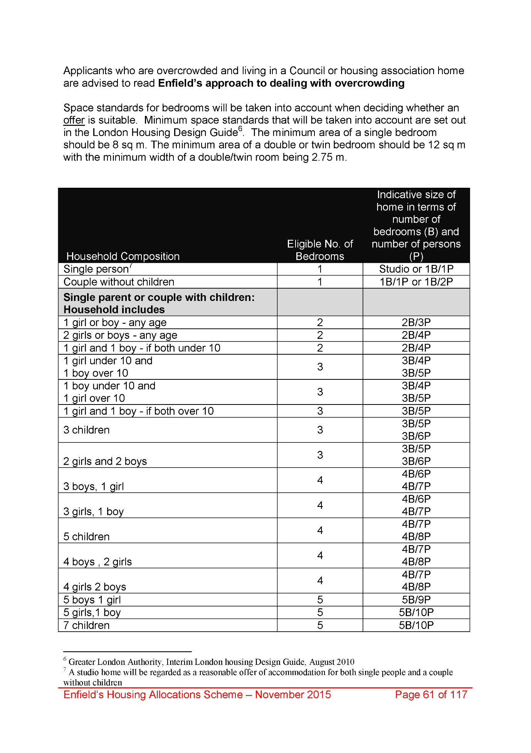
2020,
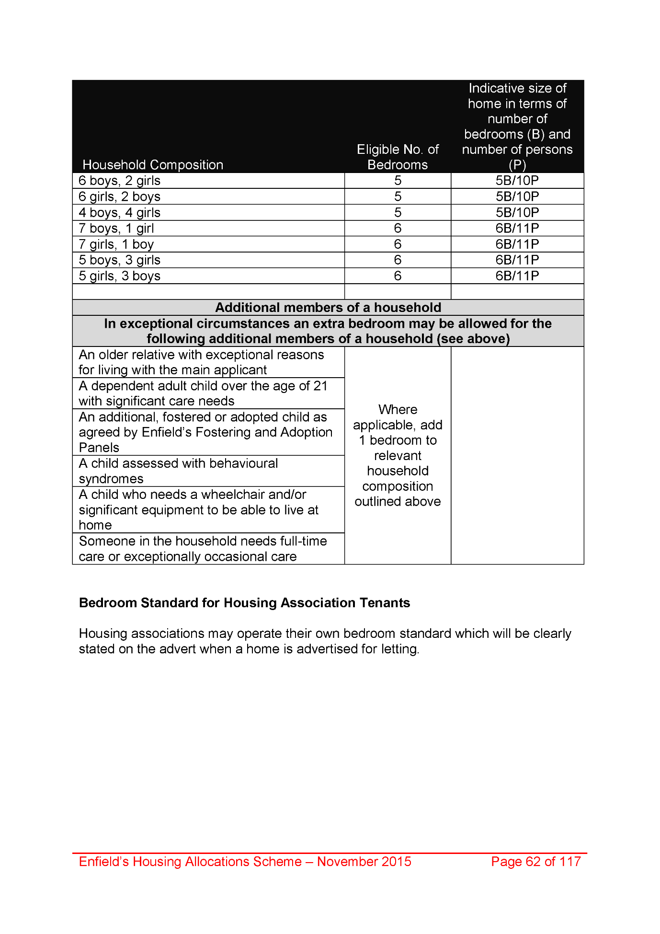
2021,
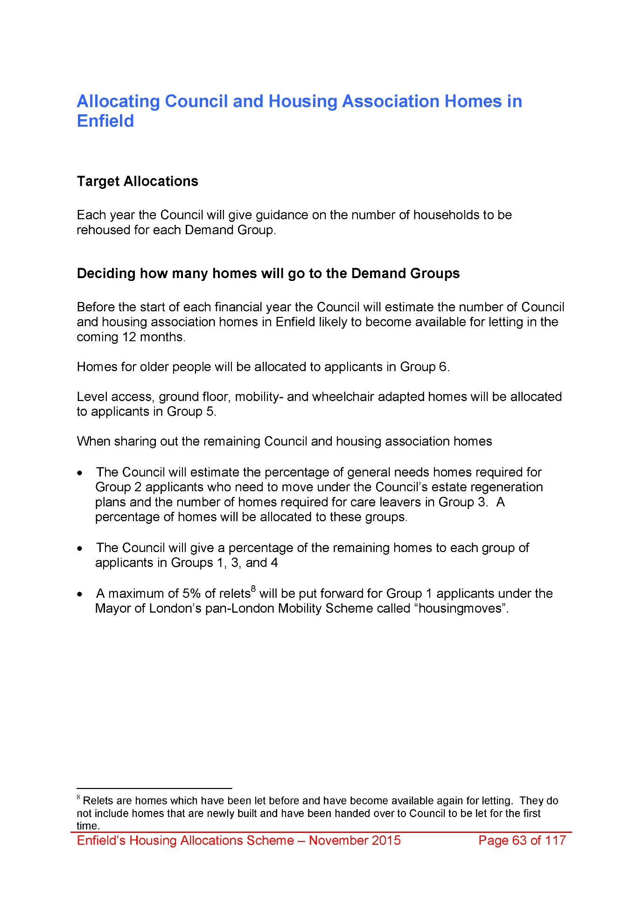
2022,
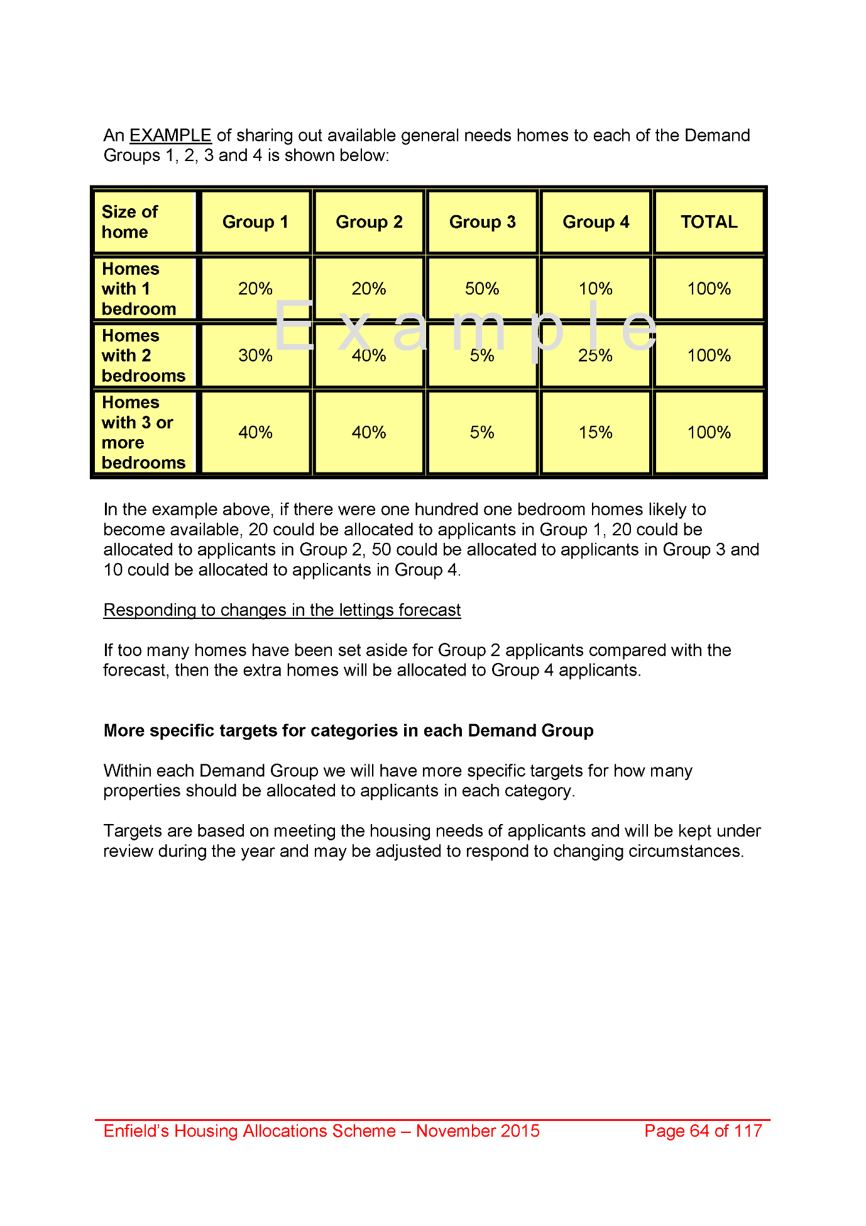
2023,
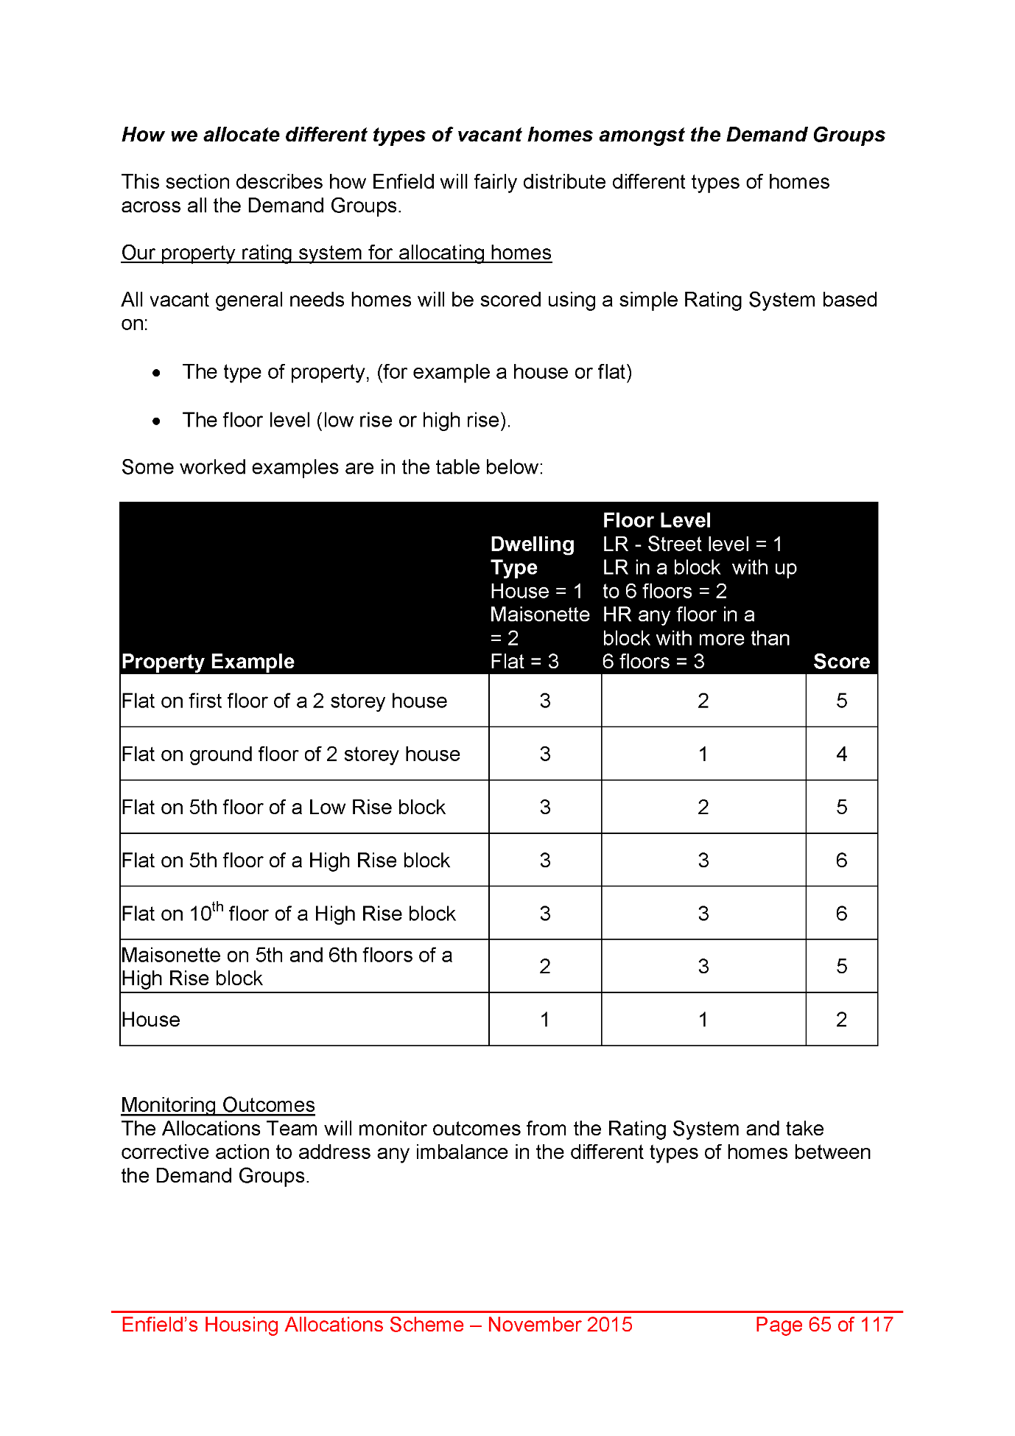
2024,
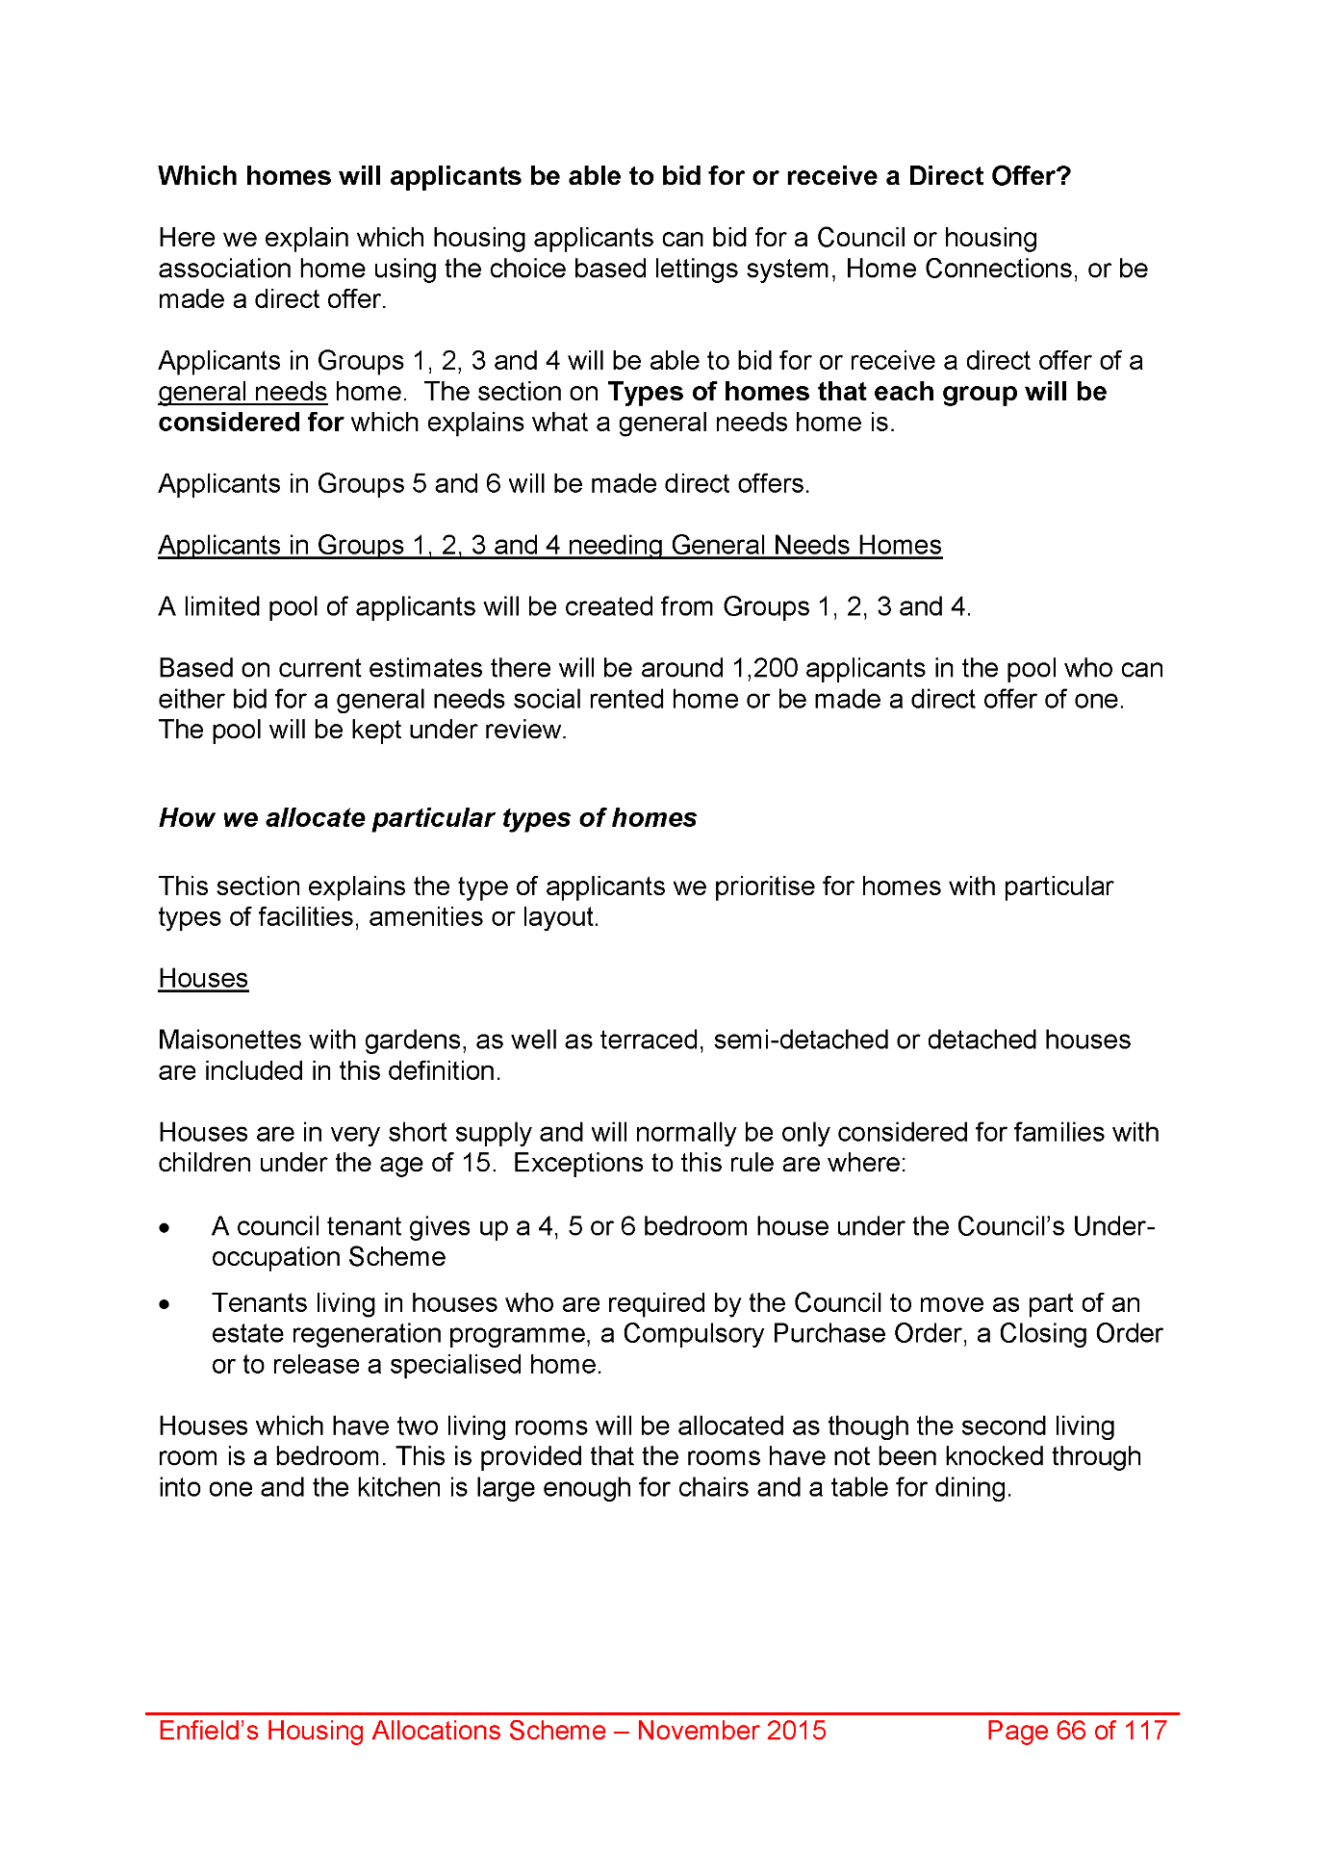
2025,
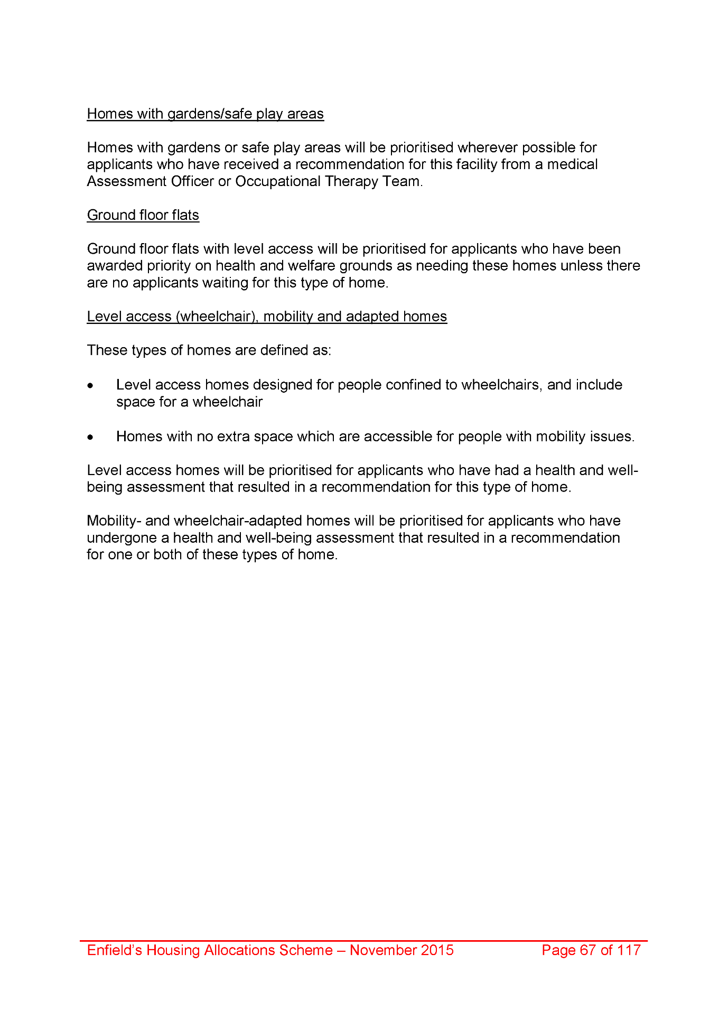
2026,
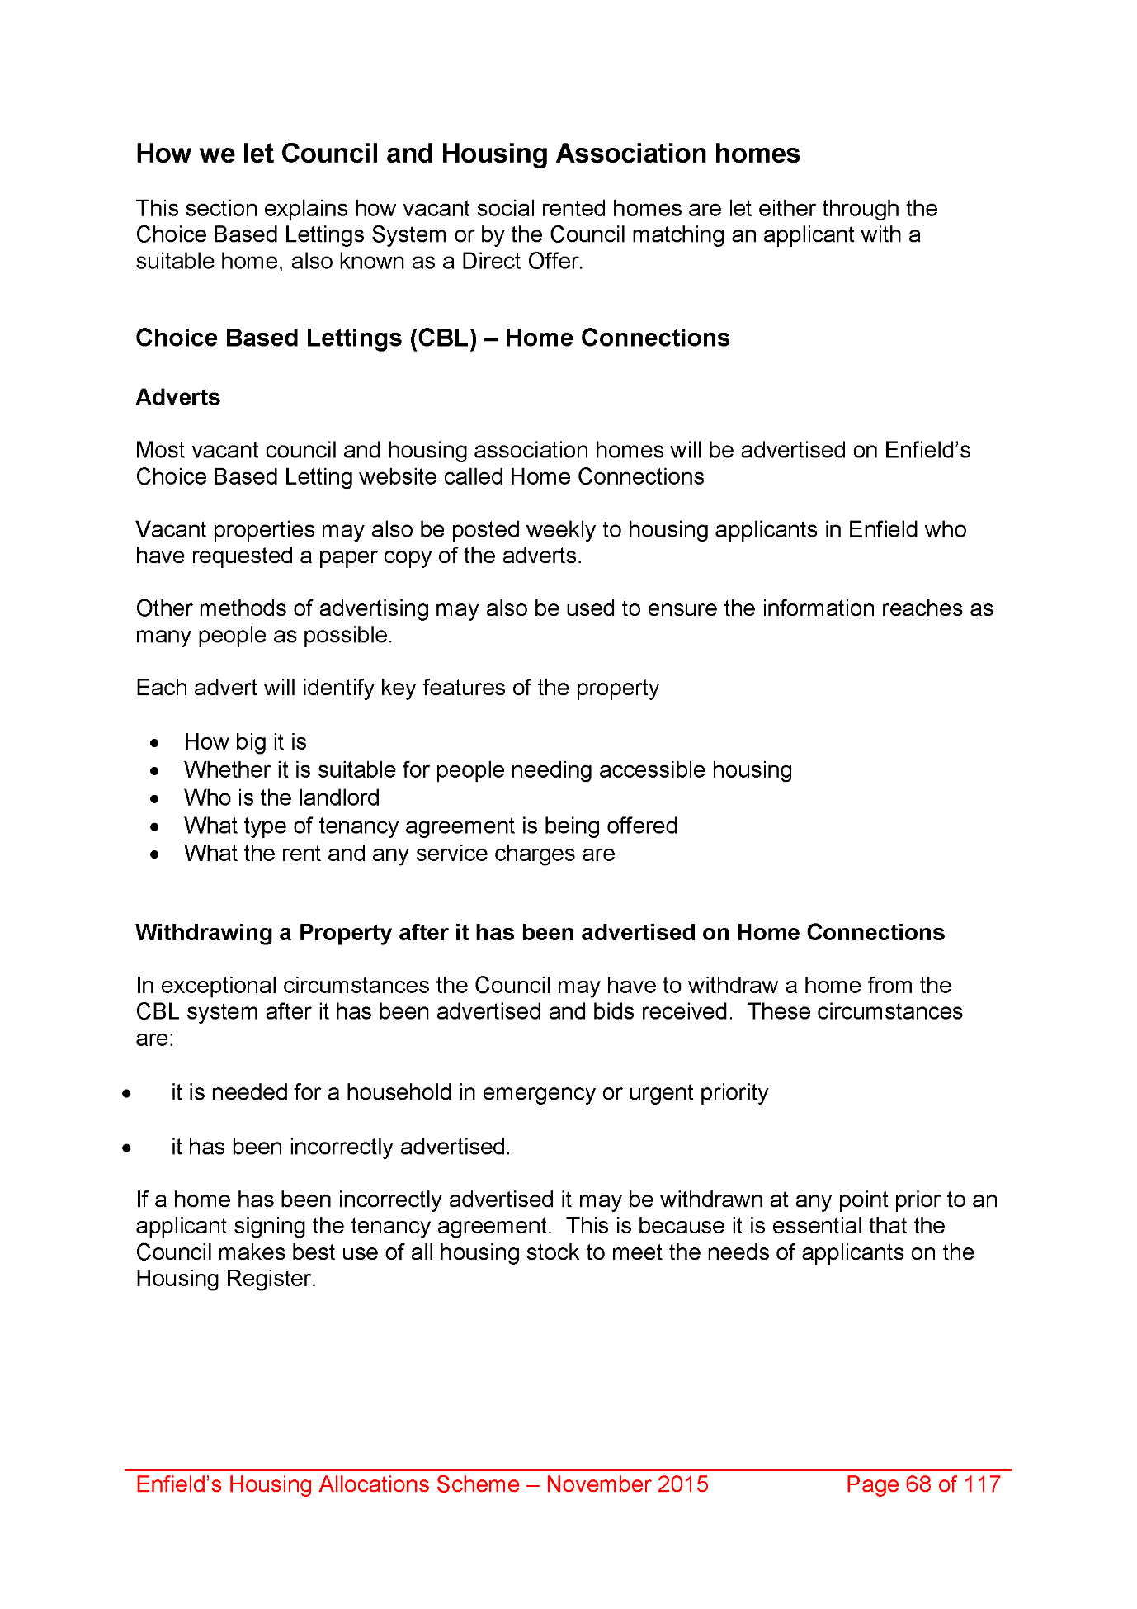
2027,
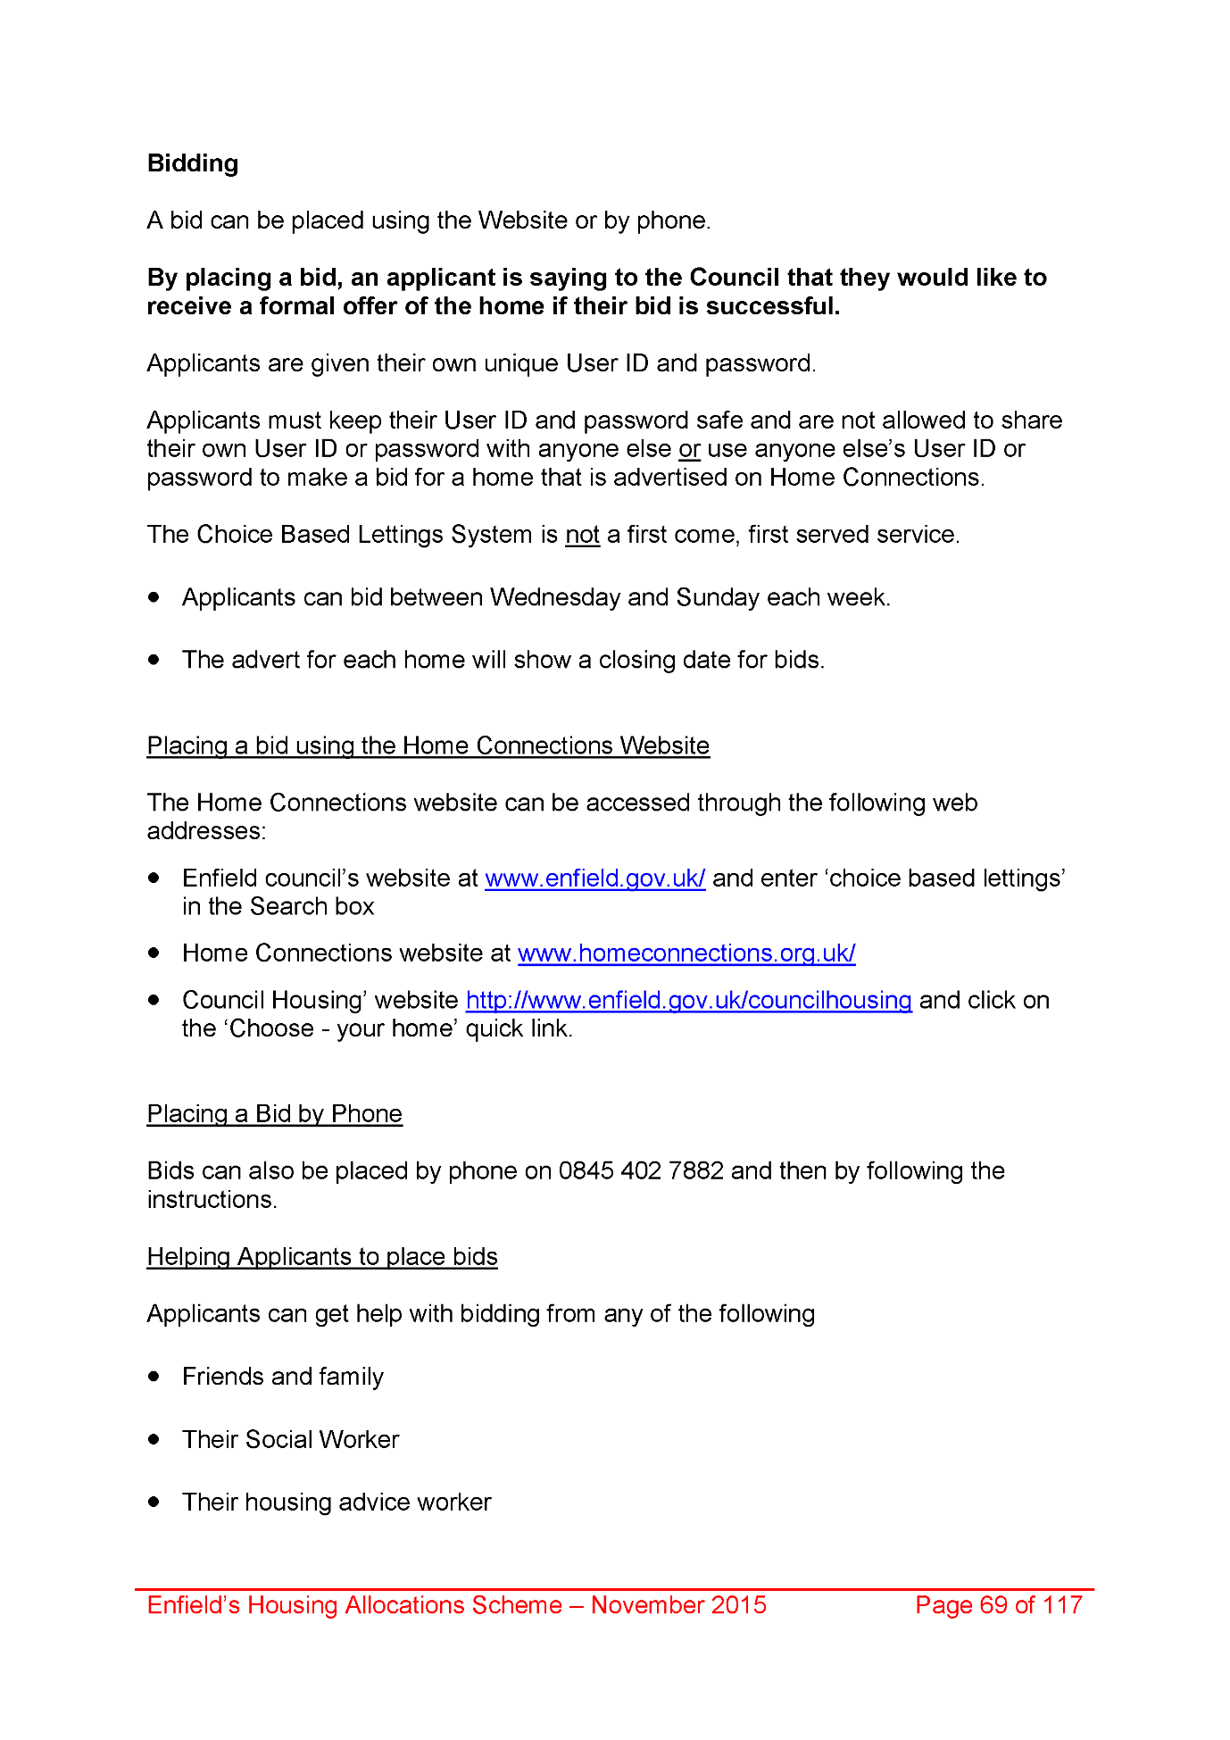
2028,
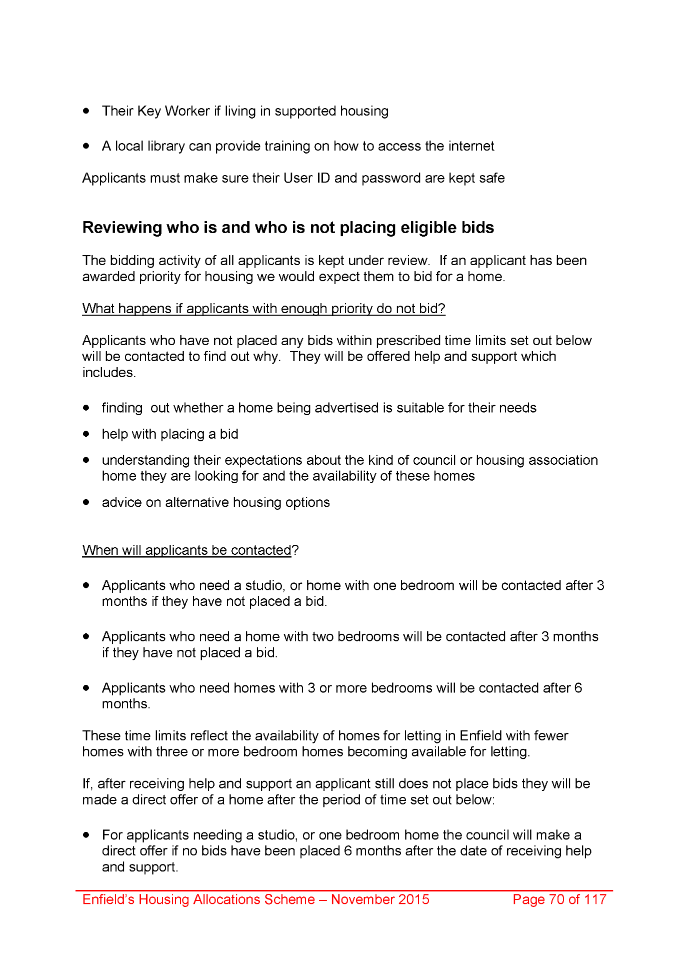
2029,
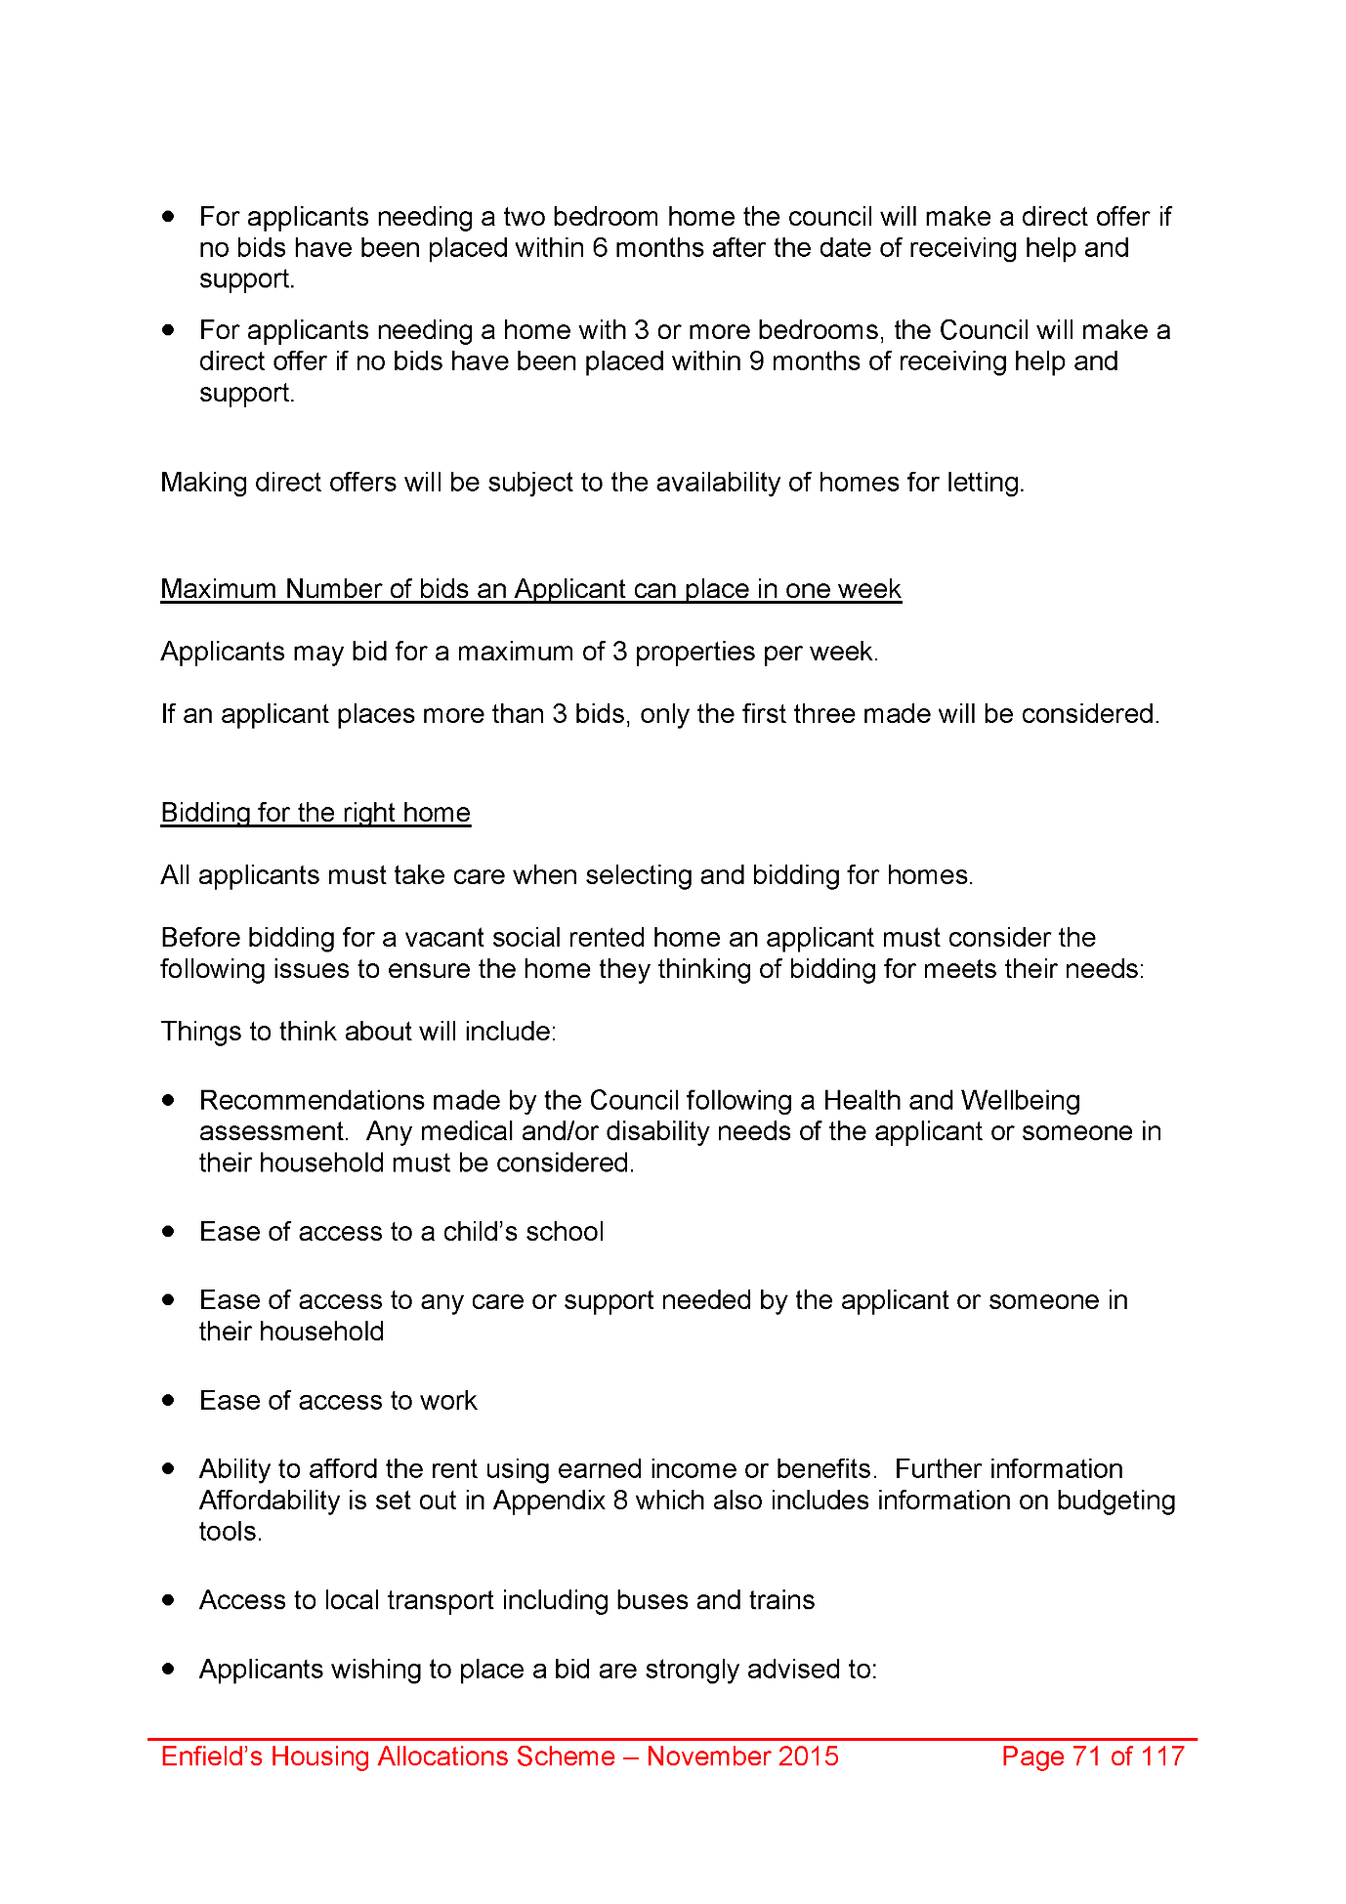
2030,
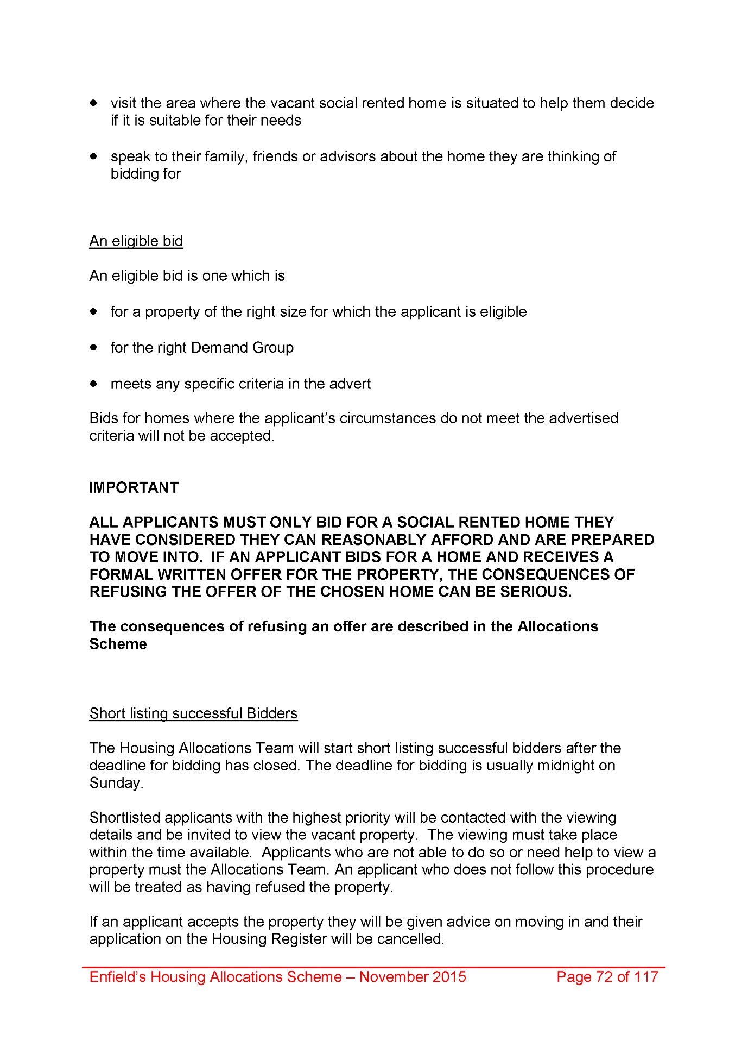
2031,
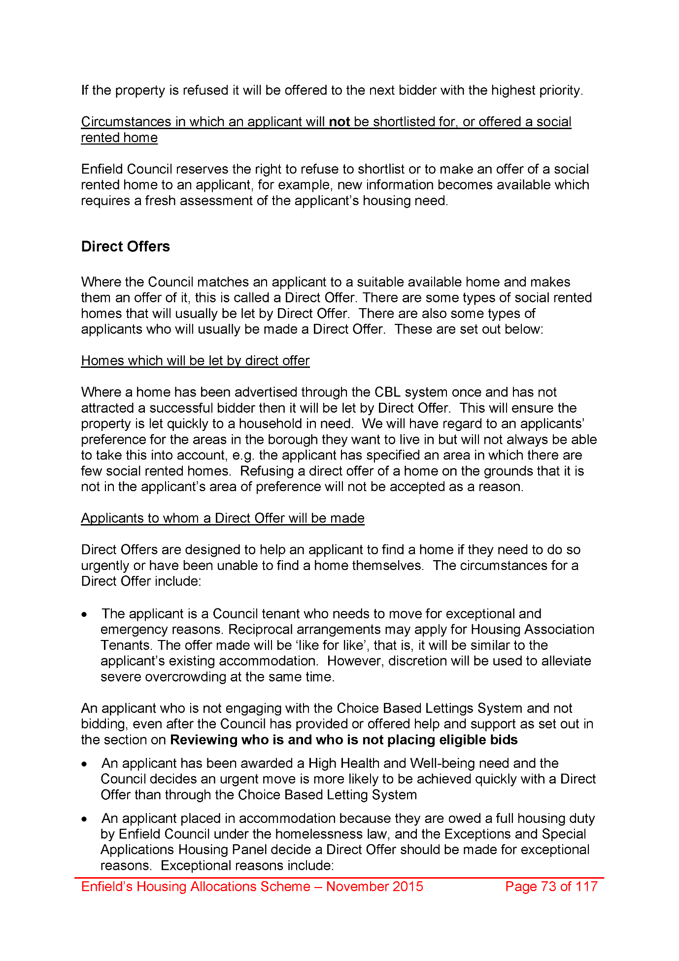
2032,
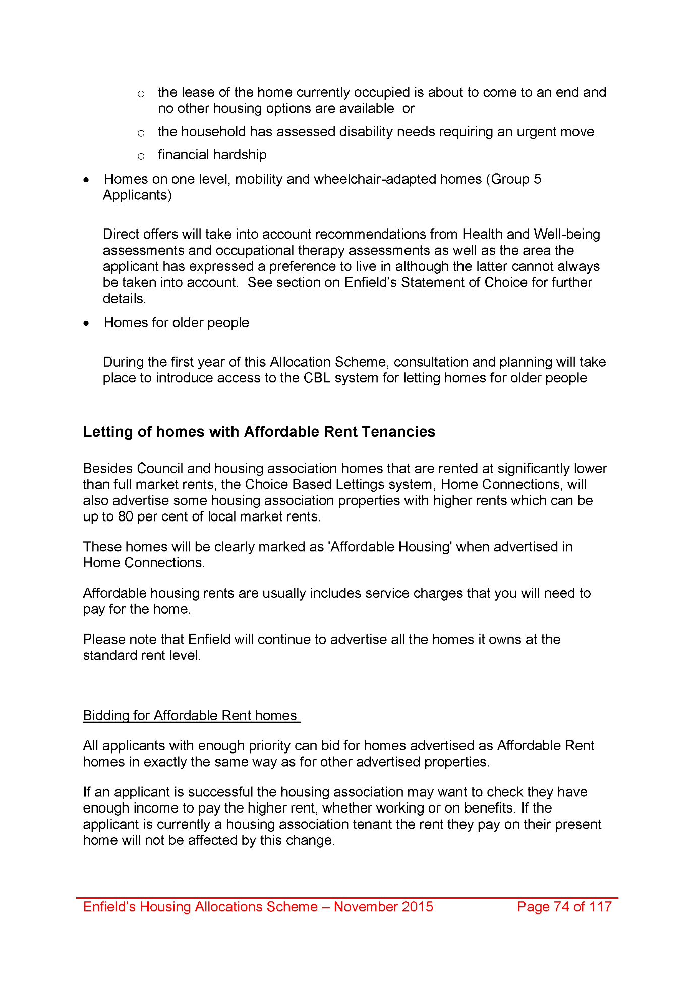
2033,
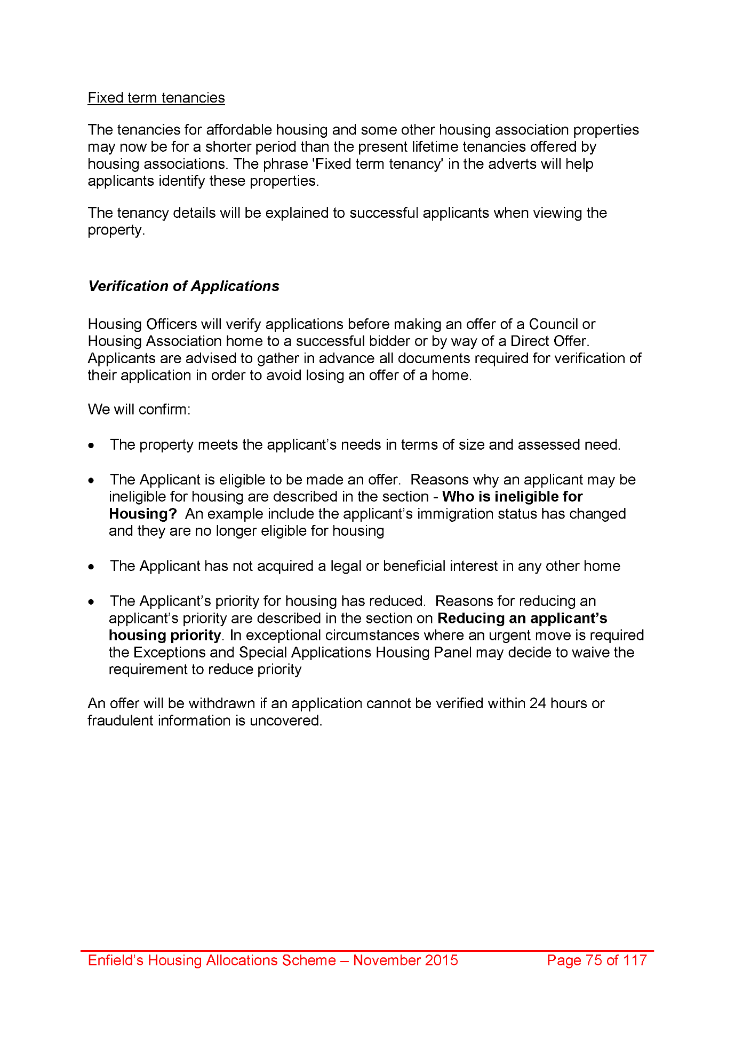
2034,
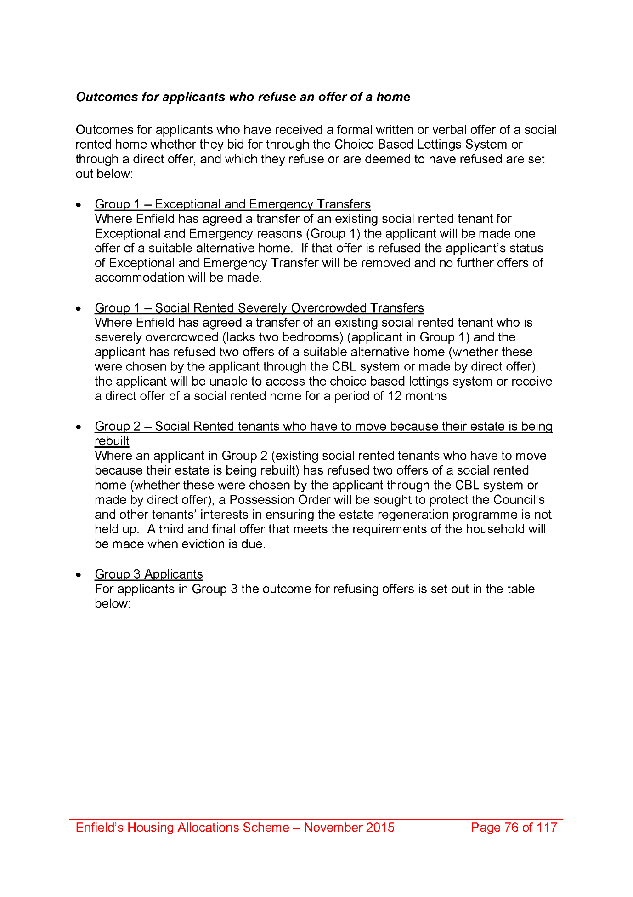
2035,
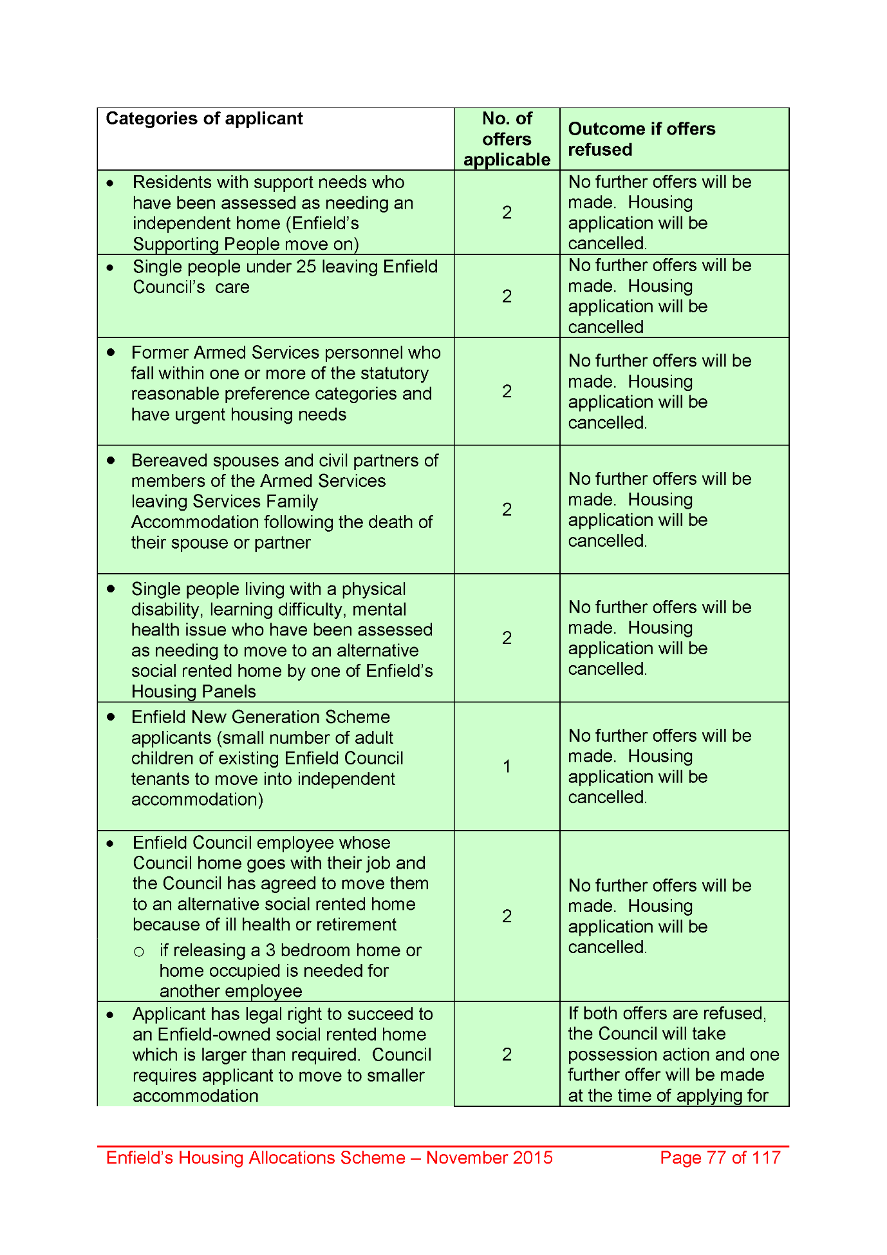
2036,
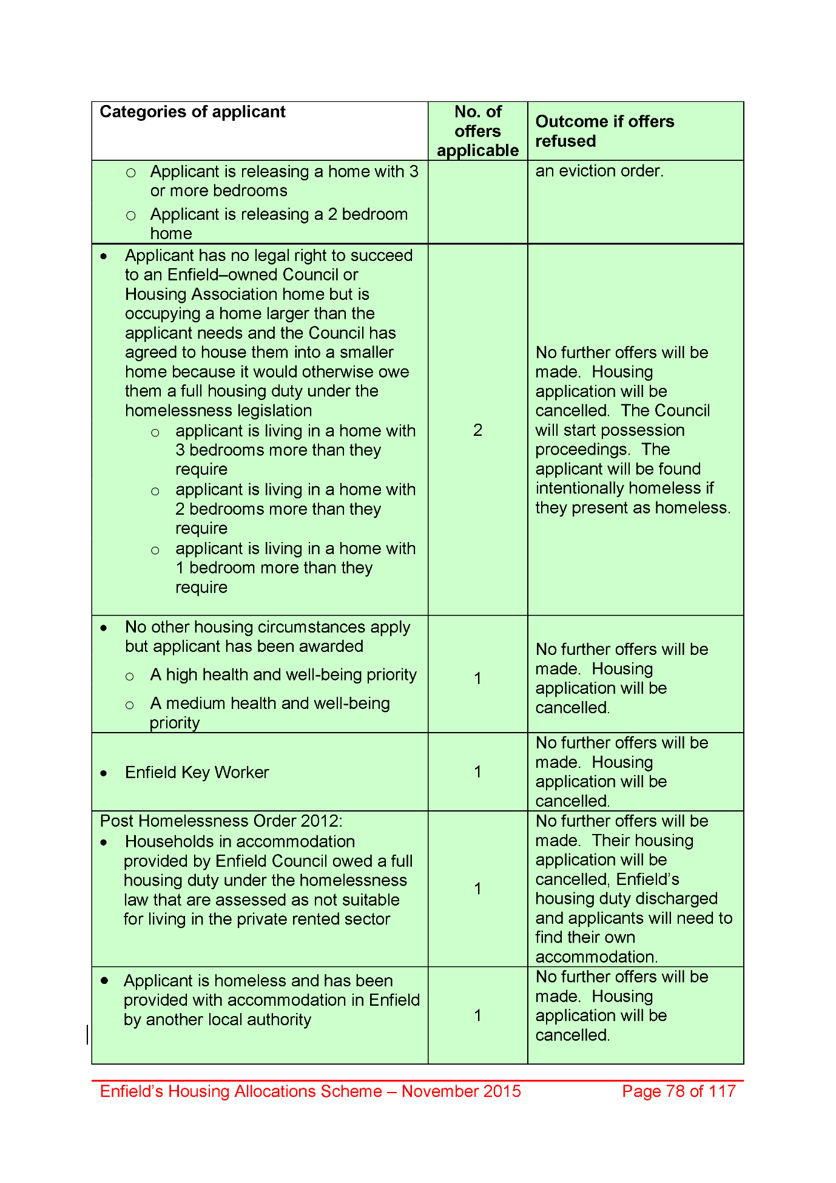
2037,
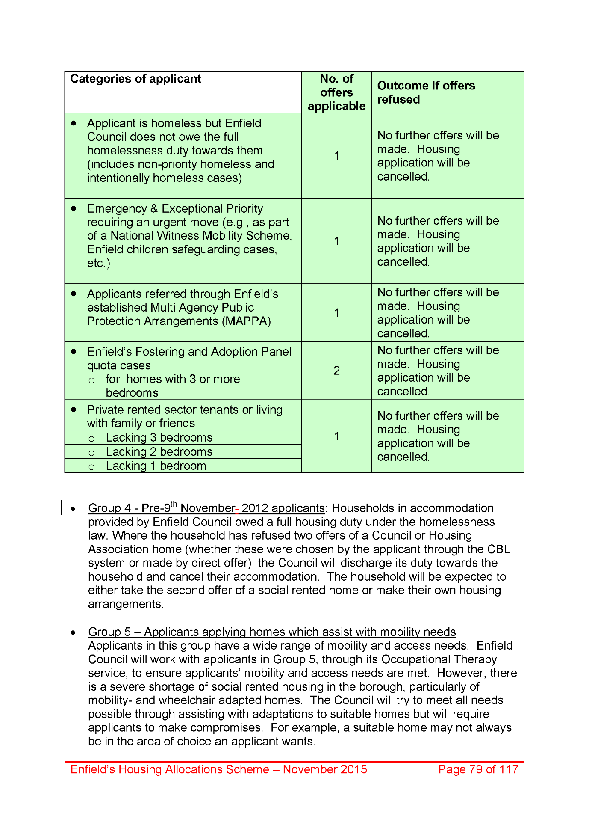
2038,
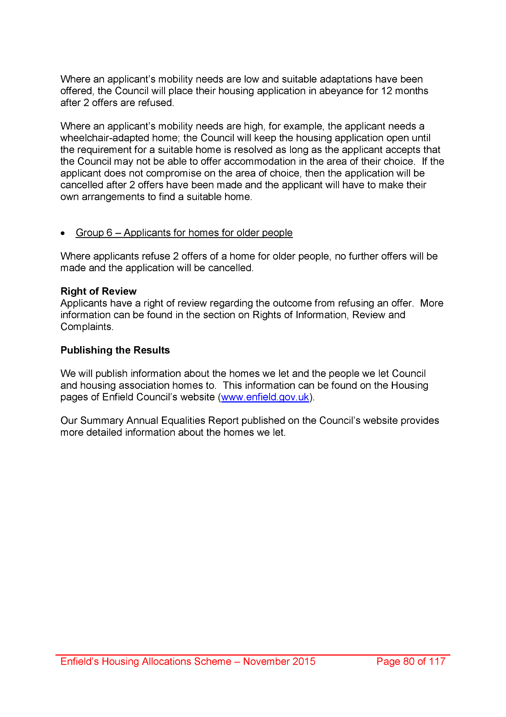
2039,
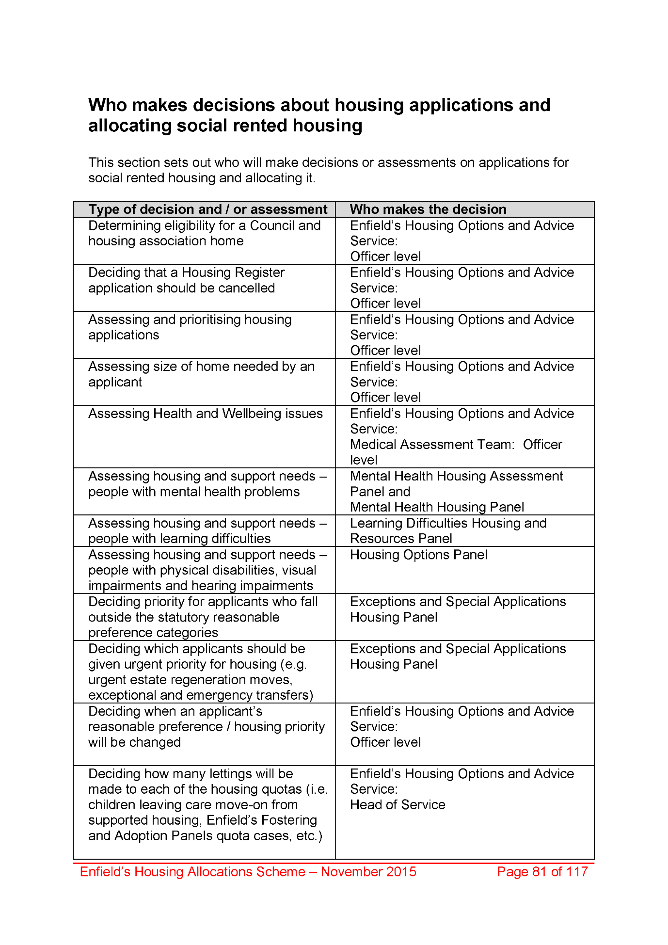
2040,
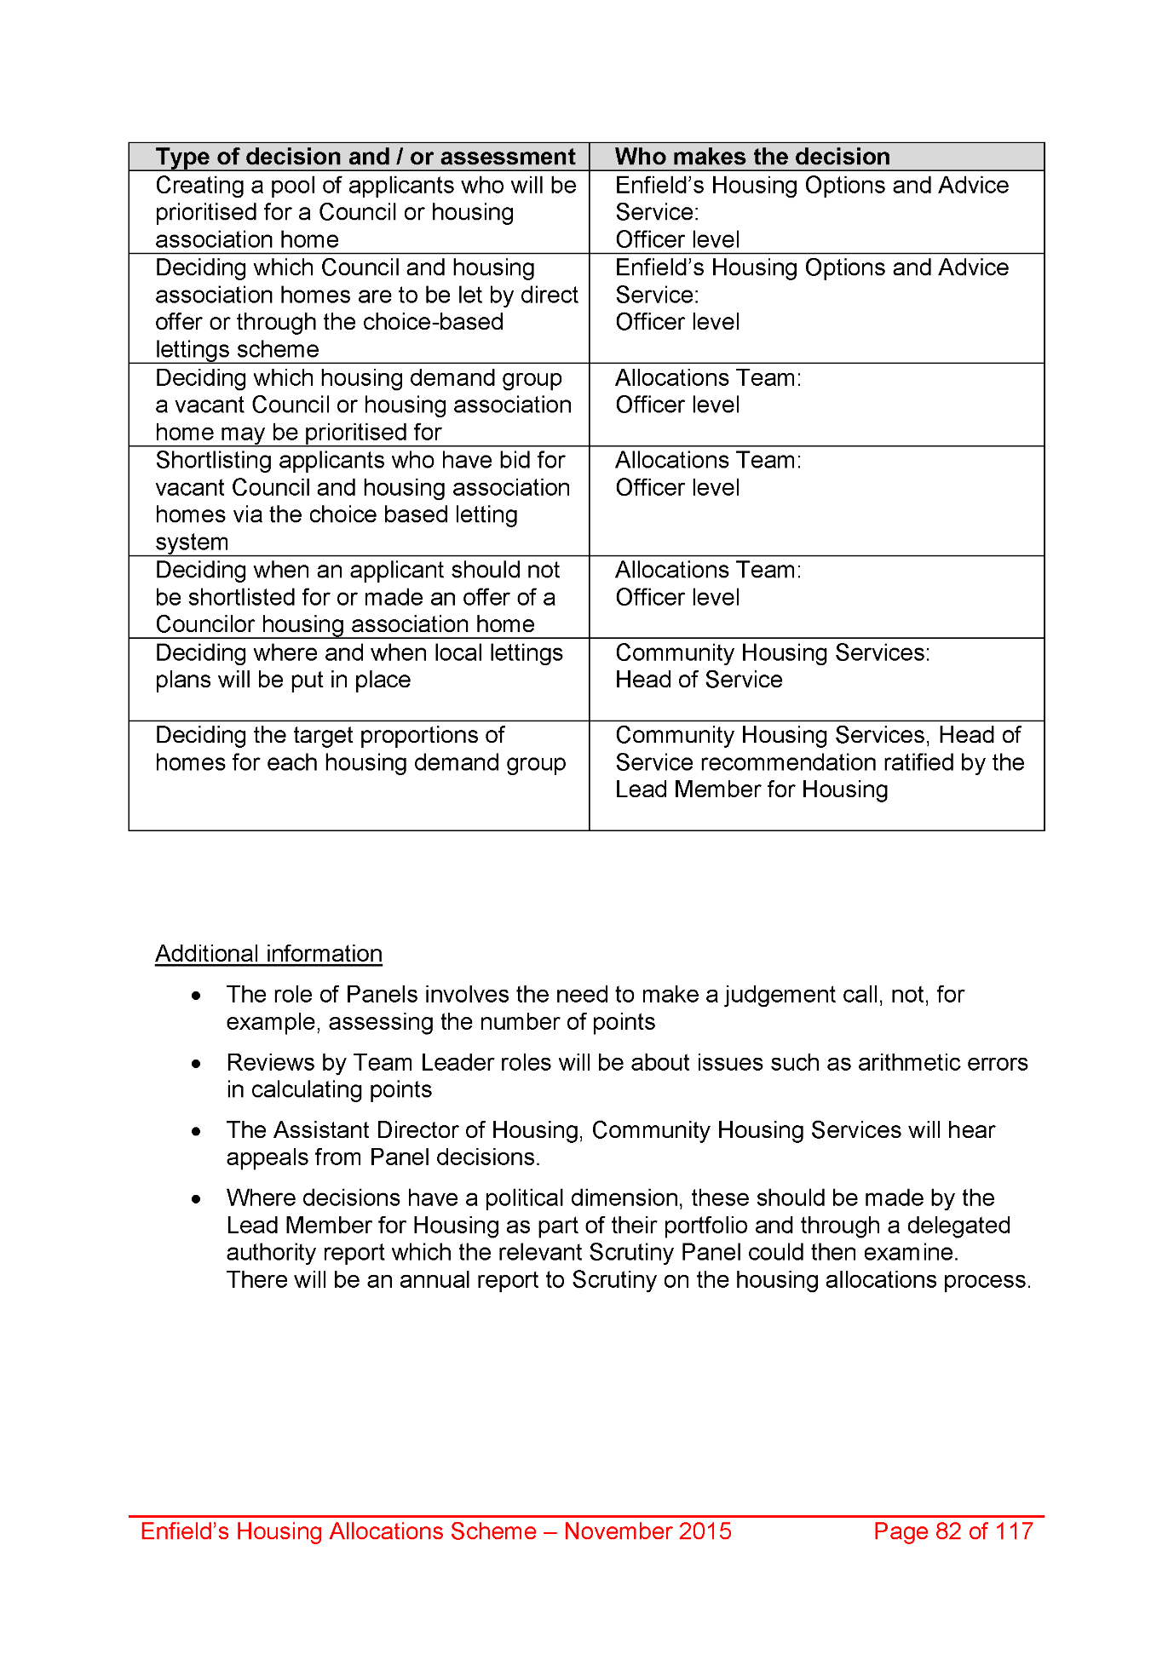
2041,
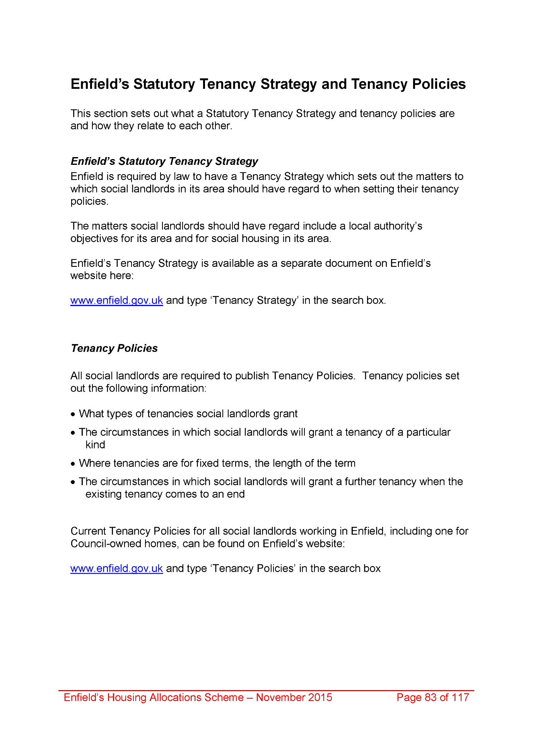
2042,
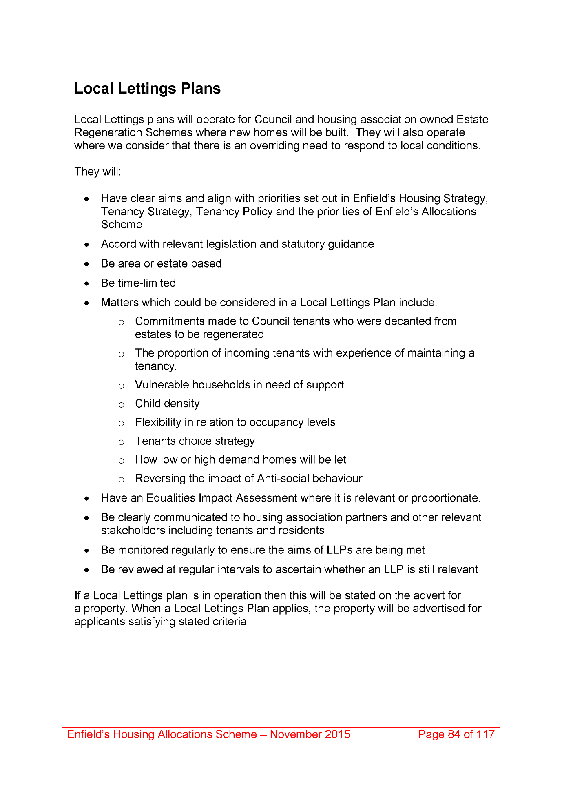
2043,
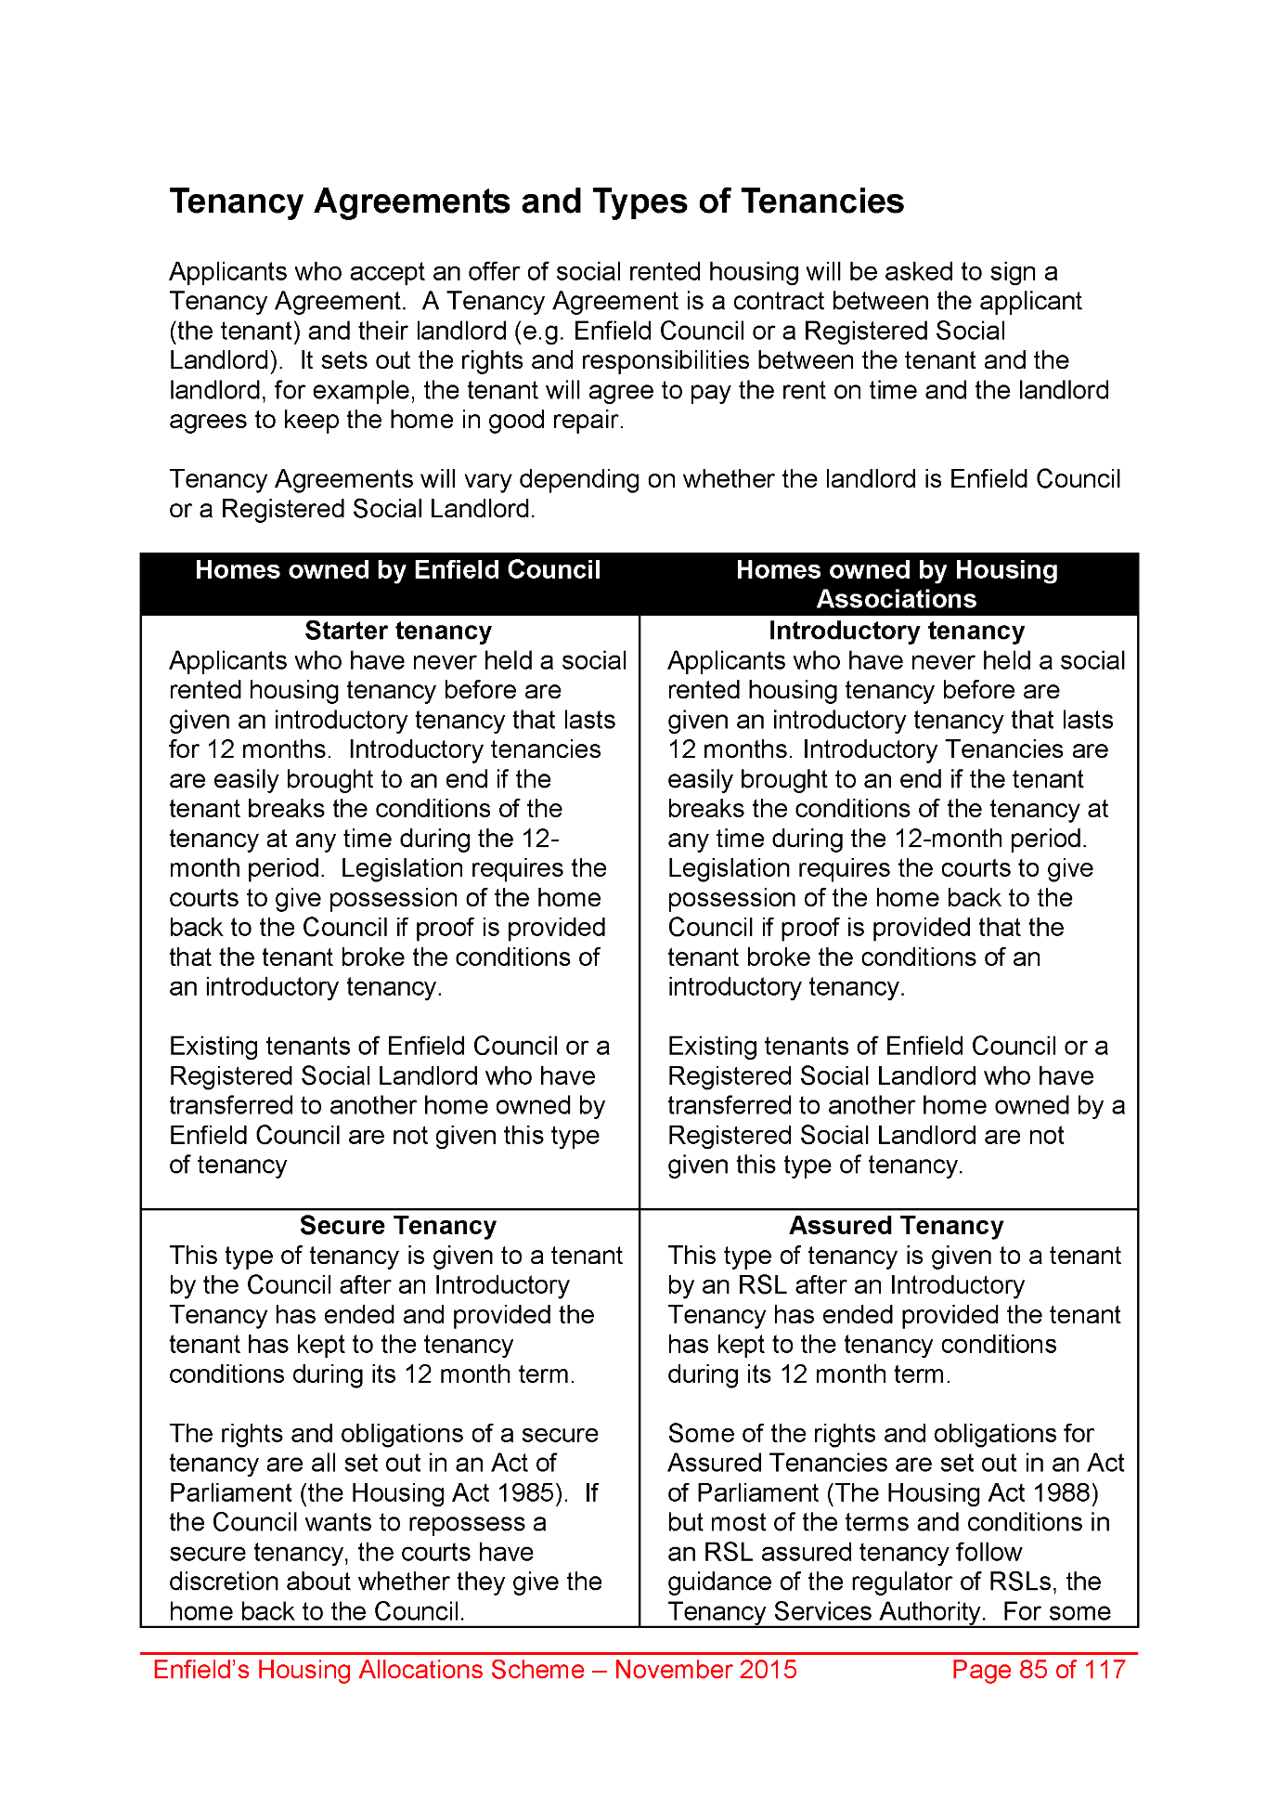
2044,
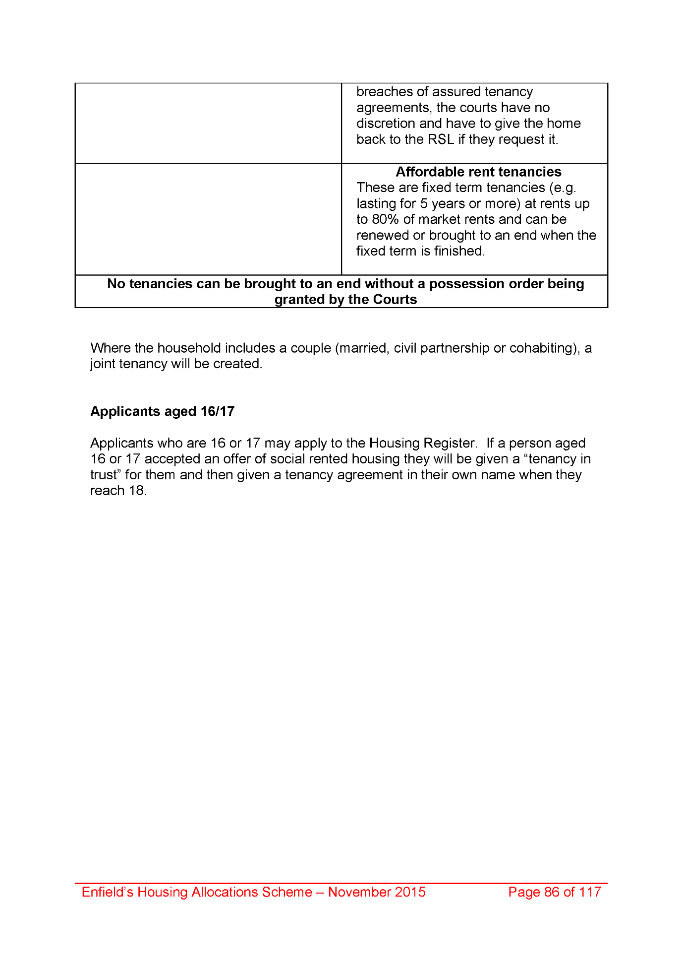
2045,
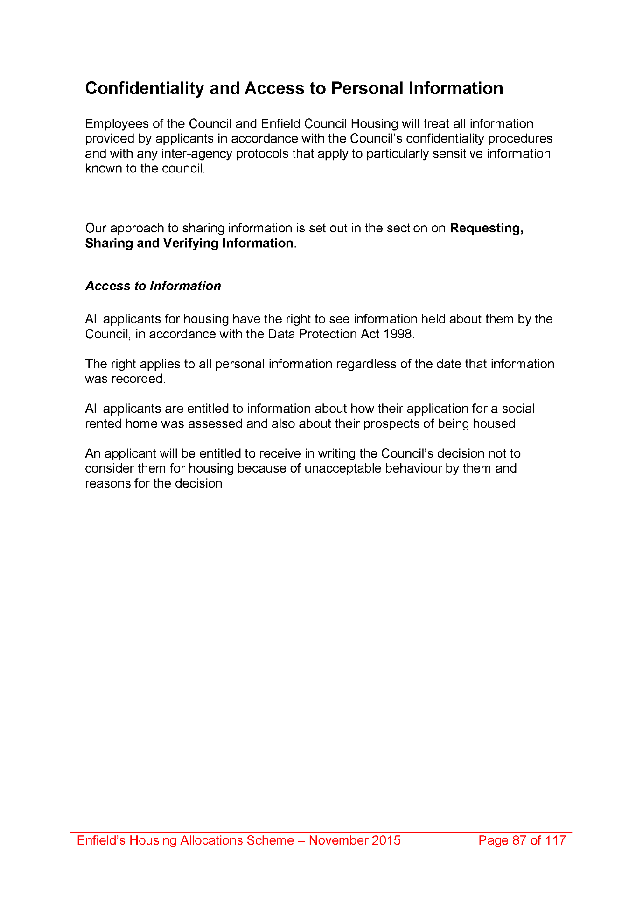
2046,
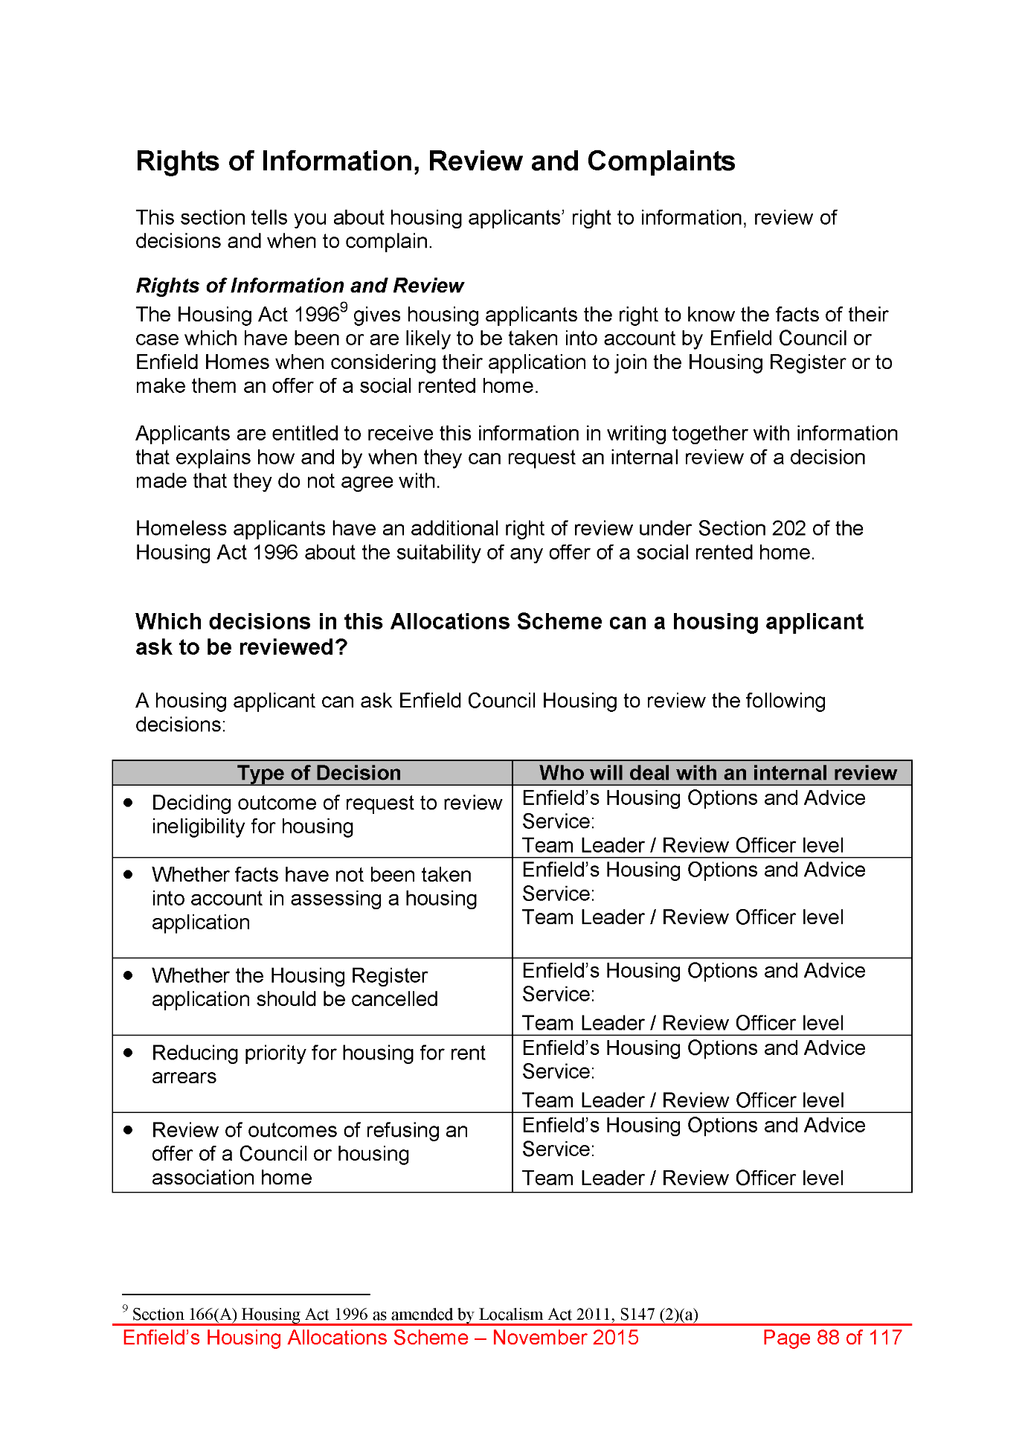
2047,
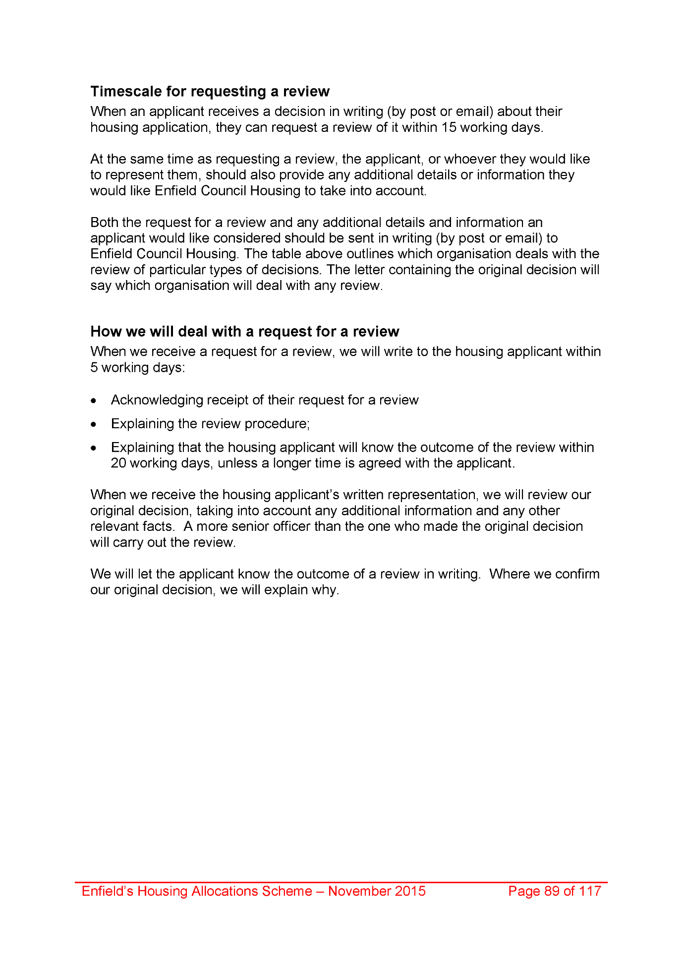
2048,
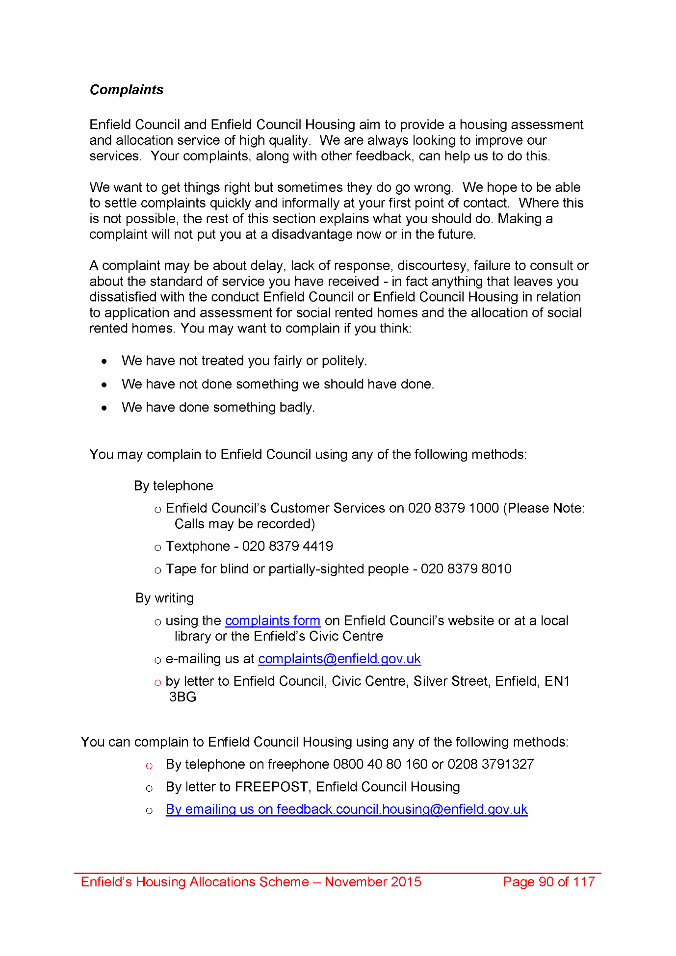
2049,
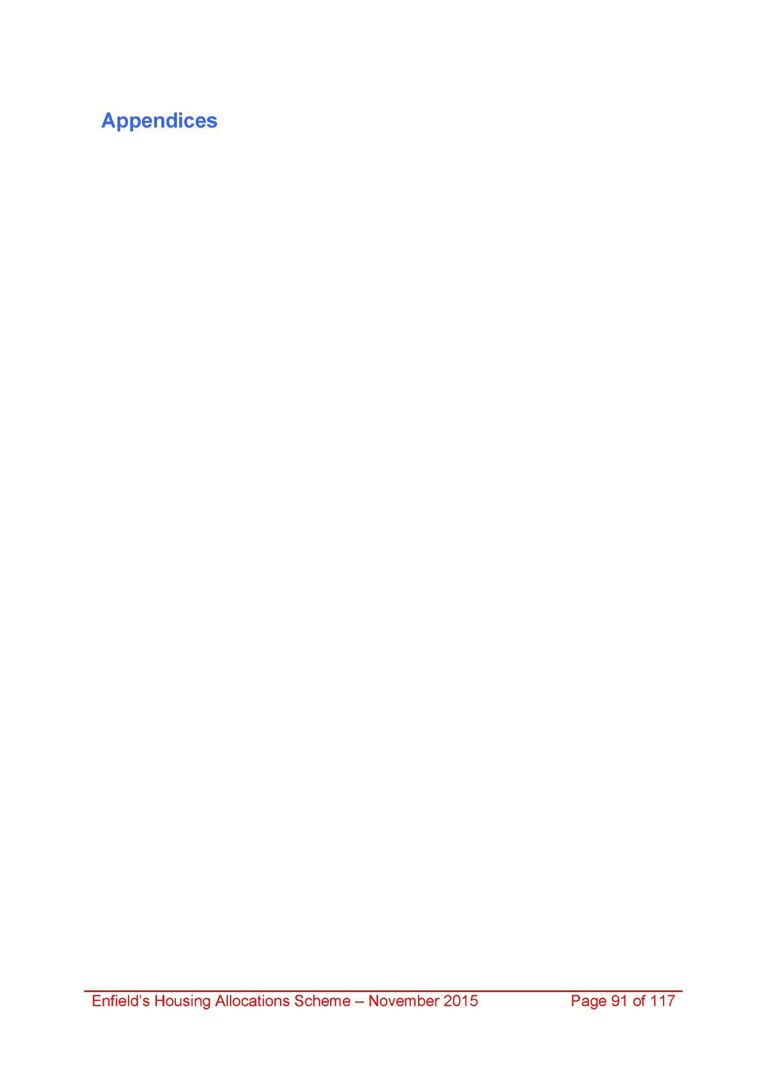
2050,
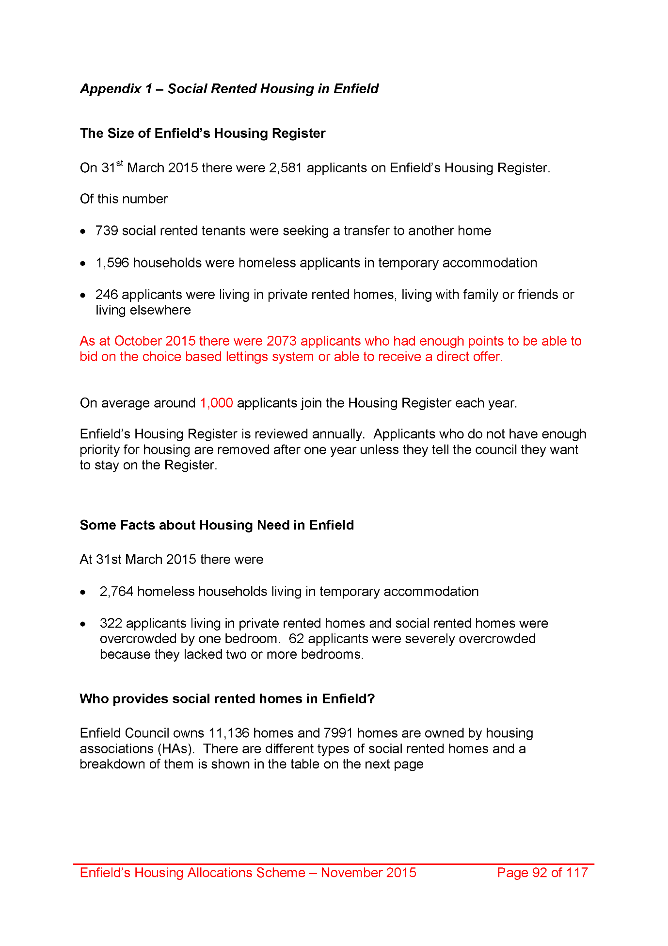
2051,
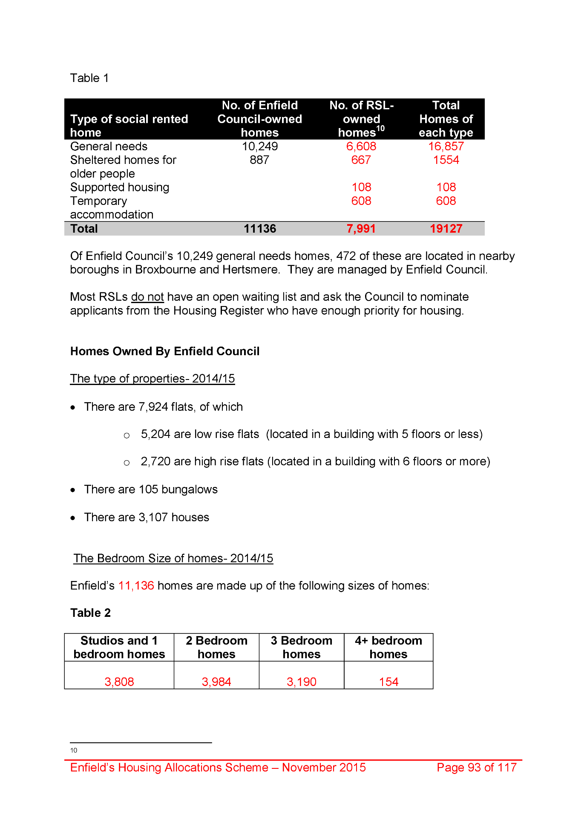
2052,
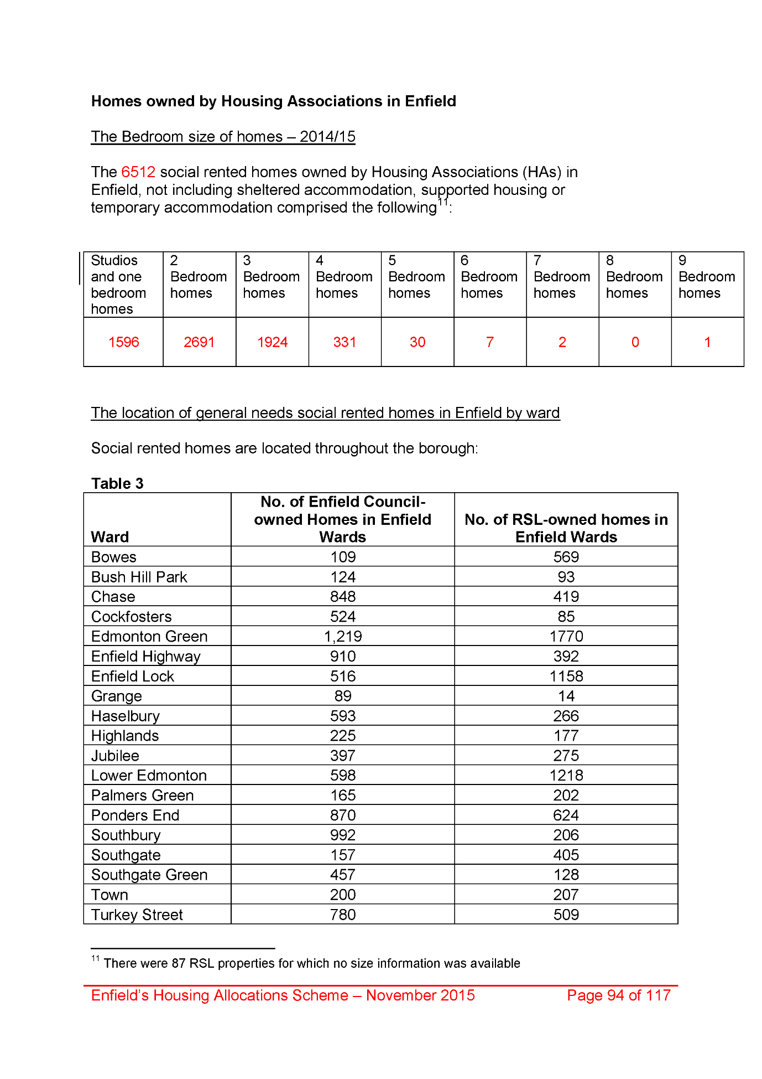
2053,
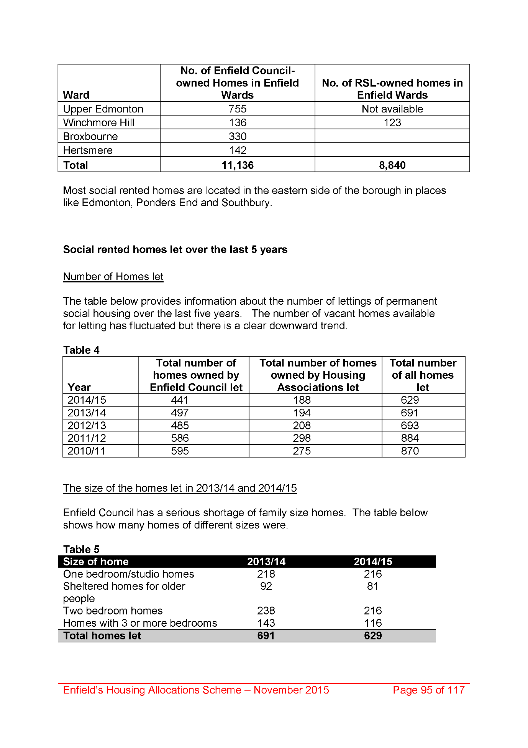
2054,
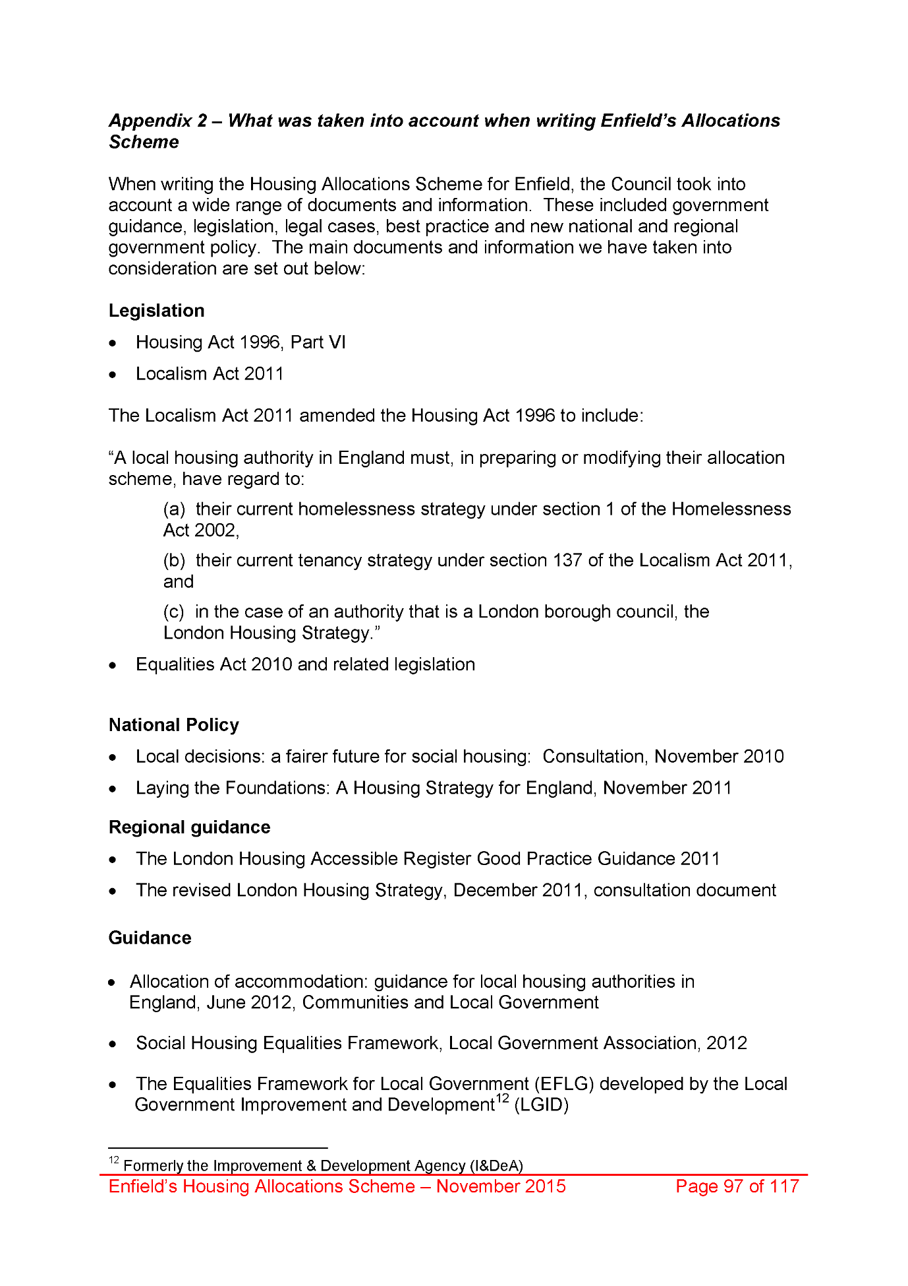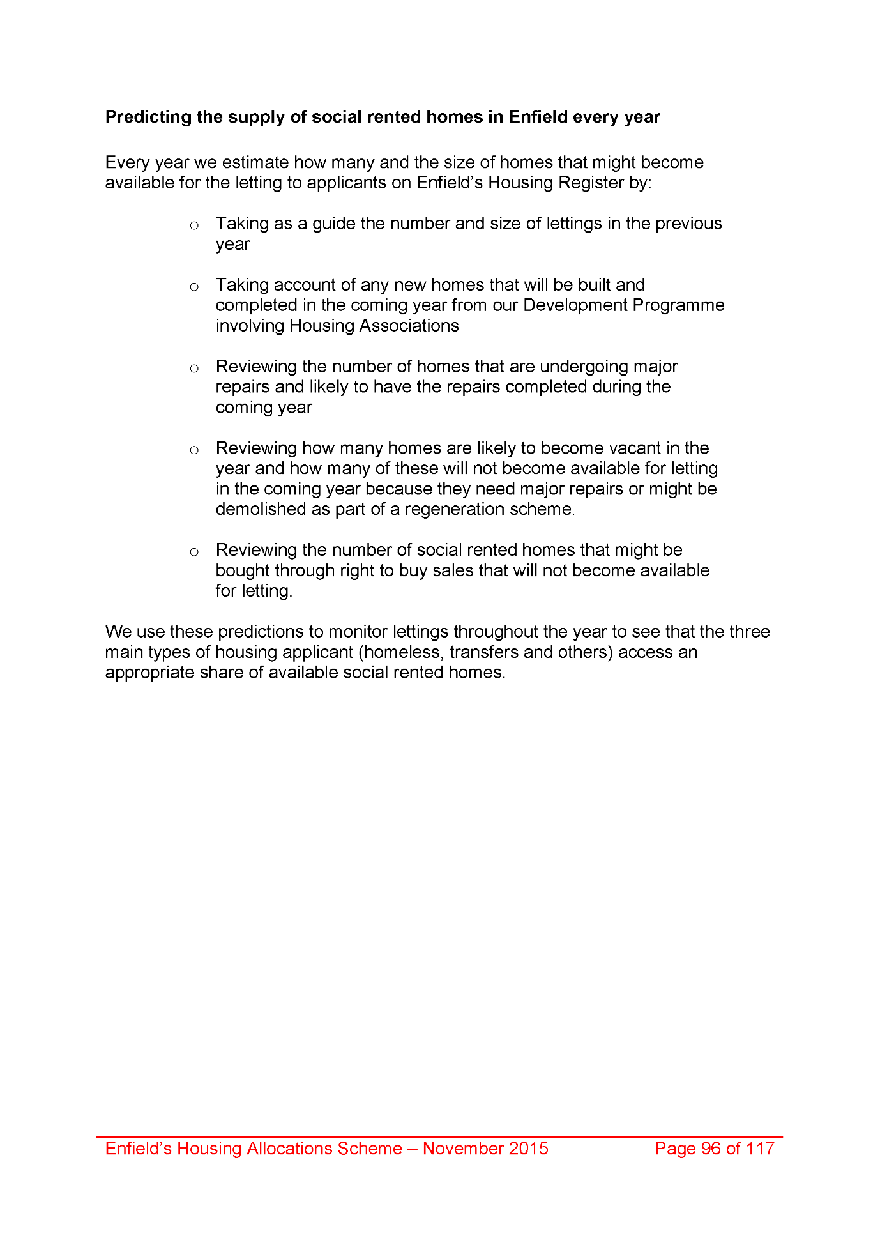
2055,
2056,
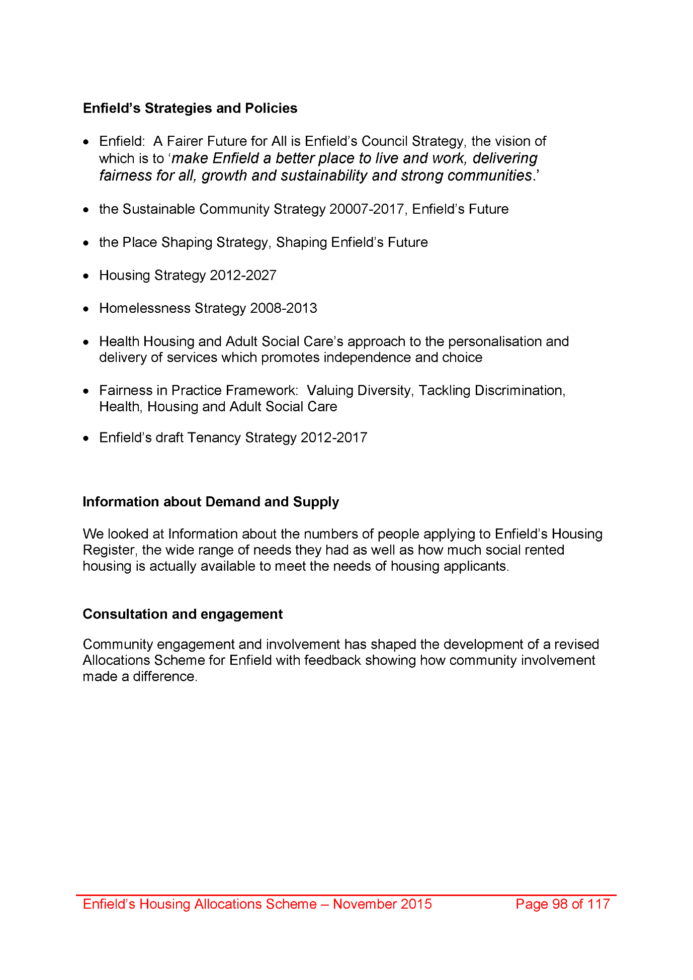
2057,
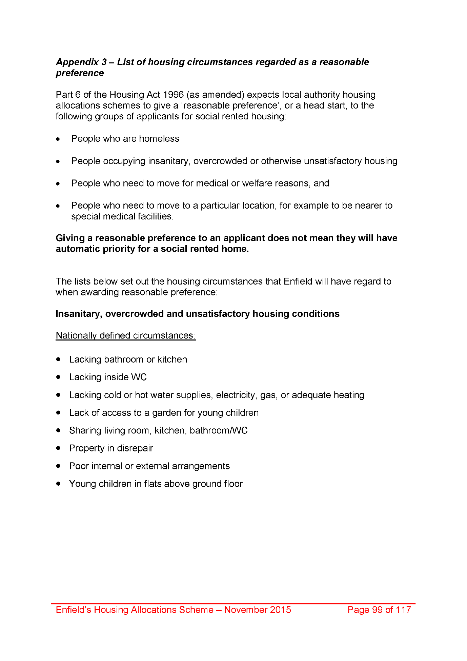
2058,
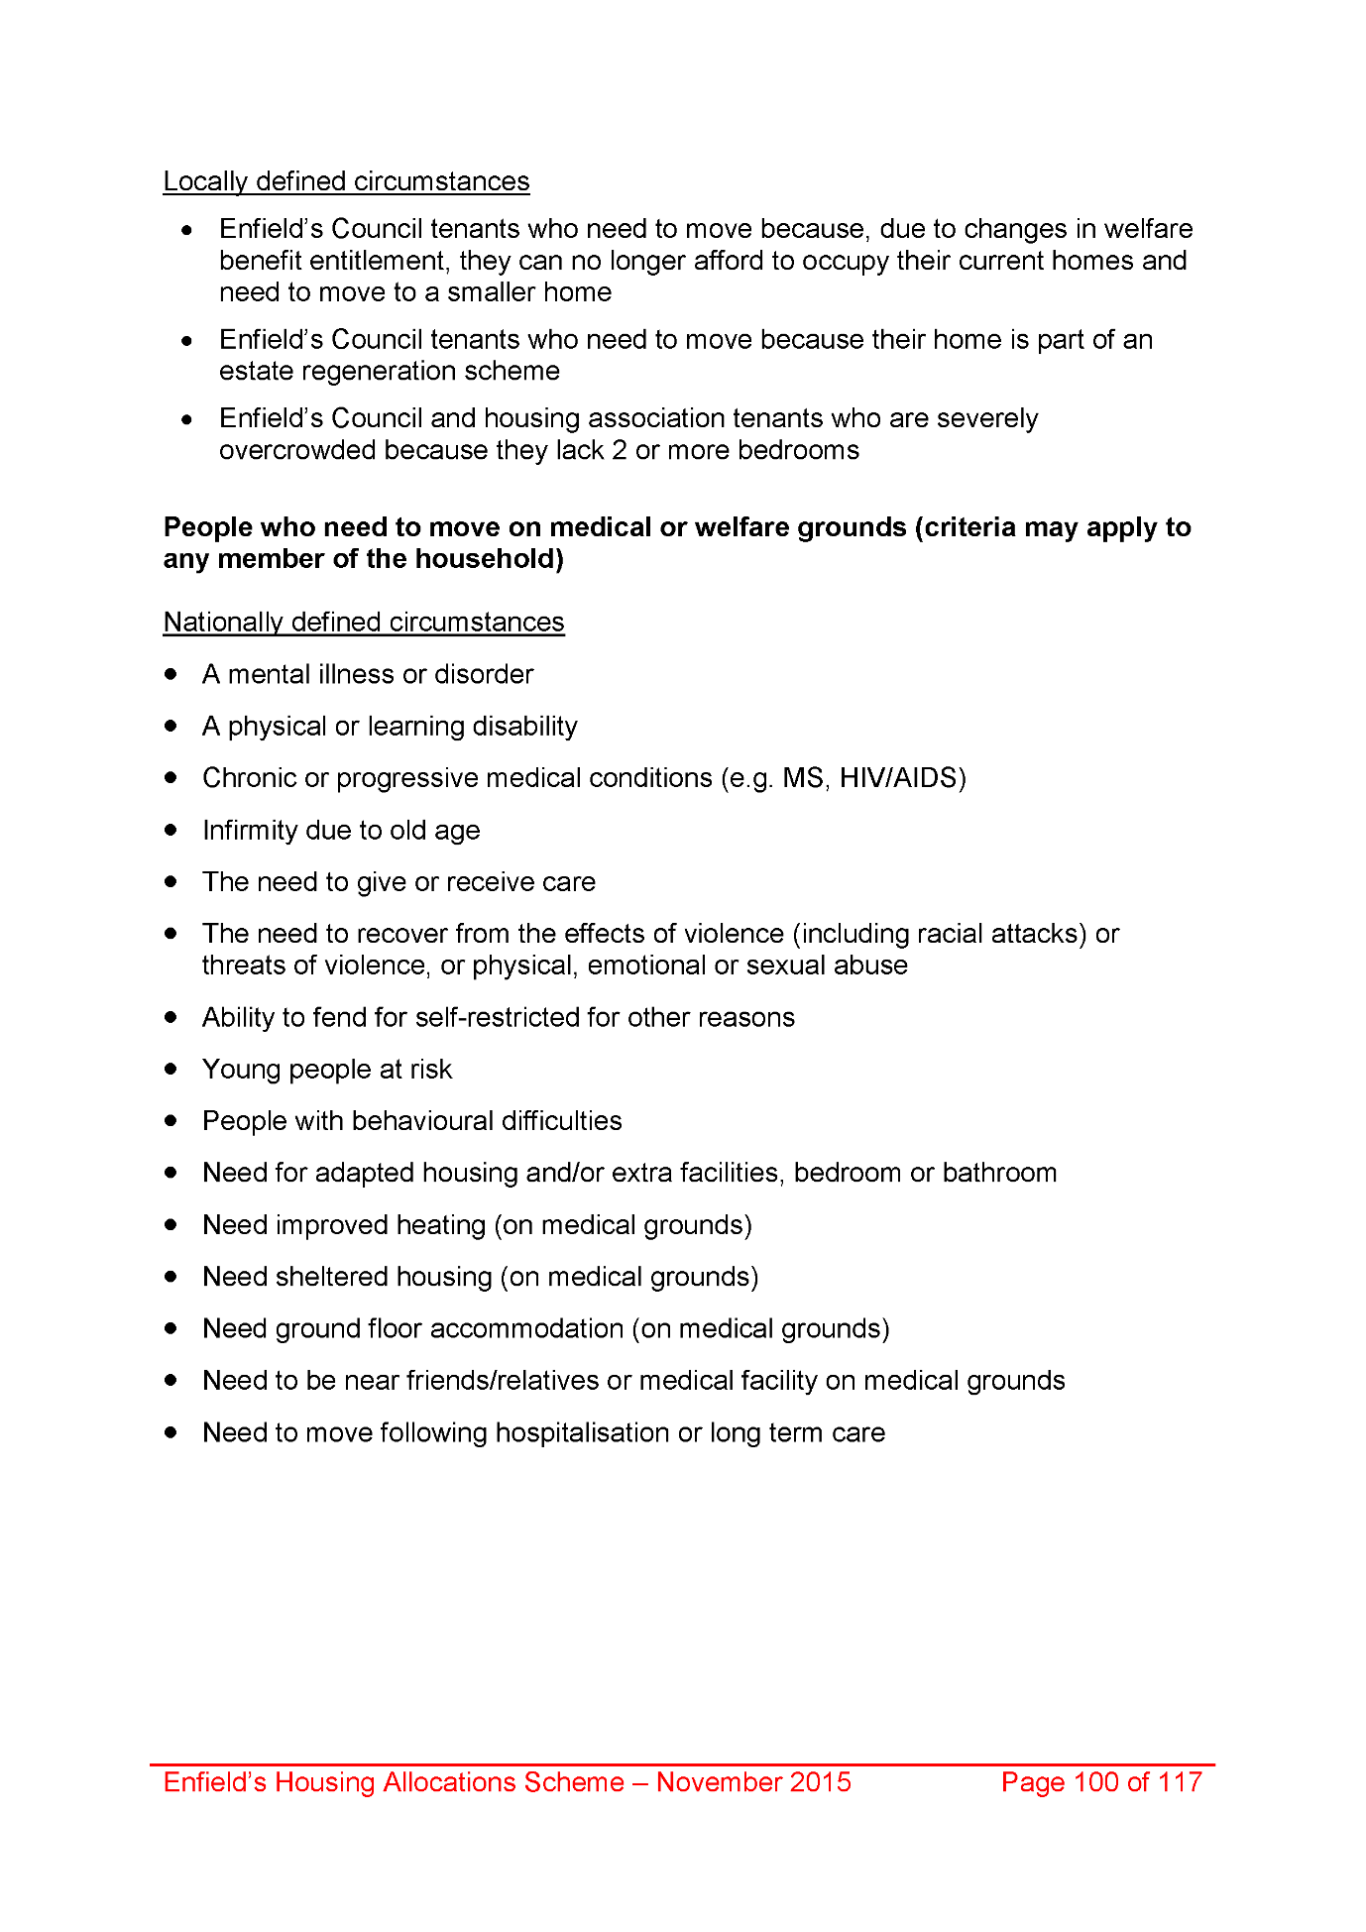
2059,
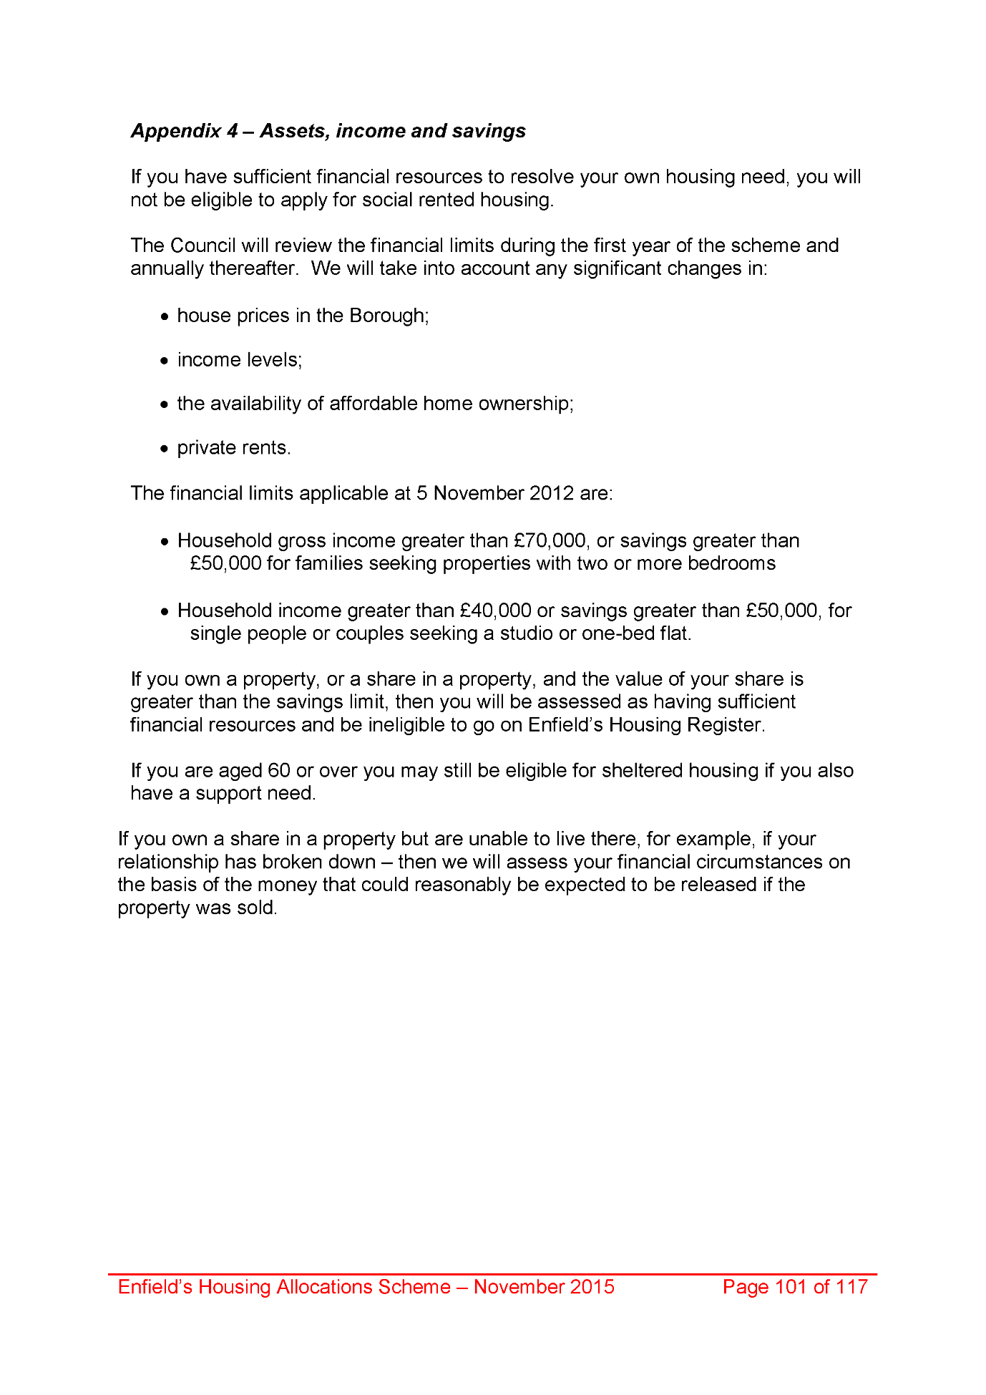
2060,
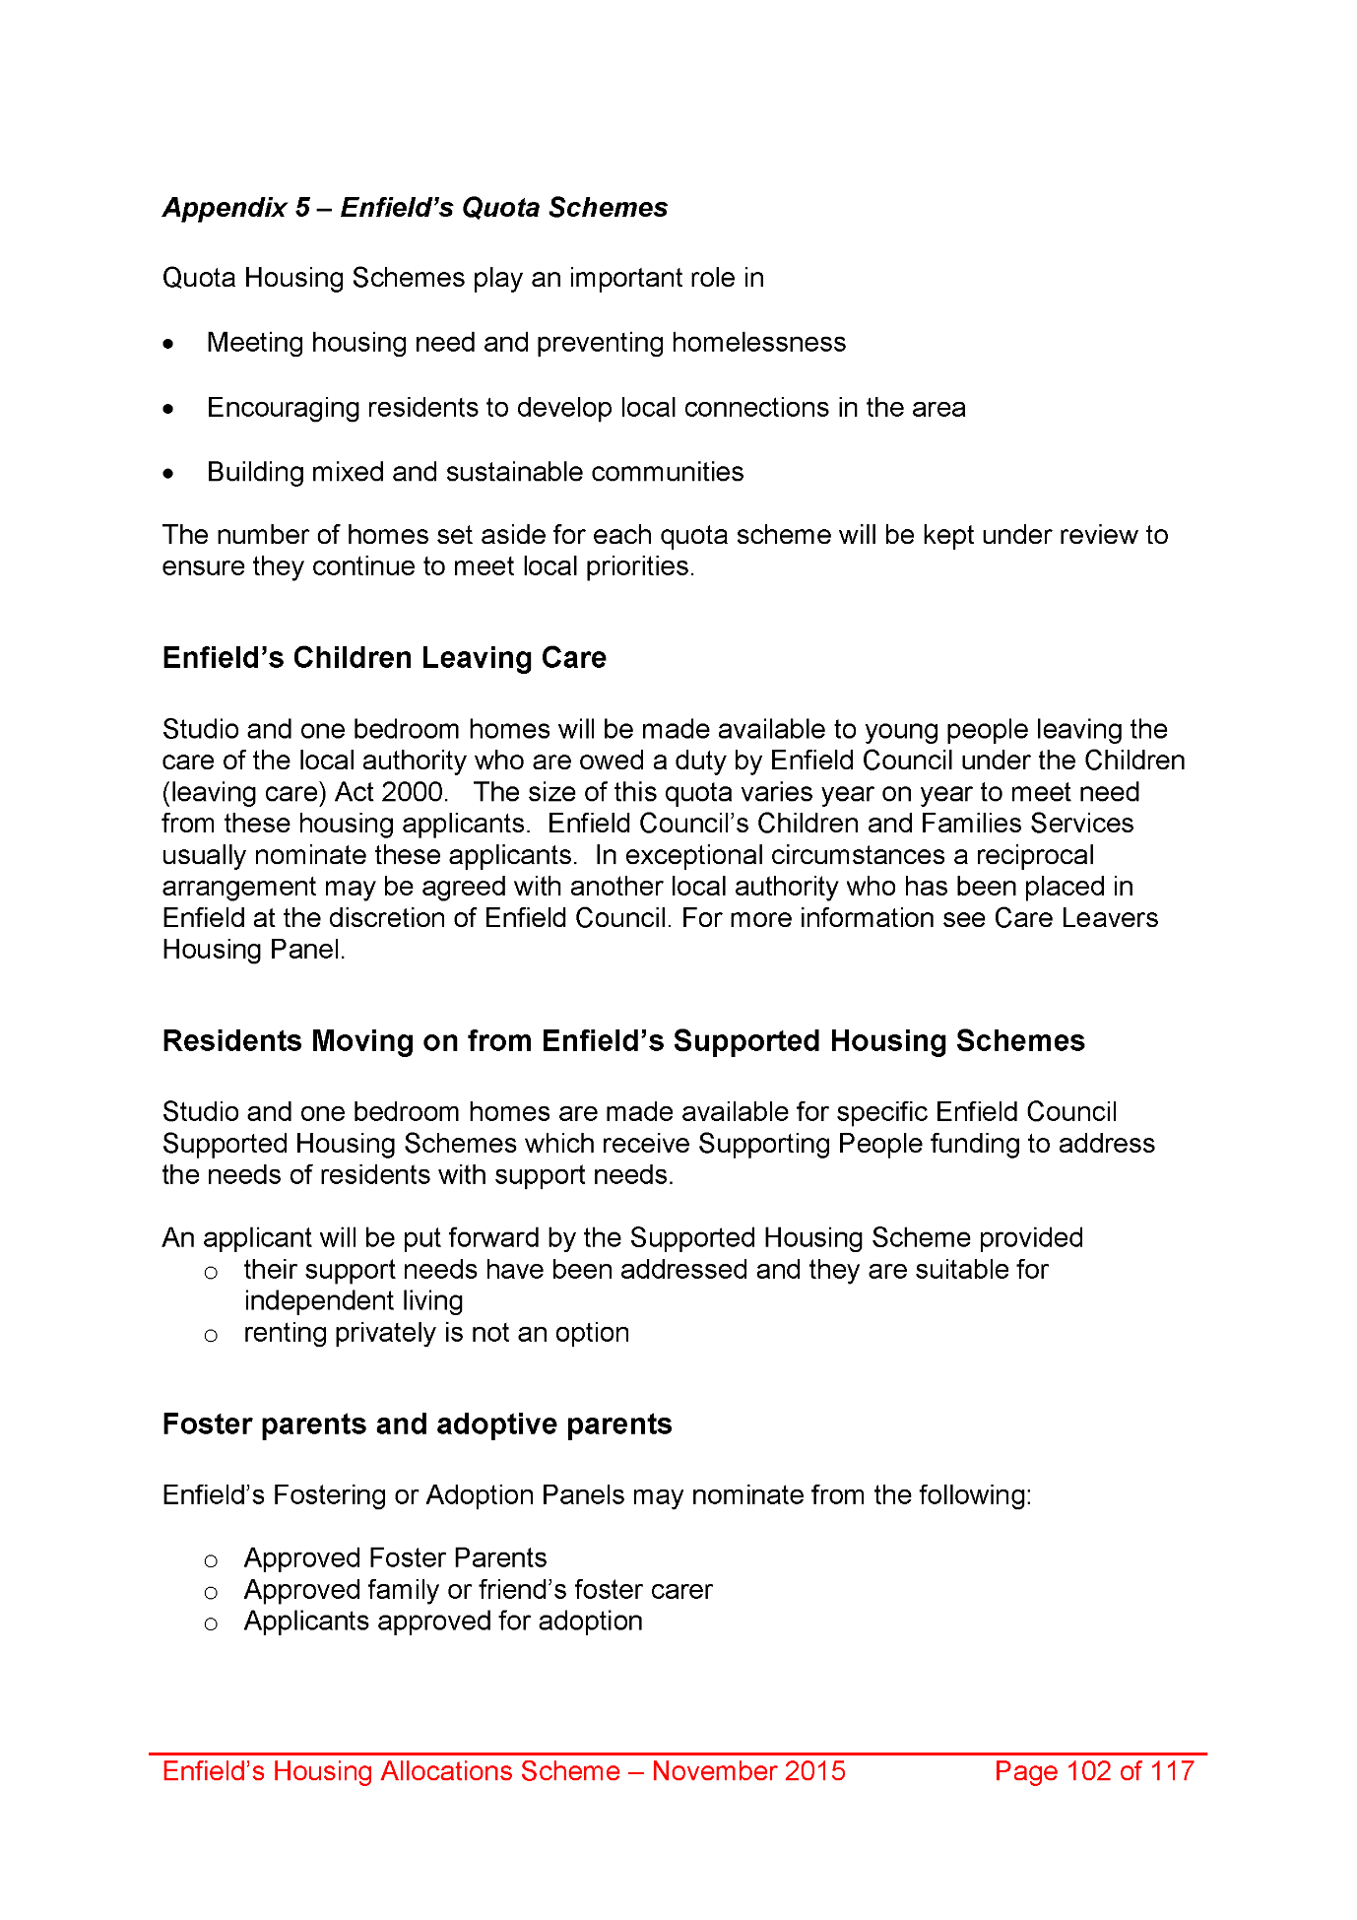
2061,
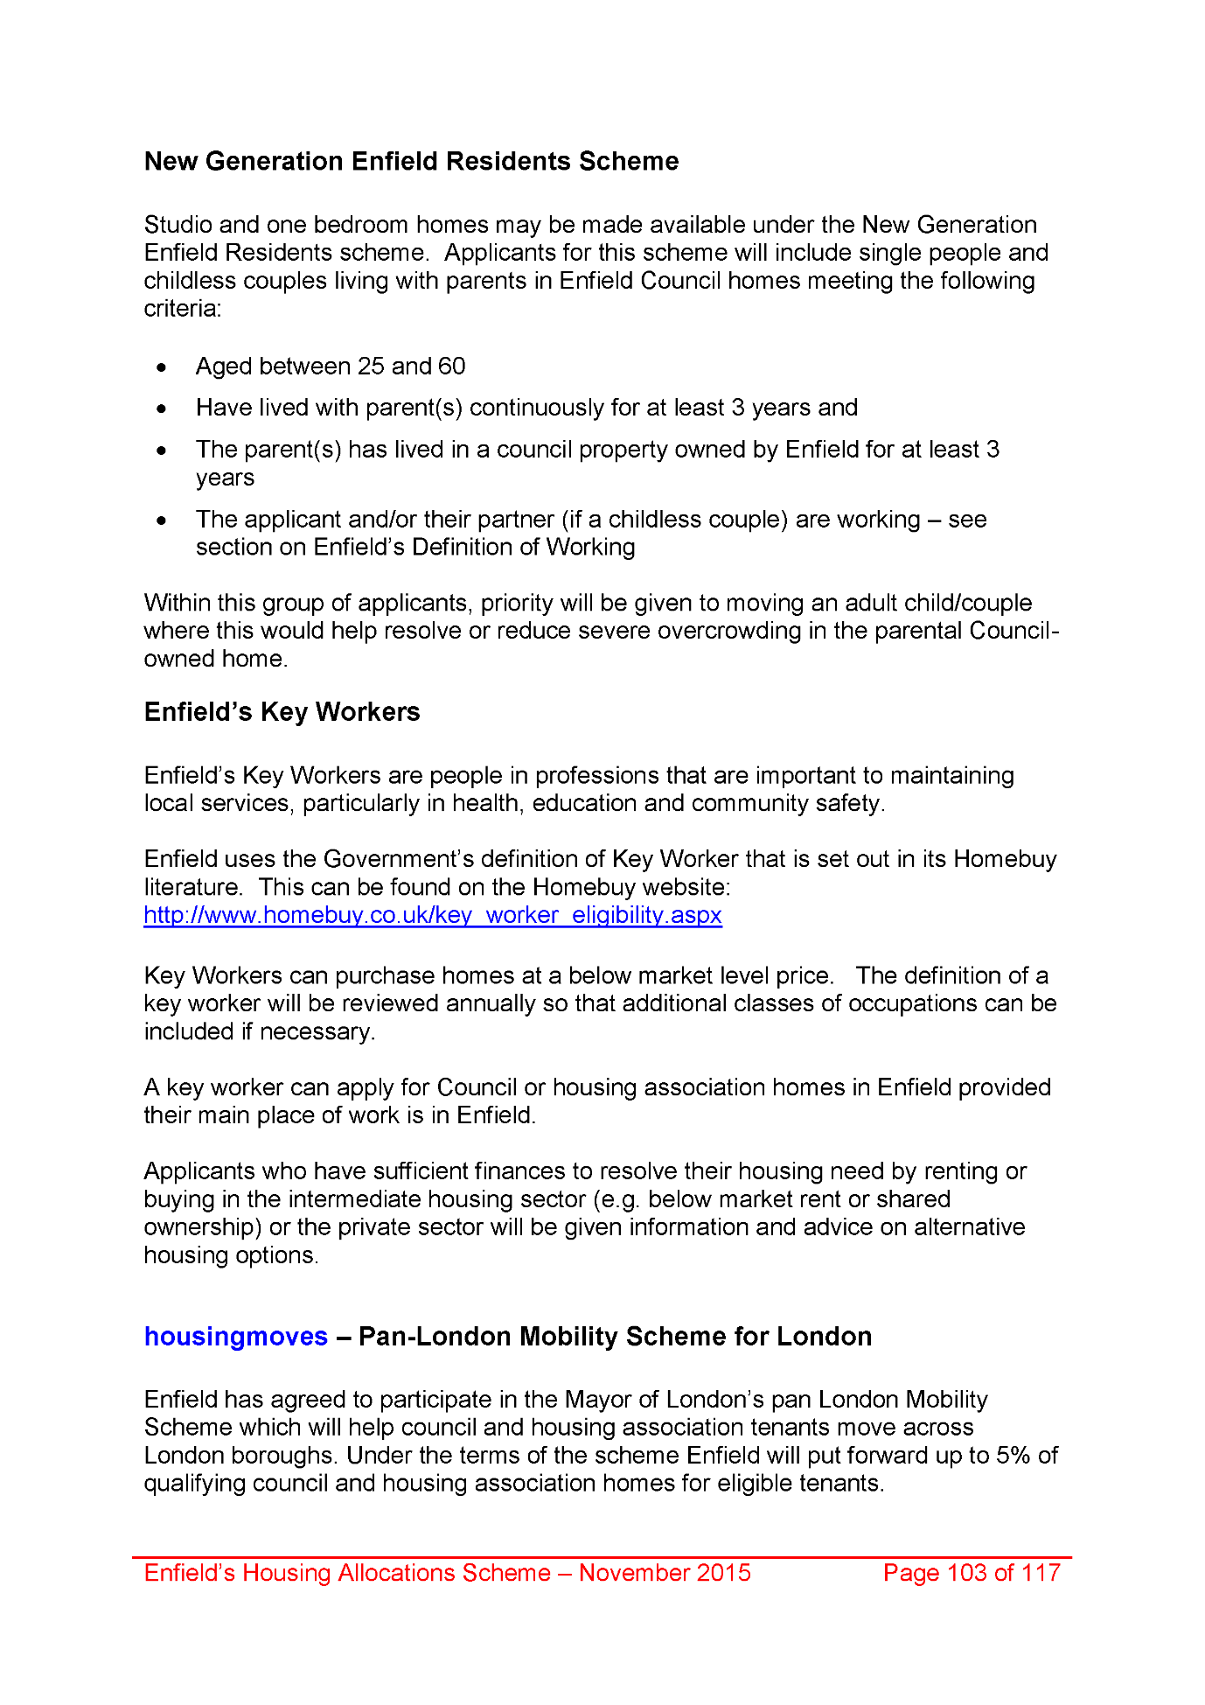
2062,
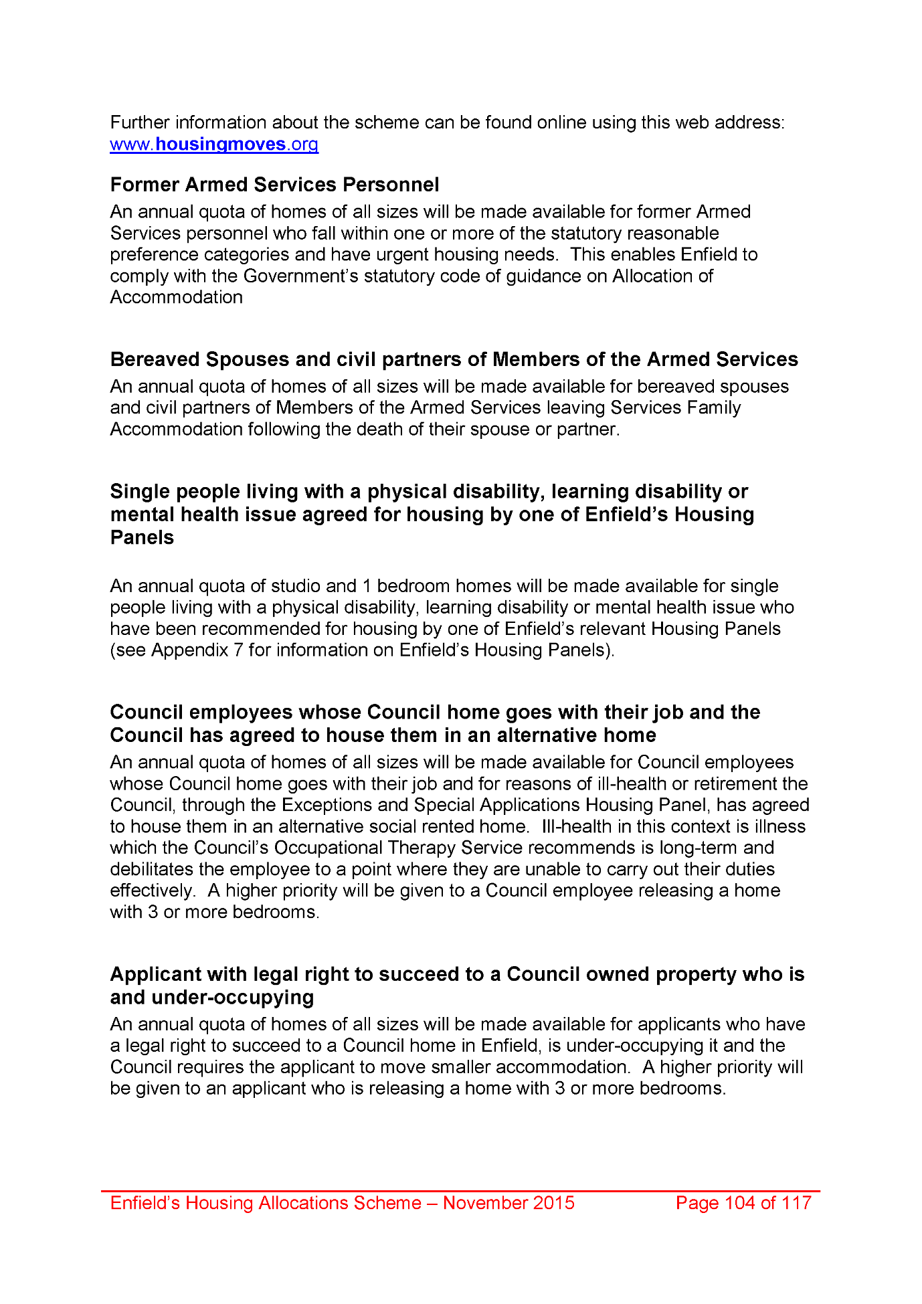
2063,
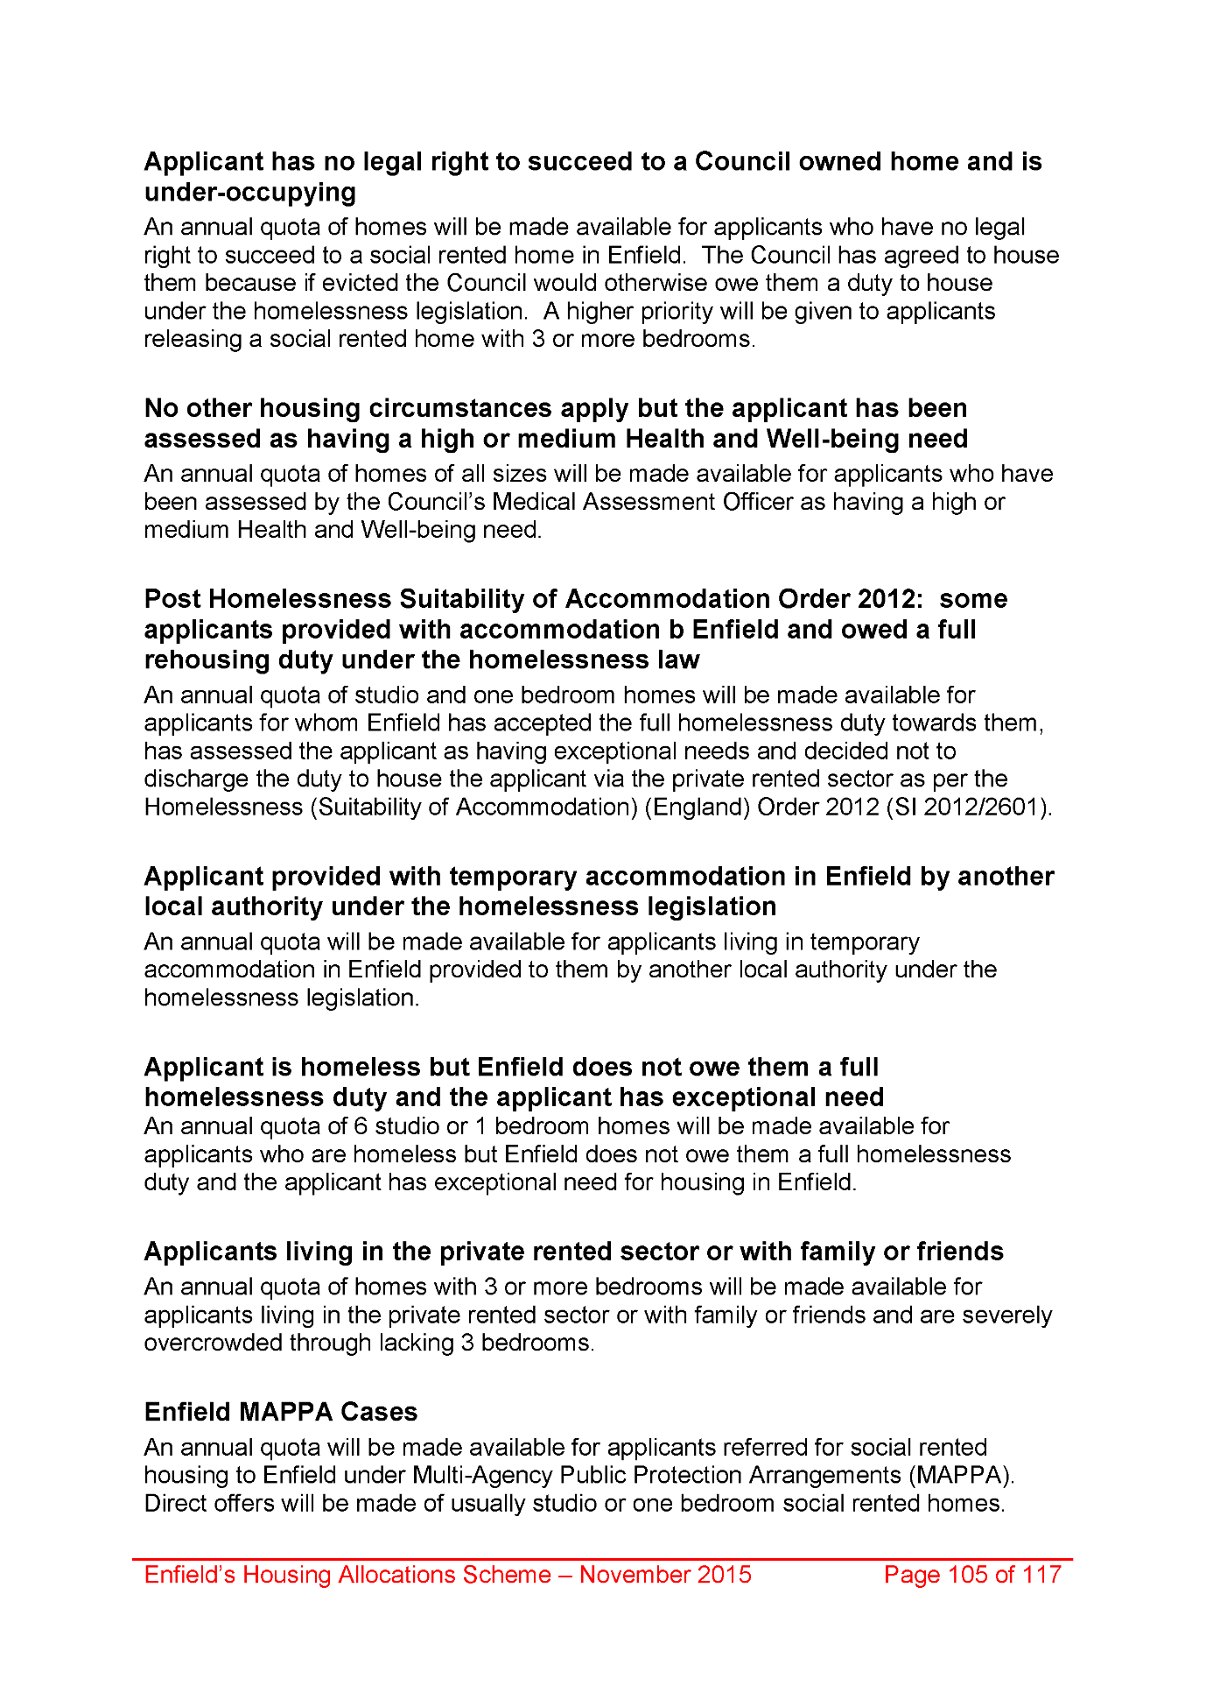
2064,
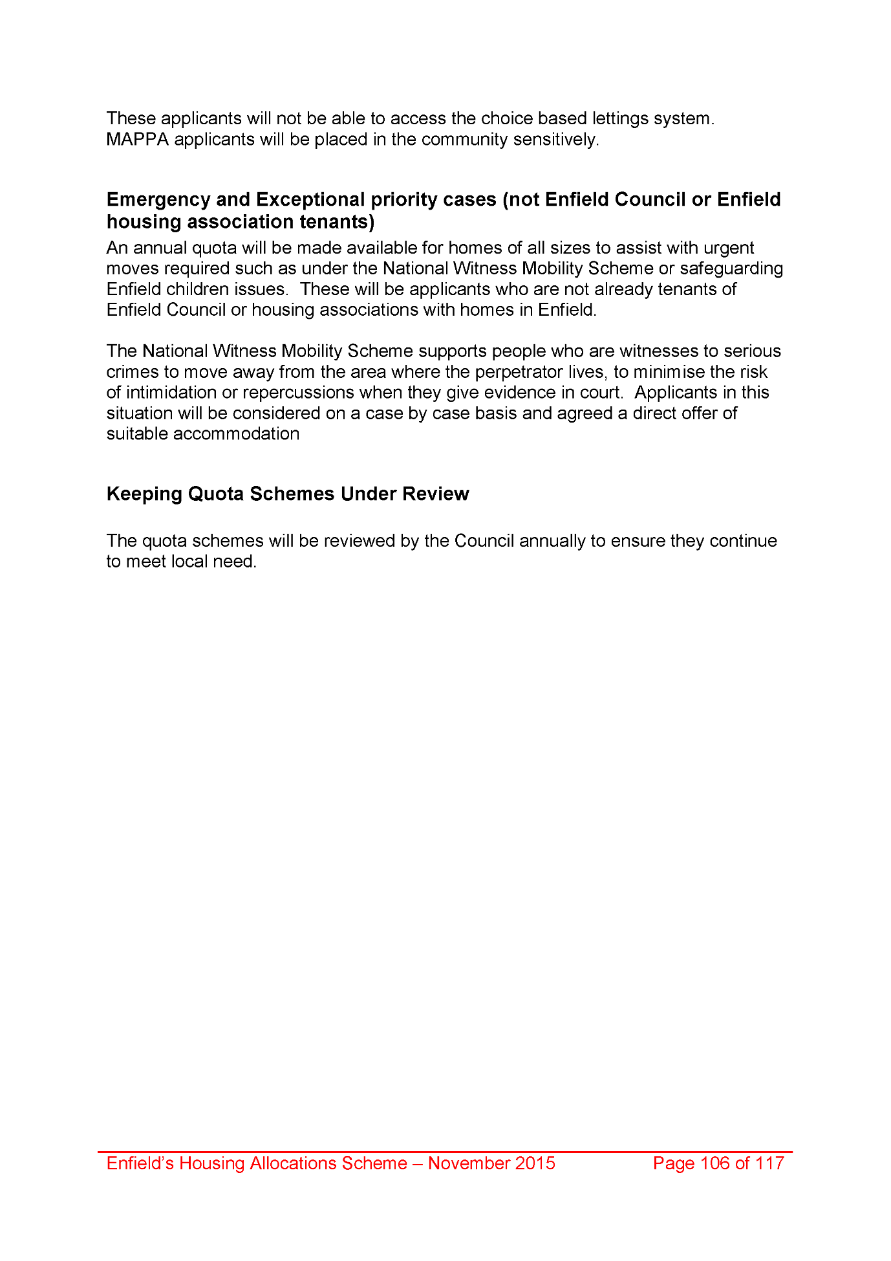
2065,
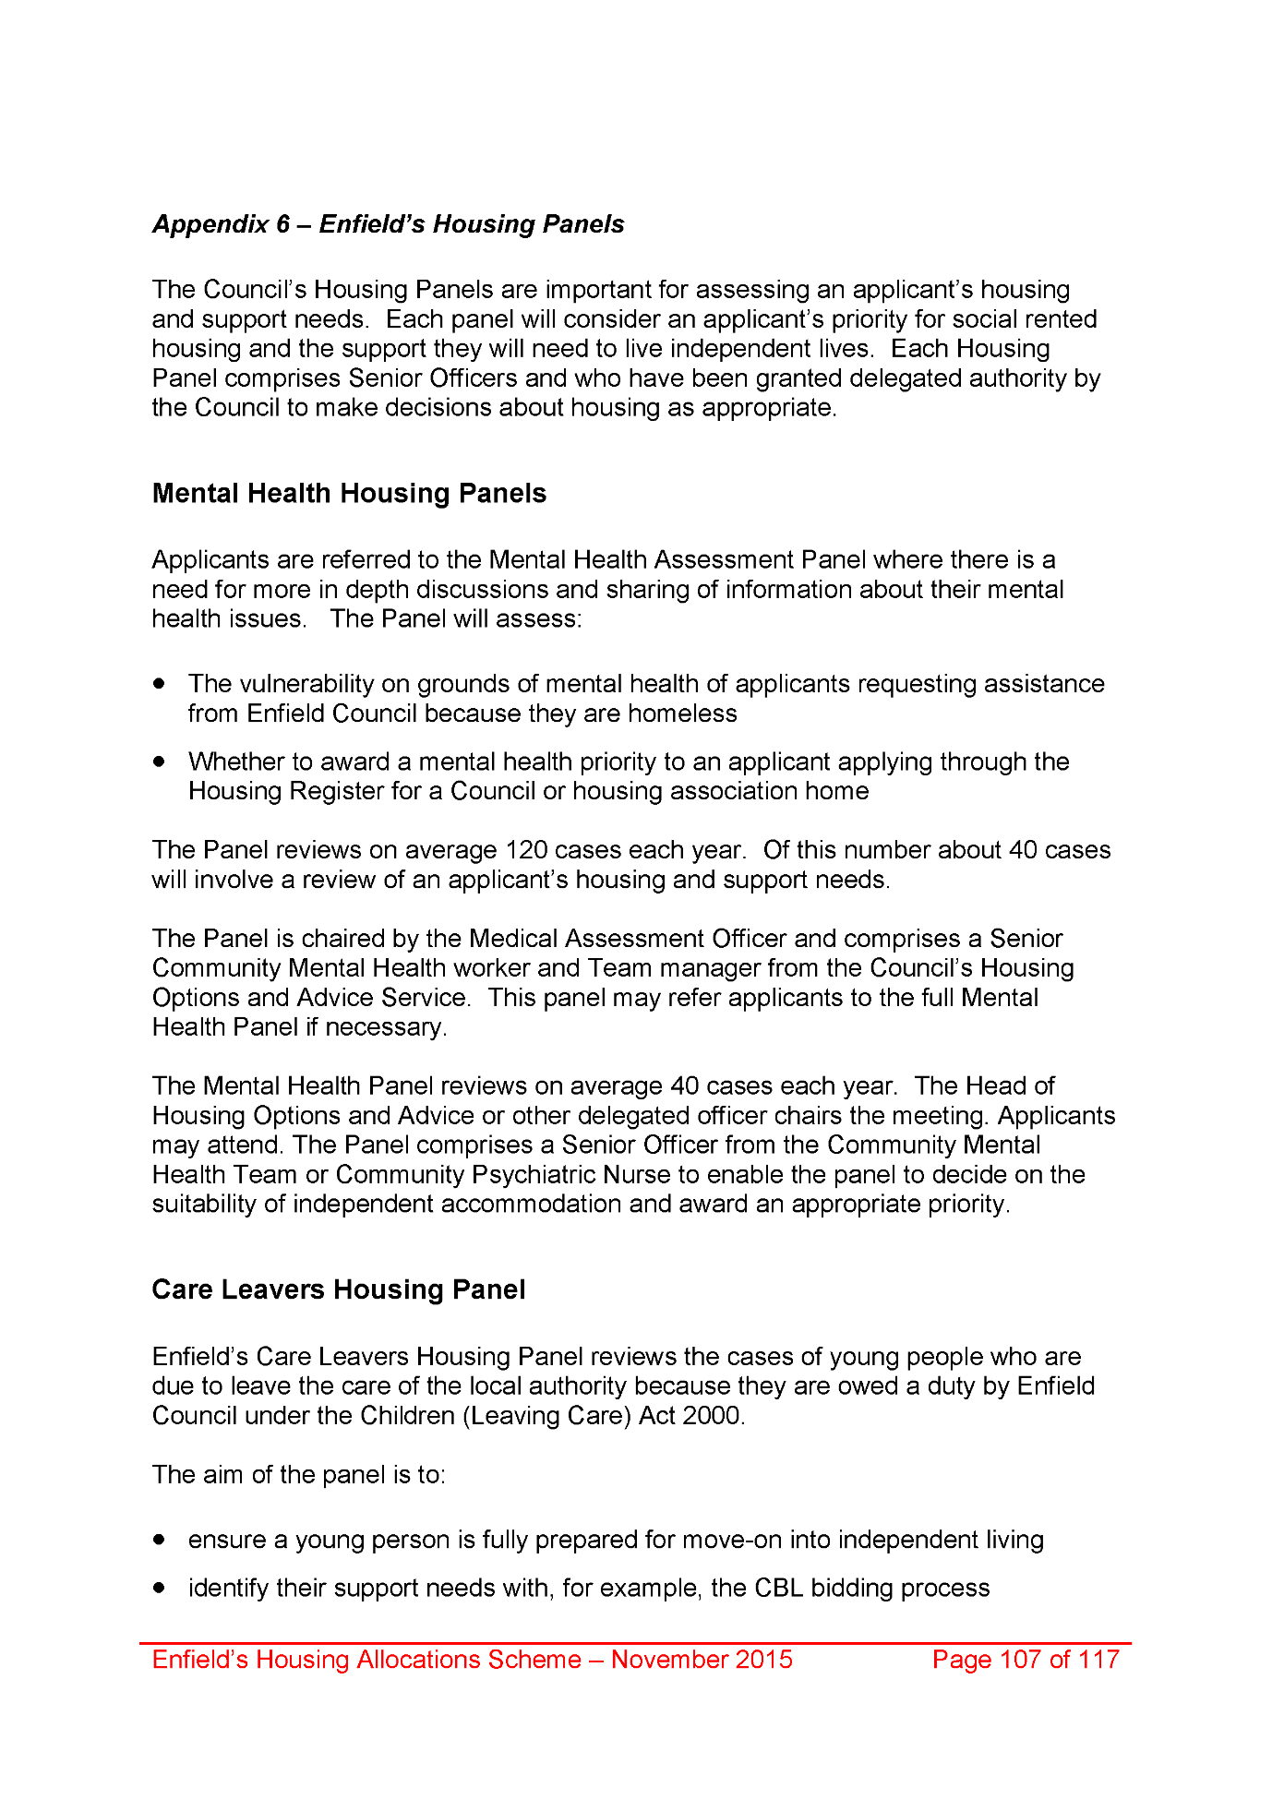
2066,
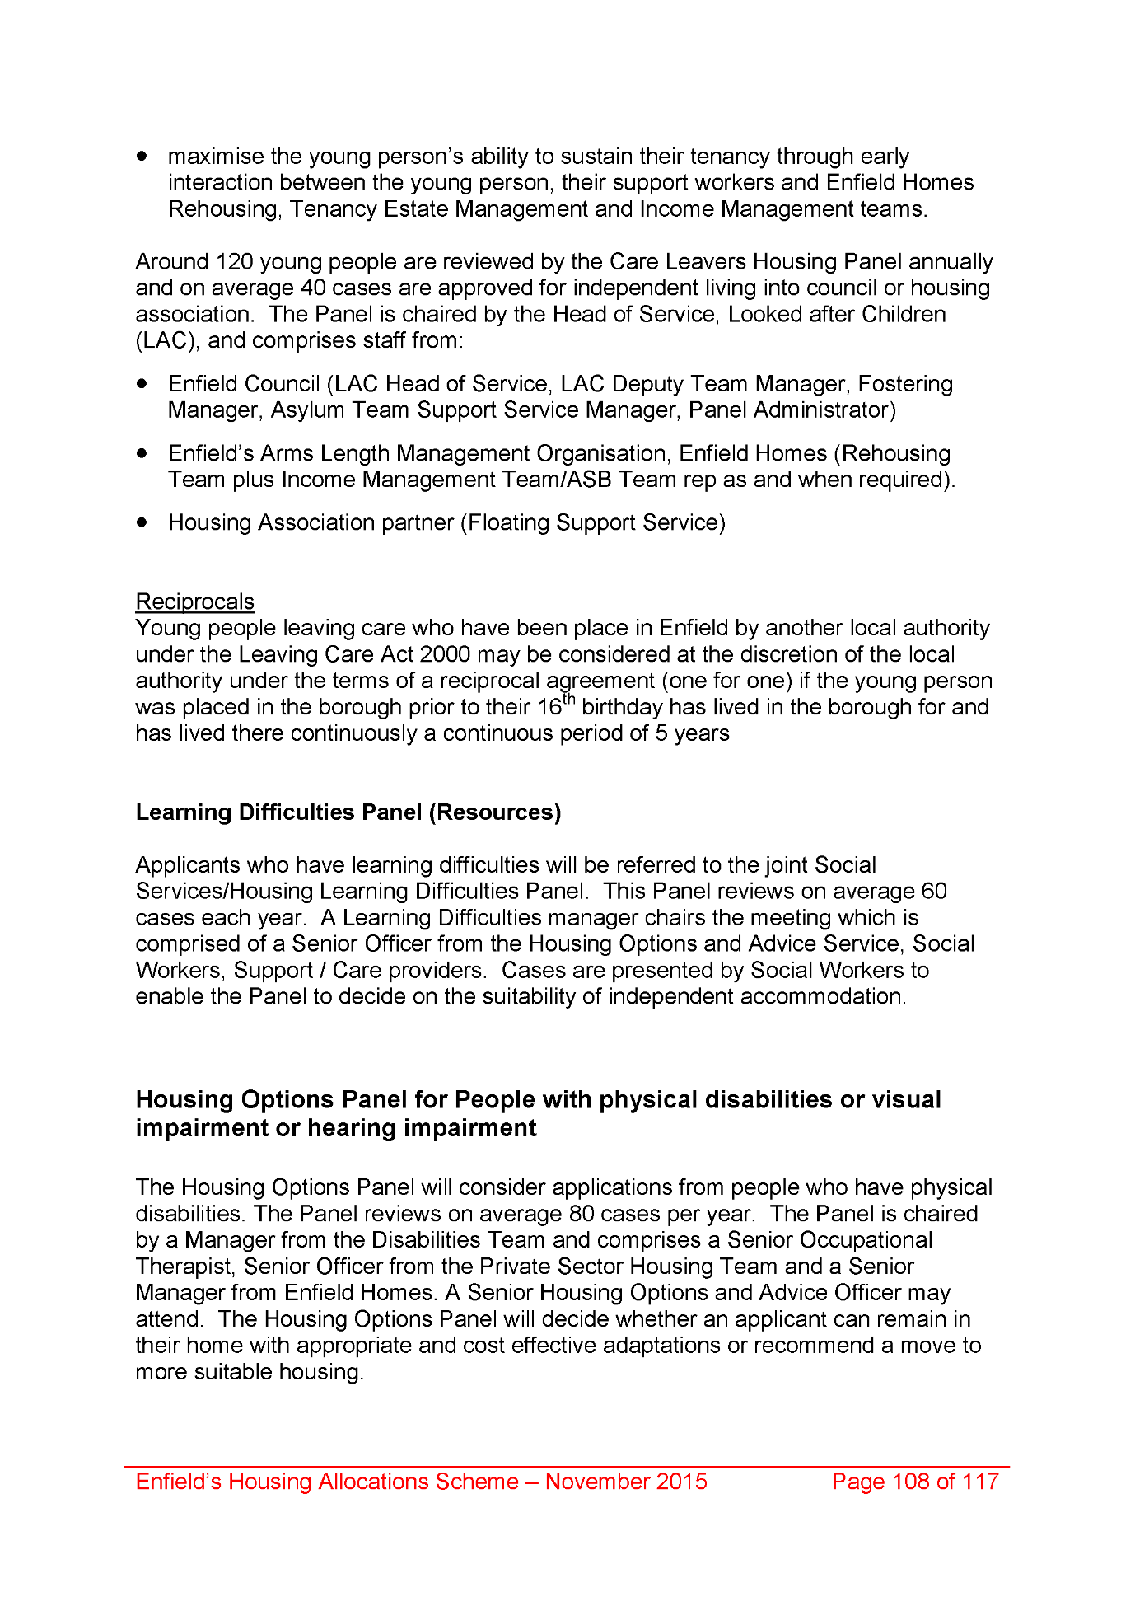
2067,
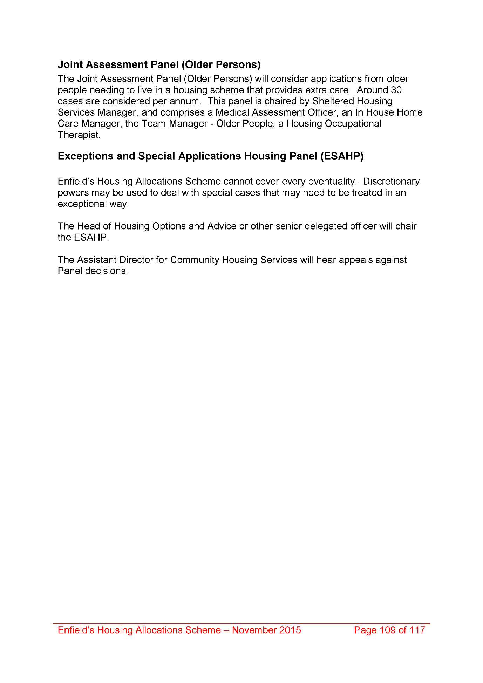
2068,
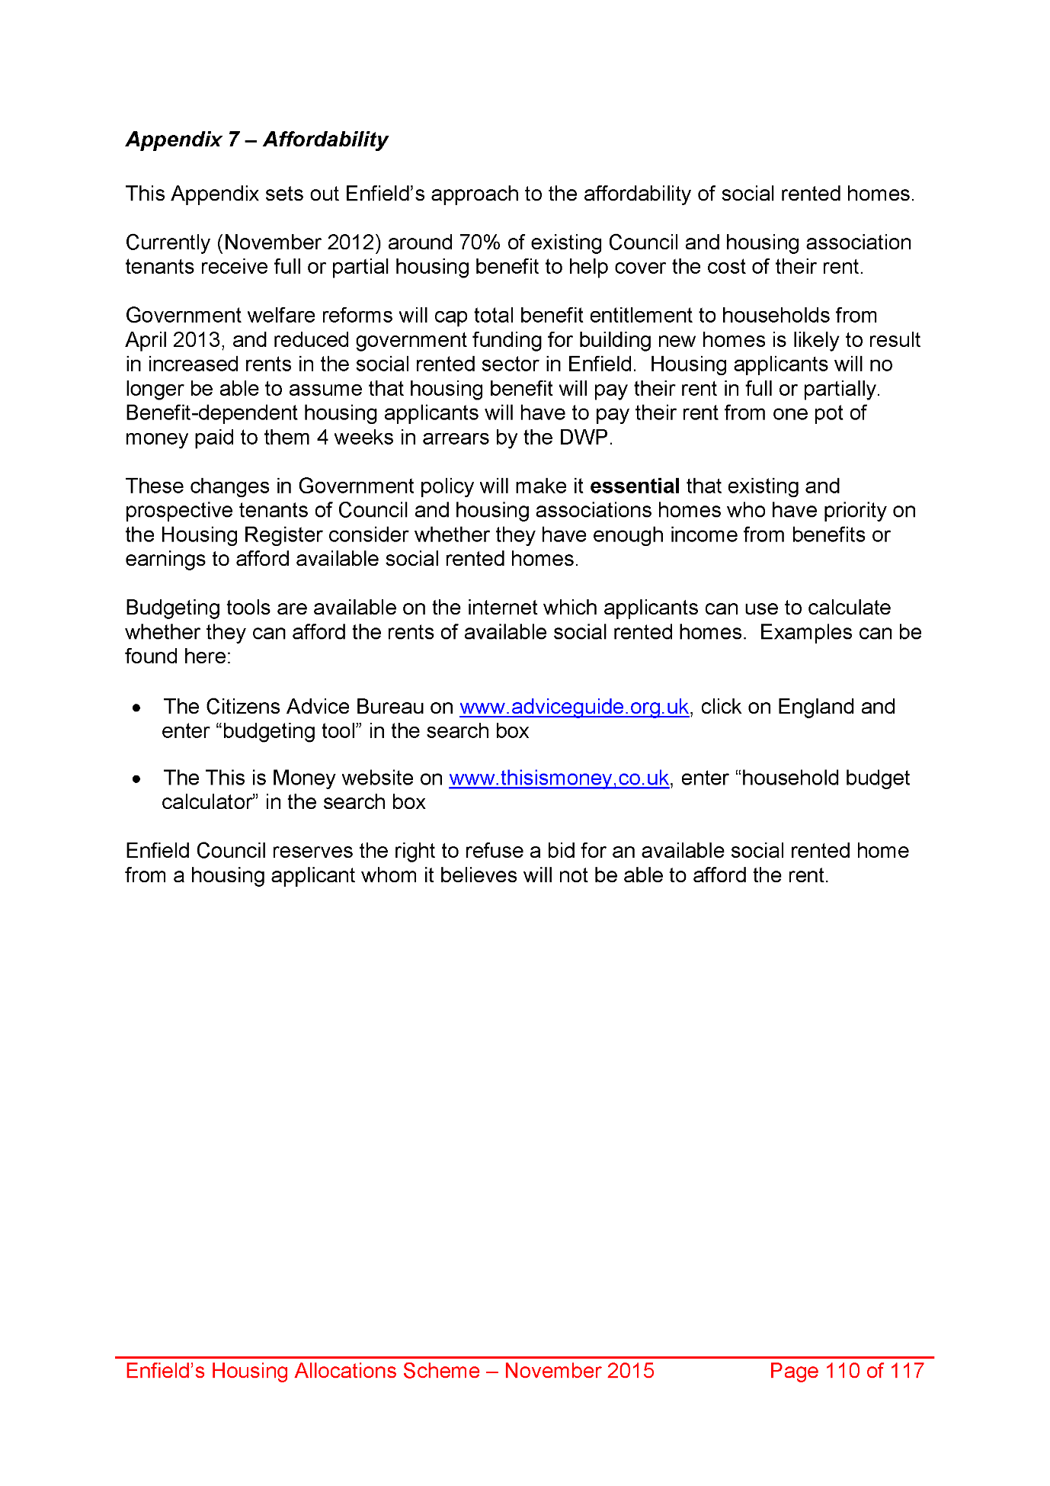
2069,
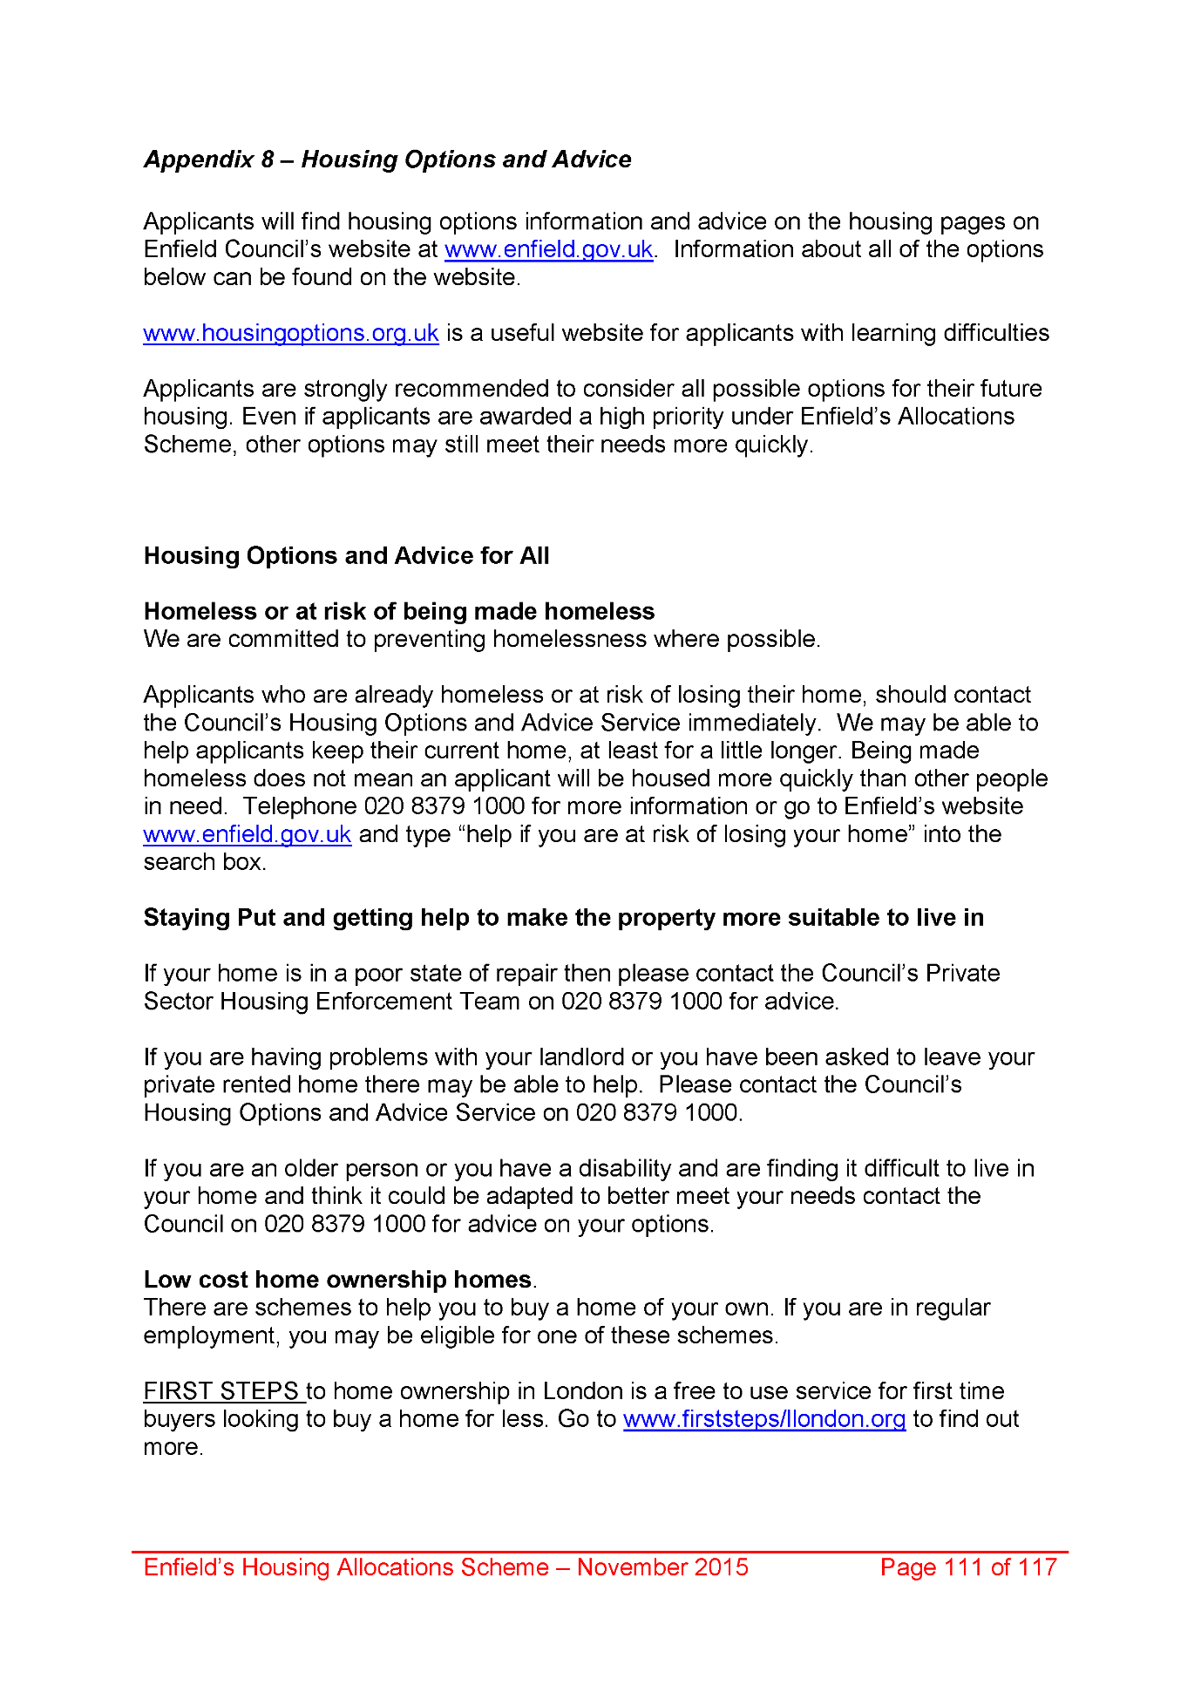
2070,
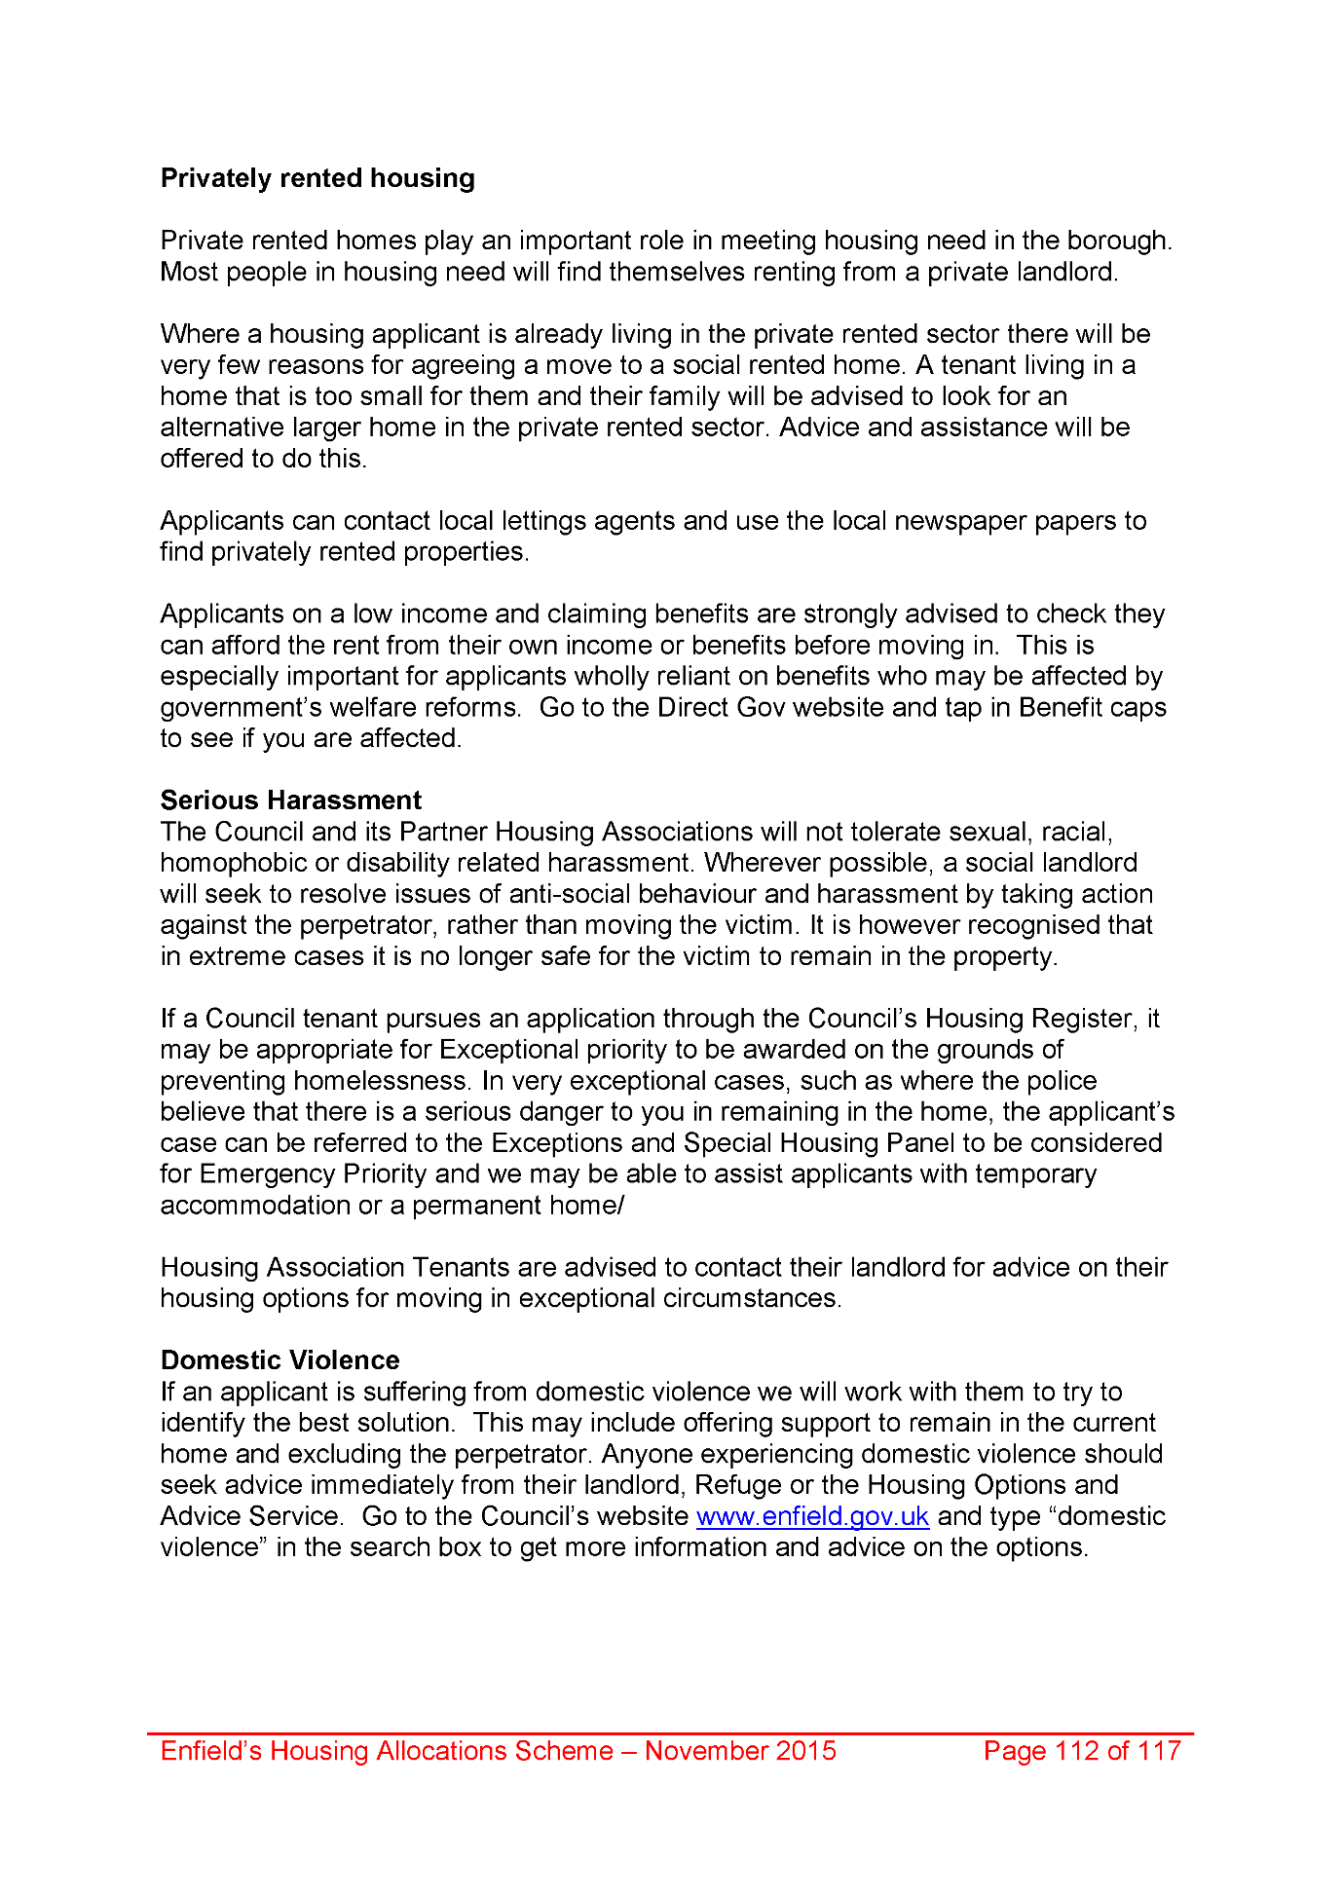
2071,
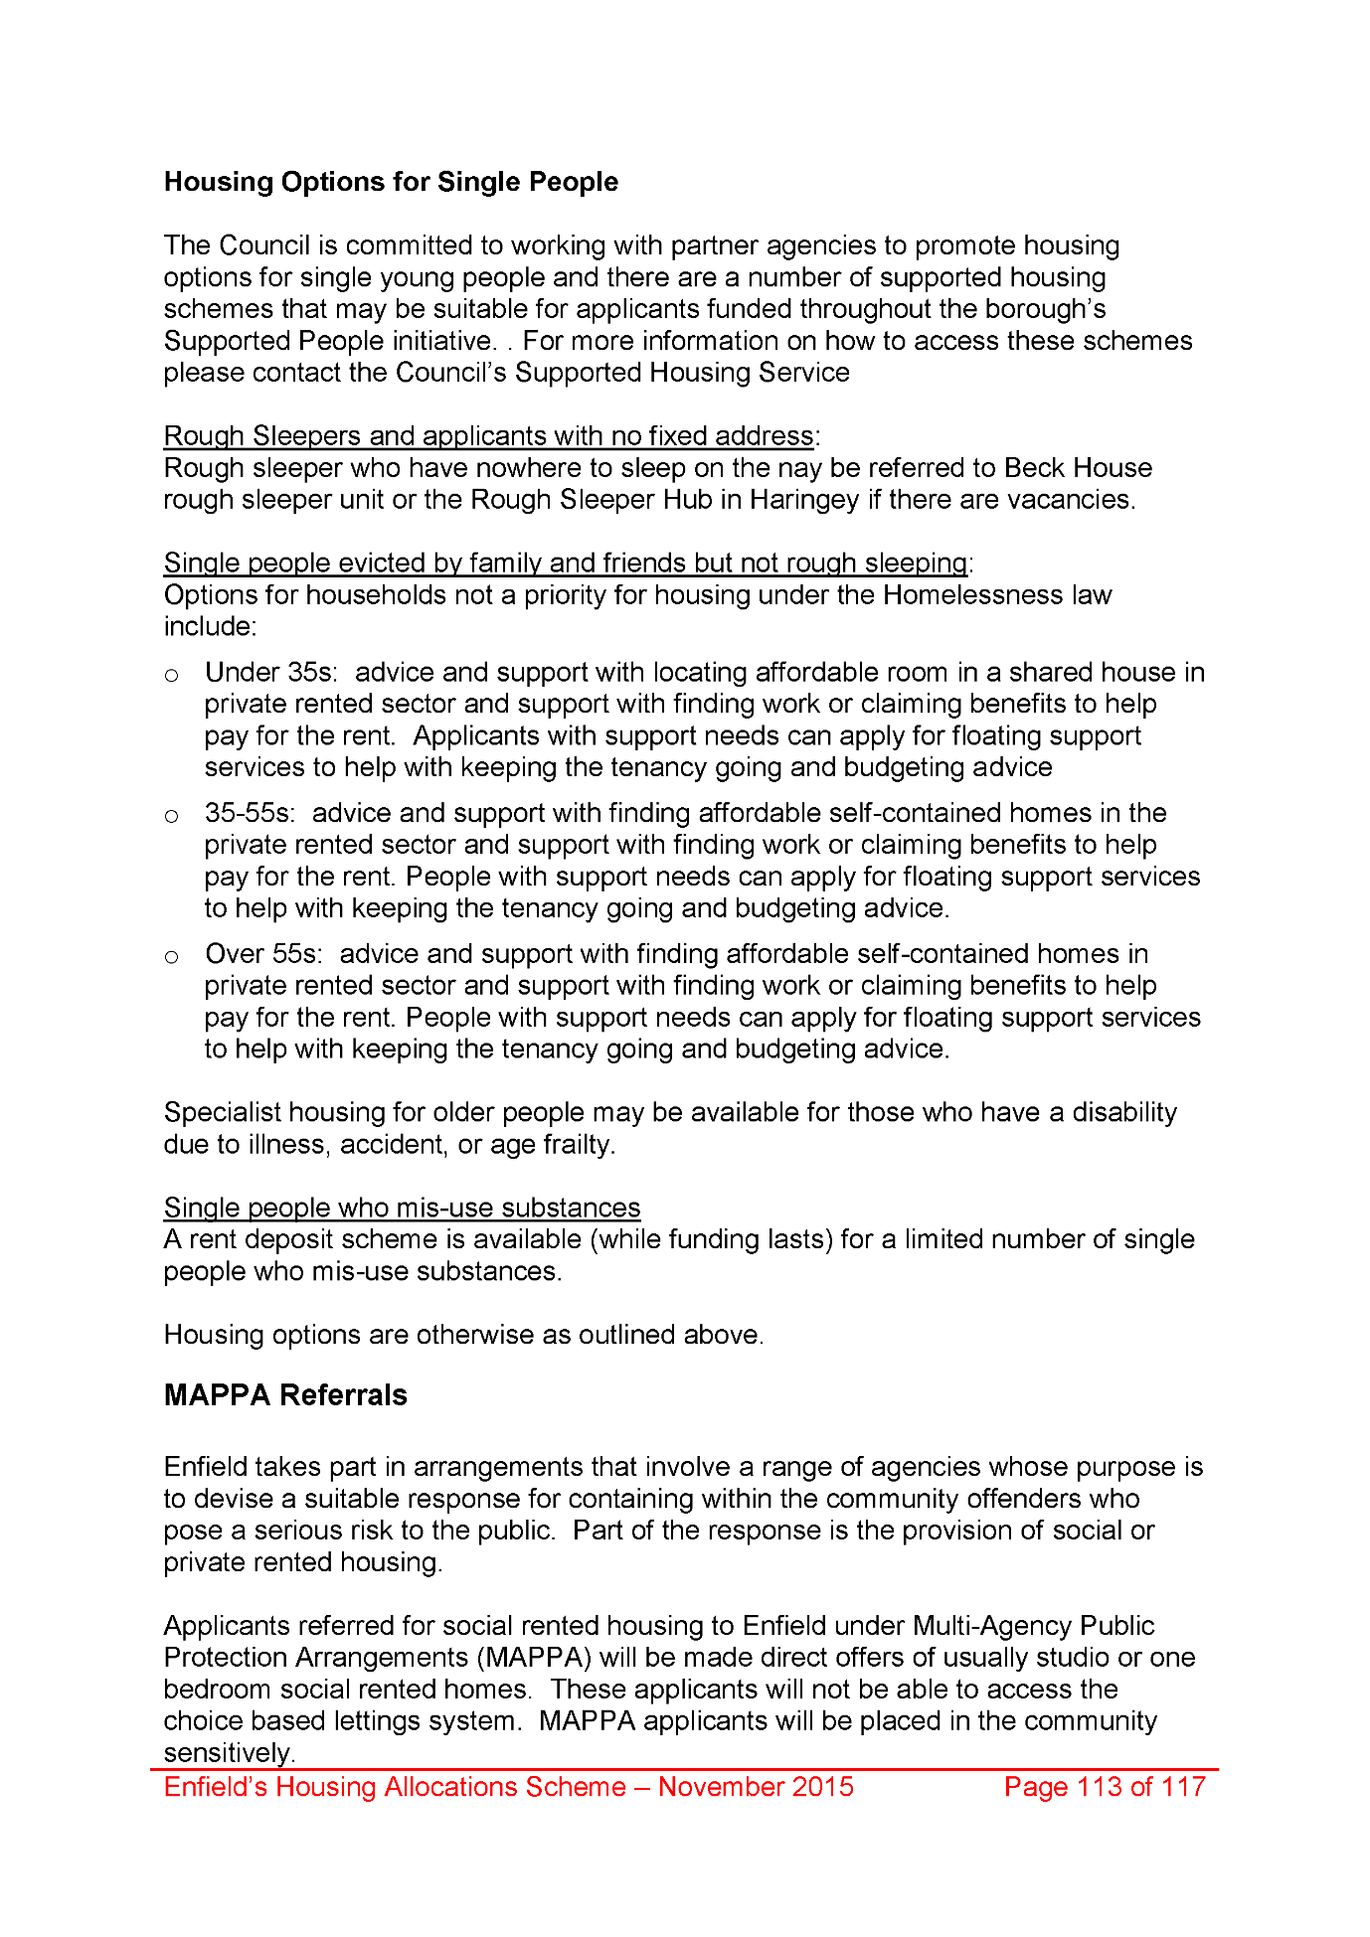
2072,
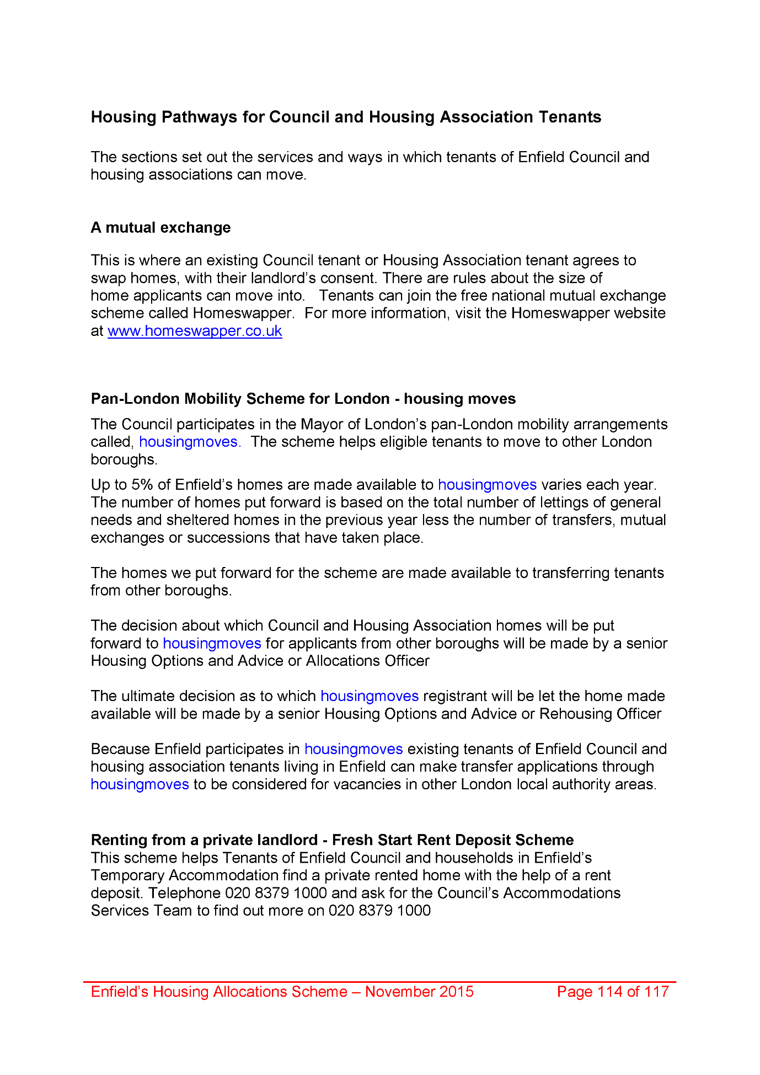
2073,
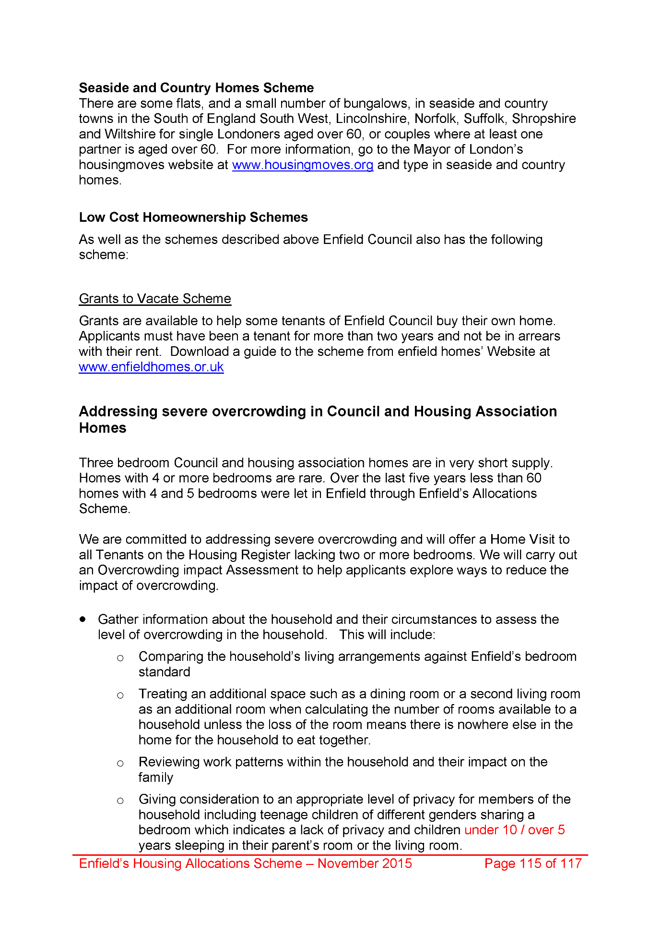
2074,
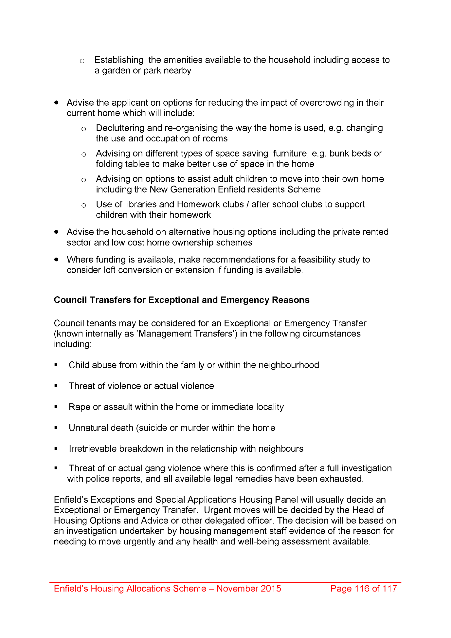
2075,
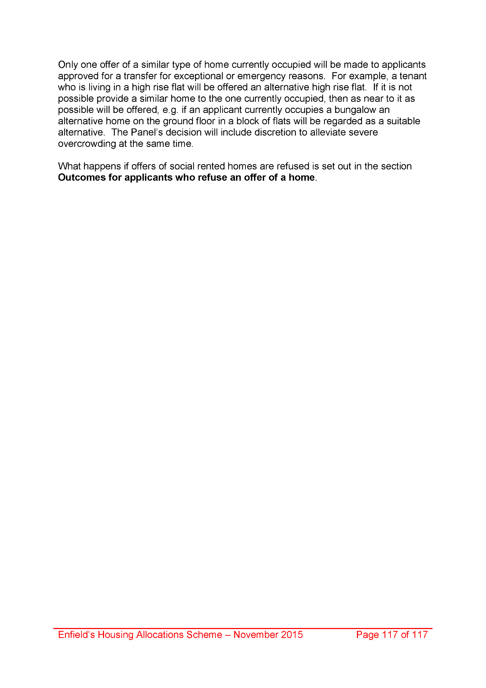
End of picture!

